**VIETNAM - KOREA UNIVERSITY OF INFORMATION AND COMMUNICATION TECHNOLOGY**

**FACULTY OF COMPUTER ENGINEERING AND ELECTRONICS**



**GRADUATION PROJECT**

**BUILDING AN ENTERPRISE NETWORK SYSTEM WITH AUTOMATION USING ANSIBLE, MONITORING WITH PROMETHEUS, AND SECURITY WITH PFSENSE IDS/IPS**

**Student's full name**  : *Nguyen An Phuc*

**Class :** *21NS*

**Major**  : Information Technology

**Specialization :** *Network and Information Security*

**Supervisor**  : *Dr. Dang Quang Hien*

**Da Nang – 12/2025**

**VIETNAM - KOREA UNIVERSITY OF INFORMATION AND COMMUNICATION TECHNOLOGY**

**FACULTY OF COMPUTER ENGINEERING AND ELECTRONICS**



**GRADUATION PROJECT**

**BUILDING AN ENTERPRISE NETWORK SYSTEM WITH AUTOMATION USING ANSIBLE, MONITORING WITH PROMETHEUS, AND SECURITY WITH PFSENSE IDS/IPS**

**Student's full name**  : *Nguyen An Phuc*

**Class** : *21NS*

**Major**  : *Information Technology*

**Specialization :** *Network and Information Security*

**Supervisor**  : *Dr. Dang Quang Hien*

**Da Nang – 12/2025**

ACKNOWLEDGEMENTS

To achieve the results I have seen in this thesis, I have received dedicated support, assistance, and guidance from my professor. With deep and sincere gratitude, I would like to express my profound thanks to all the professors who have provided me with the necessary support and assistance throughout my studies and research.

First and foremost, I would like to extend my warmest greetings, best wishes for good health, and deepest gratitude to the faculty of the Vietnam-Korea University of Information and Communication Technology. With their attentive care, dedicated guidance, and extensive knowledge in various fields, the faculty have imparted to us a wealth of necessary knowledge and skills, enabling us to complete our thesis today.

In particular, I would like to express my sincere gratitude to Dr. Dang Quang Hien, lecturer and supervisor, for his kind attention, assistance, and guidance that enabled me to successfully complete this thesis throughout the past period.

Given the limited time and experience, this topic inevitably has shortcomings. I sincerely hope to receive guidance and feedback from the professors so that we can supplement and improve our knowledge and skills, better serving our future practical work.

Thank you very much!

Student,

Nguyen An Phuc

SUPERVISOR'S EVALUATION

…………………………………………………………………………………………

…………………………………………………………………………………………

…………………………………………………………………………………………

…………………………………………………………………………………………

…………………………………………………………………………………………

…………………………………………………………………………………………

…………………………………………………………………………………………

…………………………………………………………………………………………

…………………………………………………………………………………………

…………………………………………………………………………………………

…………………………………………………………………………………………

…………………………………………………………………………………………

…………………………………………………………………………………………

…………………………………………………………………………………………

*Da Nang, …/…/2025*

Supervisor

TABLE OF CONTENTS

ACKNOWLEDGEMENTS i

SUPERVISOR'S EVALUATION ii

TABLE OF CONTENTS iii

LIST OF ABBREVIATIONS vi

LIST OF TABLES viii

LIST OF FIGURES ix

INTRODUCTION 1

CHAPTER 1. OVERVIEW OF THEORETICAL FOUNDATIONS 5

1.1. Overview of enterprise network systems 5

1.1.1. Modern enterprise network architecture 5

1.1.2. Challenges in traditional network management and security 5

1.1.3. NetDevOps and Automation Trends 6

1.2. Infrastructure automation solutions 6

1.2.1. Introducing Ansible 6

1.2.2. Ansible's architecture 7

1.2.3. Advantages of Ansible 7

1.3. Monitoring and Alerting System 8

1.3.1. Prometheus 8

1.3.2. Alertmanager 10

1.3.3. Grafana 10

1.4. Centralized Logging Management System 11

1.4.1. Grafana Loki 11

1.4.2. Promtail 12

1.5. Information Security and Defense Systems (IDS/IPS) 12

1.5.1. pfSense Firewall 12

1.5.2. Suricata (IDS/IPS Engine) 13

1.6. Other supporting technologies 14

1.6.1. Docker & Docker Compose 14

1.6.2. Teleport (Secure Access) 14

1.6.3. Webhook 15

1.7. Virtualization and Network Simulation Tools 15

1.7.1. VMware Workstation 15

1.7.2. GNS3 (Graphical Network Simulator-3) 16

1.8. End of Chapter 1 16

CHAPTER 2. ANALYSIS AND DESIGN 17

2.1. Analyze the problem requirements. 17

2.1.1. Network architecture and information security requirements 17

2.1.2. Log monitoring and management requirements 17

2.1.3. Automation requirements 17

2.2. System design 17

2.2.1. Network Topology Diagram 18

2.2.2. Monitoring and control data flow design 19

2.3. Network Infrastructure Deployment: Switching and Routing 21

2.3.1. IP planning and VLAN/Trunk configuration. 21

2.3.2. Implementing High-Speed Gateway Backup (HSRP) 22

2.3.3. Implementing OSPF Dynamic Routing 23

2.3.4. Configure Management Protocols 24

2.4. Deploying pfSense firewall and IPS/IDS (Suricata) 24

2.4.1. Detailed settings 24

2.4.2. Basic functional configuration 25

2.4.3. Deploying Suricata IDS/IPS 33

2.4.4. Implement Load Balancing and Backward Proxy (HAProxy) 35

2.5. Implement a Centralized Monitoring and Logging System (PLG Stack) 36

2.5.1. Deploying Docker Stack (Infrastructure as Code) 36

2.5.2. Configuring Prometheus (The Metrics Engine) 37

2.5.3. Configure Alertmanager (The Notification Handler) 40

2.5.4. Promtail and Loki (Log Pipeline) Configuration 42

2.5.5. Building a Dashboard in Grafana 43

2.5.6. Build automated reports and alerts via Telegram. 47

2.6. Implementing Automation with Ansible and Teleport 48

2.6.1. Ansible's directory structure and architecture 48

2.6.2. Implementing an Auto Backup Script 50

2.6.3. Implementing the Teleport Setup (Provisioning) Scenario 51

2.7. End of Chapter 2 53

CHAPTER 3. EXPERIMENTAL RESULTS AND EVALUATION 55

3.1. Experimental deployment environment 55

3.1.2. Server specifications 55

3.1.3. Test script 56

3.2. Network infrastructure deployment results 56

3.2.1. Check Gateway routing and redundancy. 56

3.2.2. Check inter-regional connectivity 57

3.2.3. Results of HAProxy deployment 57

3.3. Results of the centralized Monitoring and Logging system 59

3.3.1. Dashboard Network Automation Backup Status 59

3.3.2. Dashboard Centralized Logs (Loki) 59

3.3.3. Dashboard Network Traffic (SNMP) 60

3.3.4. Dashboard pfSense Firewall Monitoring 61

3.3.5. Dashboard Node Exporter (Server Health) 63

3.4. Results of Management Automation 63

3.4.1. Result of Automatic Configuration Backup (Auto Backup) 63

3.4.2. Results of Teleport (Provisioning) Implementation 64

3.4.3. Summary of Telegram report results 65

3.5. Results of the Active Defense System (Suricata IPS) 66

3.5.1. Scenario 1: Preventing Network Scanning Attacks 66

3.5.2. Scenario 2: Preventing a Denial of Service (DoS SYN Flood) Attack 67

3.6. Overall assessment 68

3.6.1. System effectiveness 68

3.6.2. Advantages of the implemented architecture 68

3.7. Conclusion of Chapter 3 68

CONCLUSIONS AND FUTURE WORK 70

LIST OF REFERENCES vi

LIST OF ABBREVIATIONS

|  |  |
| --- | --- |
| **ABBREVIATIONS** | **CONTENT** |
| ACL | Access Control List |
| API | Application Programming Interface |
| CA | Certificate Authority |
| CI/CD | Continuous Integration/Continuous Deployment |
| CLI | Command Line Interface |
| CPU | Central Processing Unit |
| DHCP | Dynamic Host Configuration Protocol |
| DMZ | Demilitarized Zone |
| DNS | Domain Name System |
| DoS | Denial of Service |
| DDoS | Distributed Denial of Service |
| GUI | Graphical User Interface |
| HA | High Availability |
| HSRP | Hot Standby Router Protocol |
| HTTP | HyperText Transfer Protocol |
| HTTPS | HyperText Transfer Protocol Secure |
| IaC | Infrastructure as Code |
| IDS | Intrusion Detection System |
| IPS | Intrusion Prevention System |
| IP | Internet Protocol |
| JSON | JavaScript Object Notation |
| LAN | Local Area Network |
| MFA | Multi-Factor Authentication |
| MIB | Management Information Base |
| NAT | Network Address Translation |
| OSPF | Open Shortest Path First |
| PLG | Prometheus - Loki - Grafana |
| QoS | Quality of Service |
| RAM | Random Access Memory |
| RTT | Round Trip Time |
| SMB | Small and Medium-sized Businesses |
| SNMP | Simple Network Management Protocol |
| SPI | Stateful Packet Inspection |
| SSH | Secure Shell |
| SSL/TLS | Secure Sockets Layer / Transport Layer Security |
| SSO | Single Sign-On |
| SVI | Switch Virtual Interface |
| TSDB | Time Series Database |
| VIP | Virtual IP |
| VLAN | Virtual Local Area Network |
| VM | Virtual Machine |
| WAN | Wide Area Network |
| YAML | YAML Ain't Markup Language |

LIST OF TABLES

Table 1.1 Comparing Ansible with other configuration tools 8

Table 1.2 Comparing Prometheus with Zabbix/Nagios 9

Table 1.3 Comparing Grafana with Kibana 11

Table 1.4 Comparing Loki to ELK Stack 12

Table 1.5 Comparing pfSense with other Firewall solutions 13

Table 1.6 Comparison of Suricata and Snort (Legacy) 14

Table 1.7 Comparison of Teleport and traditional OpenSSH 15

Table 2.1 Describe the equipment components present in the DMZ. 18

Table 2.2 Describe the equipment components present in the LAN area. 18

Table 2.3 VLAN layout table for the entire network system. 21

Table 3.1 Experimental System Resources 55

LIST OF FIGURES

Figure 1.1. Enterprise network system architecture 5

Figure 1.2. NetDevOps Trends 6

Figure 1.3. What is Ansible? 7

Figure 1.4. Ansile's architecture 7

Figure 1.5. Prometheus logo 8

Figure 1.6. Prometheus operational architecture 9

Figure 1.7. Grafana Dashboard 10

Figure 1.8. Grafana Loki 11

Figure 1.9. Pfsense logo 12

Figure 1.10. Docker 14

Figure 1.11. Teleport is a technology replacing traditional SSH. 15

Figure 1.12. VMware Workstation 16

Figure 1.13. GNS3 (VM) runs on VMware. 16

Figure 2.1. Logic and Physical Network Design Diagram 18

Figure 2.2. Data flow diagram in the system 21

Figure 2.3. Configure trunk 2 ports e0/1 and e1/0 on SW-L3-KA 22

Figure 2.4. Configure trunk 2 ports e0/1 and e1/0 on SW-L3-KB 22

Figure 2.5. Trunk status on SW-L3-KA 22

Figure 2.6. Trunk status on SW-L3-KB 22

Figure 2.7. HSRP configuration command 23

Figure 2.8. Configuring OSPF on SW-DMZ 24

Figure 2.9. Configure smnp v2 and log on SW-DMZ 24

Figure 2.10. Choose the installation version 25

Figure 2.11. Start PFSense 25

Figure 2.12. Restart PFSense 25

Figure 2.13. WAN port is DHCP enabled. 26

Figure 2.14. Web GUI interface for access over the WAN port. 26

Figure 2.15. Configure LAN ports 26

Figure 2.16. DMZ port configuration 27

Figure 2.17. Set up aliases 27

Figure 2.18. Set up NAT Outbound 28

Figure 2.19. Configure NAT port forwarding 28

Figure 2.20. Multiple tons 29

Figure 2.21. WAN Rule 29

Figure 2.22. DMZ Rule 30

Figure 2.23. Set up SNMP 31

Figure 2.24. Add frr package 31

Figure 2.25. OSPF configuration 32

Figure 2.26. Add areas 33

Figure 2.27. Add interface 33

Figure 2.28. Turn on FRR 33

Figure 2.29. Configure Block on WAN port 34

Figure 2.30. Configuration Interface in Suricata 34

Figure 2.31. Frontend and ACL configuration table on HAProxy 36

Figure 2.32. Docker Compose configuration file 36

Figure 2.33. The state of the containers for each service running on Docker. 37

Figure 2.34. Prometheus directory structure 37

Figure 2.35. prometheus.yml configuration file 37

Figure 2.36. Contents of the alert-rules.yml configuration file 38

Figure 2.37. Contents of the nginx-rules.yml configuration file 38

Figure 2.38. Contents of the backup-rules.yml configuration file 39

Figure 2.39. Contents of the pfsense-rules.yml configuration file 39

Figure 2.40. Contents of the network-traffic.rules.yml configuration file 40

Figure 2.41. Configure alertmanager.yml 41

Figure 2.42. Standard template for Telegram 41

Figure 2.43. Template for the Backup status alert 42

Figure 2.44. Template for memory warnings on pfsense 42

Figure 2.45. Network traffic alert template 42

Figure 2.46. Template for UP/DOWN status alerts on the port. 42

Figure 2.47. Promtail configuration 43

Figure 2.48. Configure backup status panel 44

Figure 2.49. Configure the log traffic display panel. 44

Figure 2.50. Configure the live log panel to display in real time. 45

Figure 2.51. Configure the panel to display total load usage. 45

Figure 2.52. Configure the display panel to show the total input/output for each port. 46

Figure 2.53. The Rule Statistics panel configuration displays traffic flow across rules. 46

Figure 2.54. The configuration panel displays the current memory status. 46

Figure 2.55. Memory Basic panel configuration 47

Figure 2.56. This pseudocode describes the core logic of sending the report. 48

Figure 2.57. Ansible configuration directory structure 48

Figure 2.58. Configure Playbook Backup pfSense 50

Figure 2.59. Configure Playbook Backup pfSense 51

Figure 2.60. The main code snippet runs the playbook when the script file is executed. 51

Figure 2.61. Configure to create a new token for authentication. 52

Figure 2.62. Configure and set up teleport testing with the token generated above. 52

Figure 2.63. Configure the teleport-remove.yaml file. 53

Figure 2.64. The main code that runs the playbook when executing the script file. 53

Figure 3.1. Network model diagram 55

Figure 3.2. Check the routing table on SW-L3-KB 56

Figure 3.3. Check if internet connection is successful. 56

Figure 3.4. HSRP status on SW-L3-KA 57

Figure 3.5. HSRP status on SW-L3-KB 57

Figure 3.6. Results of redundancy testing 57

Figure 3.7. Prometheus Access Interface 58

Figure 3.8. Grafana access interface 58

Figure 3.9. Teleport access interface 58

Figure 3.10. The HAProxy Statistics Page displays the status of the backends. 59

Figure 3.11. Backup Status Overview Dashboard 59

Figure 3.12. Dashboard logs are collected from multiple sources. 60

Figure 3.13. Dashboard for monitoring switch devices 60

Figure 3.14. Monitor traffic in and out at each port. 60

Figure 3.15. Send alerts when the port is down. 61

Figure 3.16. Send alerts when network traffic is high. 61

Figure 3.17. pfSense Firewall Performance Monitoring Dashboard 62

Figure 3.18. Firewall resource warning 62

Figure 3.19. Linux Server Health Monitoring Dashboard 63

Figure 3.20. Display details of the stages when running the playbook. 64

Figure 3.21. Send alerts when backup fails. 64

Figure 3.22. Execute the teleport-menu.sh script. 64

Figure 3.23. The results are displayed after installing the teleport agent. 65

Figure 3.24. The Teleport interface displays a list of nodes that have been automatically joined. 65

Figure 3.25. Summary of report results on Telegram 65

Figure 3.26. Detailed PDF report on Traffic and Interface 65

Figure 3.27. Detailed report on 24-hour backups. 66

Figure 3.28. Detailed PDF report on logs and error alerts. 66

Figure 3.29. The list of blocked IPs in the snort2c table on pfSense 67

Figure 3.30. Log Suricata detects and blocks DoS/Flood attacks. 68

INTRODUCTION

1. Rationale for the Study

In the era of digital transformation, enterprise network infrastructure is no longer simply about connecting physical devices but has become the backbone of all business operations. The increasing complexity of network systems, with the combination of various environments (On-premise, Cloud, Hybrid), leads to three major challenges for system administrators:

Firstly, there is the burden of manual administration: Configuring, updating, and backing up network devices and servers in bulk using traditional methods is time-consuming and prone to human error.

Secondly, there is the need for comprehensive monitoring: When the system experiences a problem, administrators need to immediately know the cause (network, application, or hardware) through metrics and activity logs centralized in a single location, instead of having to access each individual device.

Thirdly, there's proactive cybersecurity: Cyberattacks are becoming increasingly sophisticated and automated. Traditional firewall systems that only filter static packets are no longer sufficient. Businesses need a system capable of real-time intrusion detection (IDS) and attack prevention (IPS).

Stemming from this reality, the NetDevOps trend (combining Network and DevOps) emerged to solve these problems using powerful open-source tools. The research topic, "Building an Enterprise Network System Applying Automation with Ansible, Monitoring with Prometheus, and Security with pfSense IDS/IPS," was chosen to develop a modern, self-contained network management model, encompassing deployment, monitoring, and security protection in an automated and efficient manner.

1. Research Objectives

This project focuses on researching and implementing a simulated enterprise network system with the following specific objectives:

* Infrastructure & Security Goals:
* Design and implement a secure partitioned network model (DMZ, LAN, WAN) using the pfSense firewall.
* Deploy an Intrusion Detection and Prevention System (IDS/IPS) using Suricata integrated into pfSense to block scanning and vulnerability exploitation attacks.
* Set up a secure remote access mechanism (Secure Access) to replace traditional SSH with Teleport.
* Automation Objectives:
* Ansible is used to automate repetitive administrative tasks such as backing up network device configurations (Cisco switches, pfSense) and deploying multiple monitoring agents to servers.
* Develop playbooks for centralized configuration management.
* Observability Objectives:
* Build a centralized monitoring system using the Prometheus toolkit (for collecting metrics) and Grafana (for displaying dashboards).
* Implement a centralized log collection and analysis system using Grafana Loki and Promtail to process logs from firewalls, switches, and web servers.
* Establish a mechanism for instant, multi-channel alerts (Telegram, Webhook) upon detecting incidents or signs of attacks.

1. Research Subjects and Scope

* Research subjects
* Automation technologies: Ansible Core, YAML Playbooks.
* Monitoring technologies: Prometheus, Node Exporter, SNMP Exporter, Grafana, Alertmanager.
* Log technology: Grafana Loki, Promtail (Log Pipeline, Regex Parsing).
* Security technologies: pfSense Firewall, Suricata,Teleport.
* Infrastructure: Docker Containers, Linux (Ubuntu/Debian), Cisco IOS.
* Scope of research
* This project focuses on building a network model for small and medium-sized enterprises (SMBs) on a virtualization platform.
* Focus on addressing the following issues: Backup automation, Network resource/traffic monitoring, Syslog/Nginx log collection, and prevention of common attacks (Port Scanning, Web Attacks, Brute-force).
* We will not delve into the development of physical network hardware or physical layer attacks.
* approach
* Theoretical research method: Studying official documentation, protocol standards (Syslog, SNMP, HTTP), and the architecture of open-source tools.
* Experimental method (Lab):
* Create a realistic simulation environment (Lab).
* Use a hacking machine (Kali Linux) to test the system's defenses.
* Analyze logs and collected data to optimize the configuration.

1. Results of the research project

* After the research and implementation process, the project has achieved the following results:
* Comprehensive Monitoring System: Successfully built a Grafana dashboard displaying the health status of the entire system (CPU, RAM, Traffic) and backup status in real time.
* Intelligent centralized logging system: Successfully configured to collect logs from multiple sources (pfSense, Cisco Switch, Nginx). Notably, it has successfully processed (parsed) complex Suricata log formats to display detailed attacker information.
* Operational process automation: Scripts and Ansible Playbooks have been finalized to automatically back up configurations periodically, minimizing the risk of data loss and saving administration time.
* Active Defense System: Successfully integrated Suricata in IPS mode, enabling automatic detection and immediate blocking of invading IPs without human intervention.

1. The structure of the topic

Following the Introduction, the report is presented in three chapters, as follows:

Chapter 1: Overview of the theoretical foundation.

This chapter presents the basic concepts and overview of network security automation, monitoring, and alerting systems in line with the NetDevOps trend. The content includes the role of combining network administration and development processes, common monitoring models, and a comparison of the effectiveness of manual and automated methods. Particular emphasis is placed on introducing Ansible, Prometheus, Grafana, Loki, and pfSense IDS/IPS – the core technologies chosen for implementation in this project.

Chapter 2: System Analysis, Design, and Implementation.

This chapter delves into a detailed description of the system building process, from network diagrams and service installation to configuring log processing pipelines. It focuses on analyzing key components such as the Playbook, Exporter, Alertmanager, log data collection mechanisms, and intrusion detection. It also presents how these tools can be integrated into an enterprise network to create a closed-loop process from configuration and monitoring to security response, writing automation scripts, and establishing security rules on the firewall.

Chapter 3: Experimental Results and Evaluation.

This chapter presents the process of building a complete network model in a simulation environment, realistic test scenarios (scanning attacks, web attacks), illustrated with logs, dashboards, and an evaluation of the performance and stability of the built system.

Finally, the Conclusion, References, serve to illustrate and provide technical support for the implementation process.

1. OVERVIEW OF THEORETICAL FOUNDATIONS
   1. Overview of enterprise network systems
      1. Modern enterprise network architecture

Enterprise networks serve as the backbone for data transmission and business application operation. A standard enterprise network architecture, ensuring security and performance, is typically designed using a layered and segmented (Security Zoning) model, comprising the following key components:

Edge/WAN: The area where the internal network connects to the Internet. Edge routers and firewalls are typically located here to filter packets, perform NAT, and prevent unauthorized access from outside. In this project, pfSense performs this role.

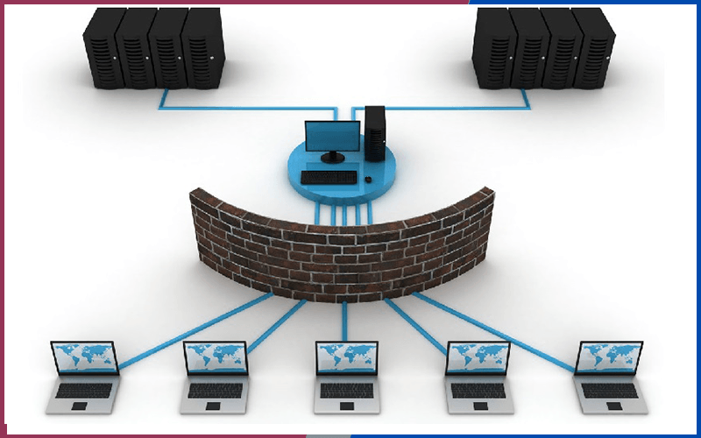

* + - * 1. Enterprise network system architecture

A DMZ (Demilitarized Zone) is an intermediate network zone containing servers that provide public services such as web servers, email servers, and proxies. The DMZ is isolated from the local area network (LAN) to ensure that even if the web server is attacked, attackers cannot penetrate deeper into the internal network.

Local Area Network (LAN): This area contains end-user devices (PCs, laptops, printers) and critical internal servers. This area is often divided into multiple VLANs to enhance security and bandwidth management.

Switching system: Uses Layer 2 and Layer 3 switches to route and switch data between devices in the LAN and DMZ.

* + 1. Challenges in traditional network management and security

In traditional network management models, administrators often encounter the following problems:

Manual configuration: Configuring each device (Switch, Router) via the command-line interface (CLI) is time-consuming and prone to human error.

Lack of comprehensive monitoring capabilities: Difficulty in early detection of network congestion, resource overload, or unusual behavior without a centralized data collection system.

Passive response to attacks: Older security systems often only log passively. When an attack is detected, administrators must manually intervene to block the IP address, leading to significant delays and high risks.

* + 1. NetDevOps and Automation Trends

To address these challenges, this project applies the NetDevOps (Network + DevOps) approach. This is a trend that applies automation, programming, and rigorous monitoring processes to network management.

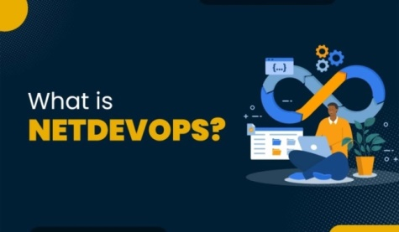

* + - * 1. NetDevOps Trends

Automation: Using source code (Infrastructure as Code) to manage configuration (Ansible), replacing manual operations.

Active Monitoring: Collects real-time data (Prometheus) to provide immediate alerts when incidents occur.

Automated Security: Combines monitoring and automation to automatically prevent threats (pfSense + Suricata + Ansible).

* 1. Infrastructure automation solutions
     1. Introducing Ansible

Ansible is an open-source automation tool developed by Red Hat, known for its simplicity and high scalability. In this project, Ansible acts as an "extension" to perform batch management tasks.

Operating Architecture : The biggest difference of Ansible is its Agentless architecture (no agent installation required). Ansible works by connecting to nodes (servers, network devices) via SSH (for Linux/Cisco) or WinRM (for Windows) and pushing small code modules to execute tasks.



* + - * 1. What is Ansible?
* The role of Ansible in a network system:
* Automate device configuration (routers, switches, firewalls, servers).
* Centralized management minimizes errors caused by manual operations.
* Reusing playbooks saves deployment time.
  + 1. Ansible's architecture

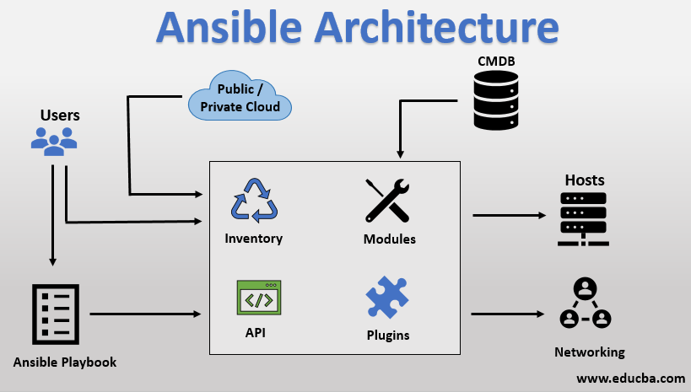

* + - * 1. Ansile's architecture
* Ansible consists of the following main components:
* Control Node: the management server where Ansible is installed and the playbook runs.
* Managed Node: devices/servers that are managed.
* Inventory: A file containing a list of servers and network devices that need to be managed, grouped logically.
* Playbook: A file that defines the automation script, written in the easily readable YAML language. The playbook describes the desired state of the system.
* Modules: Code libraries that perform specific tasks (e.g., apt module, ios_config module).
  + 1. Advantages of Ansible

Easy to learn, easy to implement.

No agent needed, reducing resource load on the device.

It is scalable and integrates with many DevOps tools.

Supports a wide range of operating systems and network devices.

Comparing Ansible with other configuration tools

|  |  |  |  |
| --- | --- | --- | --- |
| **Criteria** | **Ansible** | **Puppet / Chef** | **SaltStack** |
| Architecture | Agentless (No agent installation required) | Agent-based (Agent needs to be installed on all client machines) | Agent-based (primarily) |
| Language | YAML | Ruby DSL (More complex) | YAML |
| Mechanism | Push (Server pushes the command down) | Pull (Agent pulls the configuration) | Push/Pull |
| Suitable for | Rapid deployment, network administration, server configuration. | Manage extremely large-scale configurations, maintaining continuous state. | Large systems require high execution speeds. |

* 1. Monitoring and Alerting System
     1. Prometheus

Prometheus is a time-series database (TSDB) monitoring system. Unlike traditional monitoring systems, Prometheus is specifically designed for dynamic environments such as containers and microservices.



* + - * 1. Prometheus logo

Time series databases (TSDBs) are databases that store data according to timestamps. This means that each piece of data is always associated with a specific timestamp, creating a data series over time. This allows us to review data for a period of one hour or one minute.

* + - 1. Prometheus operational architecture

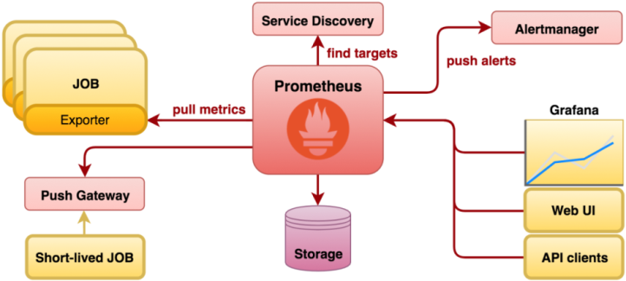

* + - * 1. Prometheus operational architecture
* Prometheus's architecture operates on a pull-based model:
* The Prometheus server periodically "pulls" data from exporters via the HTTP endpoint.
* The data is stored as a time series in the internal TSDB (Time Series Database).
* When an event exceeds the configured threshold, Alertmanager will send an alert to the administrator.
* Users can use PromQL for querying or combine it with Grafana for visualization.
  + - 1. Operating mechanism
* Operating and Storage Mechanism:

Comparing Prometheus with Zabbix/Nagios

|  |  |  |
| --- | --- | --- |
| **Criteria** | **Prometheus** | **Zabbix / Nagios** |
| Model | Pull (Actively retrieve data) | Push (Agent pushes data) |
| Data | Time-series (Optimized for metrics/charts) | Relational DB (SQL - difficult to scale) |
| Query language | PromQL (Powerful, dynamic computation) | SQL or click-based interface |
| Fit | Cloud-native, Container, and advanced Metrics | Traditional physical infrastructure, status monitoring (Up/Down) |

* Pull Model: Prometheus actively "scrapes" data from targets over HTTP periodically. This prevents Prometheus from becoming overloaded when the number of metrics spikes.
* TSDB: Data is stored locally as time series, each series identified by a metric name and key-value pairs (labels).
  + 1. Alertmanager

Alertmanager is a standalone component that handles alerts sent from the Prometheus Server. It doesn't generate alerts; it only manages them.

* Advanced features:
* Grouping: When a major network failure occurs, hundreds of alerts can be triggered simultaneously. Alertmanager groups them into a single notification sent to the administrator, preventing an "alert storm" (Alert Fatigue).
* Inhibition: Automatically disables low-level alerts if a high-level alert is already triggered (e.g., if the entire Datacenter experiences a power outage, only the Datacenter will be reported, not individual client servers).
* Silencing: Temporarily suspends alerts during system maintenance.
  + 1. Grafana

Grafana is a visualization tool that displays metrics as charts or graphs, which are then combined into a highly customizable dashboard, making it easy to monitor node status.

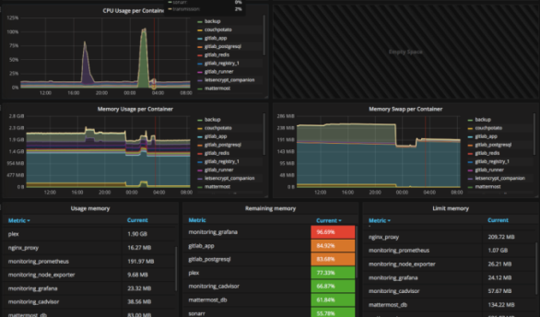

* + - * 1. Grafana Dashboard
* Key features:
* Diverse data sources: Grafana can simultaneously query from Prometheus, Loki, MySQL, and Elasticsearch on the same dashboard.
* Extensive plugins: Supports various chart types (Graph, Gauge, Map, Table, Logs panel).
* Provide a warning mechanism directly within the graphical interface.
* Supports user management, permission control, and dashboard sharing.
* Role in the monitoring system:
* Grafana does not collect data; instead, it displays information from various data sources. In the Prometheus-Grafana model:
* Prometheus is responsible for storing and providing the data.
* Grafana queries data from Prometheus and displays visual graphs.

Comparing Grafana with Kibana

|  |  |  |
| --- | --- | --- |
| **Criteria** | **Grafana** | **Kibana** |
| Main focus | Metrics & System Performance Monitoring | Logging & Analyzing Text Data |
| Ecosystem | Diverse (Prometheus, Loki, SQL, InfluxDB) | Closely integrated with the ELK Stack (Elasticsearch). |
| Warning | Unified multi-source alerting system | Watcher (Usually requires a paid version) |

* 1. Centralized Logging Management System
     1. Grafana Loki

Loki is a log aggregation system designed for cost and performance optimization, inspired by Prometheus ("Like Prometheus, but for logs").

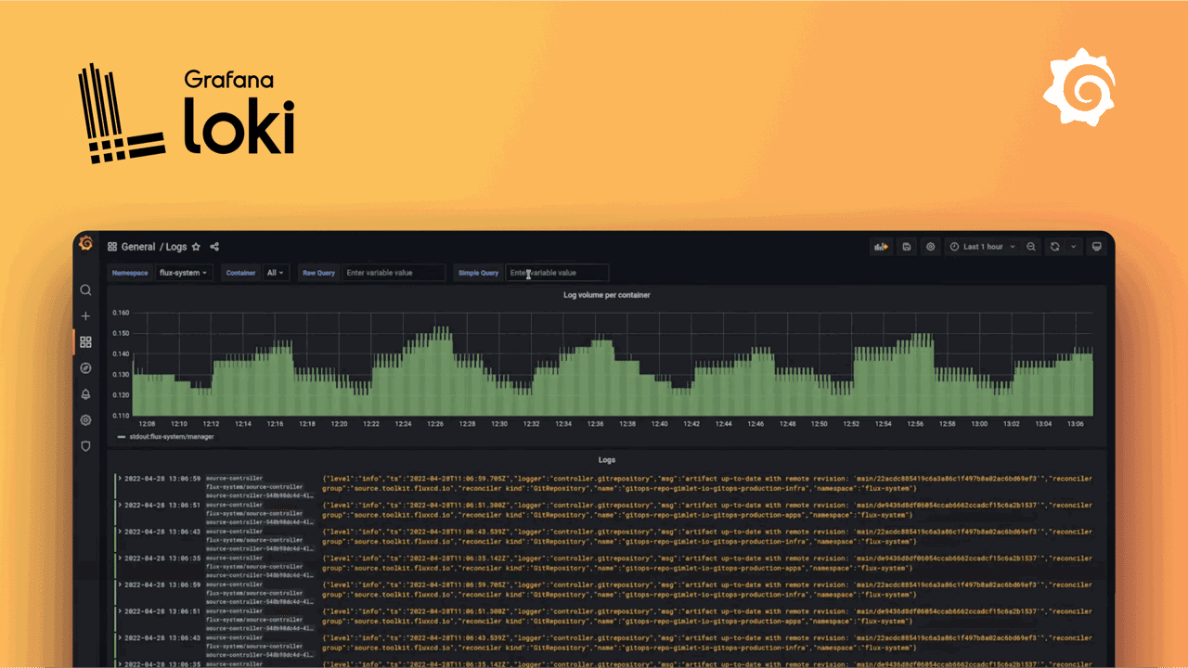

* + - * 1. Grafana Loki

Index-free architecture : This is Loki's breakthrough. Instead of indexing the entire log content (full-text indexing) like Elasticsearch, Loki only indexes the metadata labels of the log stream (e.g., job="nginx", host="web-server").

*Reasons for choosing Loki:* For small and medium-sized enterprises (SMEs) needing tight integration with Prometheus within the same Grafana interface, Loki is the optimal solution in terms of operating costs.

Comparing Loki to ELK Stack

|  |  |  |
| --- | --- | --- |
| **Criteria** | **Grafana Loki** | **ELK Stack (Elasticsearch)** |
| Storage | Low index (labels only), tightly compressed log. | Large index (full text), takes up a lot of storage space. |
| RAM resources | Very low (Suitable for SMB/Lab) | Very high (Java-based) |
| Query | LogQL (Integrated with Prometheus) | Lucene (a powerful search engine) |
| Expense | Low, easy to operate. | High complexity in cluster administration. |
| Purpose | Suitable for DevOps, Debugging, Network Logging | Suitable for Big Data Analytics and Business Intelligence. |

* + 1. Promtail

Promtail is an agent that collects logs from various sources (pfSense/Cisco's Syslog, Nginx log files) and sends them to Loki. Specifically, Promtail has the ability to process logs (Pipeline Stages) to extract important information such as attack IPs and HTTP error codes for automated blocking.

* Pipeline Mechanism: Promtail not only reads files, it also acts as a pre-processor. Through Pipeline Stages, Promtail can:
* Regex: Extracts information (IP, Status Code) from raw log streams.
* Labels: Assign dynamic labels based on log content.
* Metrics: Generate error counts directly from logs (e.g., count 404 errors per second) and send them to Prometheus, which converts the logs into metrics.
  1. Information Security and Defense Systems (IDS/IPS)
     1. pfSense Firewall



* + - * 1. Pfsense logo

PFSense is an open-source firewall software distribution based on the FreeBSD operating system. It uses OpenBSD's pf – one of the most powerful and secure packet filters available today.

* Key features:
* NAT: Supports static NAT in 1:1 format. When performing 1:1 NAT, the private IP address being NATed will always be accessed via its corresponding public IP address and the corresponding ports on that public IP address. Supports default outbound NAT with Automatic Outbound NAT rule generation.
* Stateful Filtering: Monitoring the state of each network connection.
* Alias & Table: Flexible IP/Port address group management, allowing blocklist updates without reloading the entire ruleset.

Comparing pfSense with other Firewall solutions

|  |  |  |  |
| --- | --- | --- | --- |
| **Criteria** | **pfSense** | **OPNsense** | **Commercial Firewall (Cisco/Fortinet)** |
| Foundation | FreeBSD | FreeBSD (HardenedBSD) | OS Exclusive |
| Community | Very large, rich in documentation. | Newly emerging, more modern interface | Paid Support |
| Expense | Free (Community Edition) | Free of charge | Licenses are expensive. |
| Hardware | x86 (Regular Server/PC) | x86 | Dedicated ASIC (Higher performance) |
| Purpose | SMB, Enterprise, Lab, Home | SMB, Enterprise | Enterprise Critical Core |

* + 1. Suricata (IDS/IPS Engine)

Suricata is a next-generation intrusion detection and prevention tool (IDS/IPS).

Multi-threading architecture: Unlike Snort (the older single-threaded version), Suricata supports multi-threading. This allows Suricata to process multiple network data streams in parallel on different CPU cores, avoiding bottlenecks when network traffic increases.

* Operating modes in this project:
* Legacy Mode (IPS): In this project, Suricata is configured to use Legacy Mode on pfSense. When an attack is detected, it pushes the offending IP address to the snort2c table of the Packet Filter (pf). This mechanism allows blocking to occur at the Kernel layer, extremely quickly, and without interrupting other legitimate connections.

Comparison of Suricata and Snort (Legacy)

|  |  |  |
| --- | --- | --- |
| **Criteria** | **Suricata** | **Snort (2.9.x)** |
| Architecture | Multi-threaded | Single-threaded |
| Performance | Make good use of multi-core CPUs under high load. | Limited by CPU core clock speed. |
| Features | File extraction, Layer 7 protocol identification, Lua script | Focus on signature-based detection. |
| Handle | IPS Inline / Legacy Mode stable | IPS Inline |

* 1. Other supporting technologies
     1. Docker & Docker Compose

Docker is a virtualization platform at the operating system level (Containerization).



* + - * 1. Docker

Docker Compose: Helps define and run the entire monitoring stack (Prometheus, Grafana, Loki, Alertmanager) as a unified block (Infrastructure as Code), instead of installing each service separately.

* + 1. Teleport (Secure Access)

Teleport is a modern infrastructure access solution that replaces traditional SSH.

The problems with SSH: Difficulty in managing SSH keys, lack of session control (session recording), and difficulty in revoking access rights.

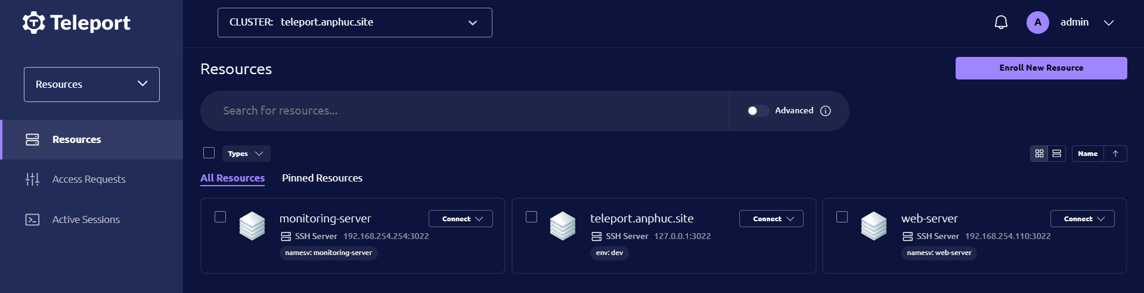

* + - * 1. Teleport is a technology replacing traditional SSH.

Teleport Solution: Utilizing short-lived certificates instead of static keys, integrating multi-factor authentication (MFA), and logging the entire administrator session ensures high compliance and security for the management system.

Comparison of Teleport and traditional OpenSSH

|  |  |  |
| --- | --- | --- |
| **Criteria** | **Teleport** | **OpenSSH** |
| Authentication mechanism | Short-lived Certificates | Static Private/Public Key (Easily compromised, difficult to manage) |
| Control | Audit Log & Session Recording | Basic Syslog (without knowing what the user typed inside) |
| Access | Web UI, CLI, Reverse Proxy (No need to open port 22 public) | CLI, requires port forwarding or VPN. |
| Manage | Clustering, SSO (Github/Google) | Distributed across individual servers. |

* + 1. Webhook

A small webhook server (written in Go) is used as a middleware bridge to receive HTTP POST signals from Alertmanager/Grafana and trigger Bash/Ansible scripts on the automation server.

* 1. Virtualization and Network Simulation Tools
     1. VMware Workstation

VMware is a powerful virtualization platform (Type 2 Hypervisor) used to create virtual machines running Linux operating systems (Ubuntu/Debian) that act as Monitor Servers, Automation Servers, and Web Servers. VMware provides a Virtual Network Editor feature that allows the creation of separate network zones (VMnets) simulating DMZs and LANs.

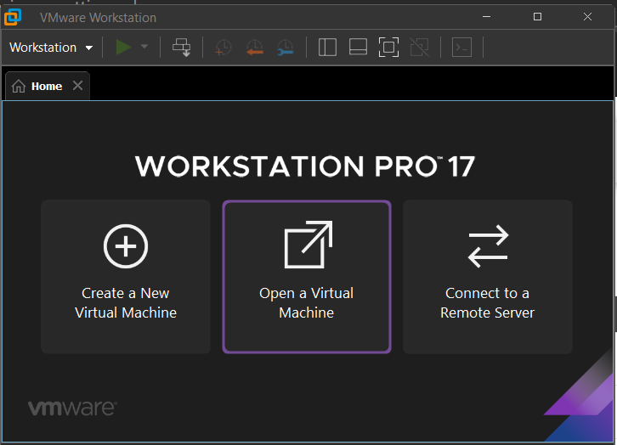

* + - * 1. VMware Workstation
    1. GNS3 (Graphical Network Simulator-3)

GNS3 is network emulation software that allows you to run realistic operating system images of network devices (such as Cisco IOS, RouterOS).

Role in the project: GNS3 is used to emulate Cisco Layer 3 switches and connect them to VMware and pfSense virtual machines, creating a complete network topology with all the routing and switching protocols as in real life.

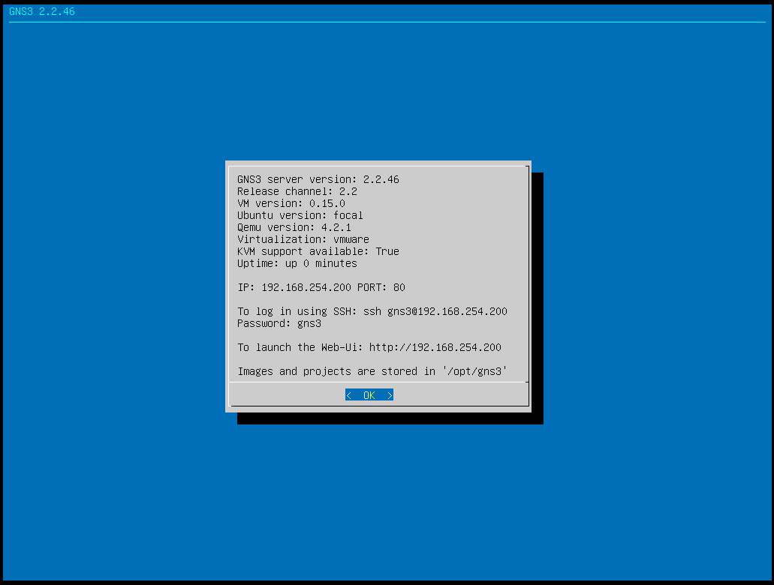

* + - * 1. GNS3 (VM) runs on VMware.
  1. End of Chapter 1

Chapter 1 provided an overview of the theoretical basis and core technologies selected for the topic. Through the analysis of NetDevOps architecture, we understood how Ansible automates administrative tasks, grasped the metrics collection mechanism of Prometheus, and the centralized log processing capabilities of the Loki-Promtail duo. In addition, security solutions such as pfSense and Suricata were introduced as indispensable components for protecting network infrastructure against threats.

The combination of these open-source tools creates a solid foundation, fully addressing the three pillars: Governance, Monitoring, and Security. Based on this foundational theory, Chapter 2 will delve into analyzing the problem requirements, designing a detailed architecture, and presenting the practical implementation process of these solutions in a simulated enterprise network model.

1. ANALYSIS AND DESIGN
   1. Analyze the problem requirements.

Based on the theoretical framework presented in Chapter 1 and the current state of network management in small and medium-sized enterprises (SMBs), this study identifies the following specific requirements to be addressed:

* + 1. Network architecture and information security requirements

Network Zoning: The system must be divided into separate network zones to control data flow. Specifically, there should be a DMZ zone for public servers (Web, App) and a LAN zone for internal users, preventing unauthorized access from the DMZ to the LAN.

Access control: All data flows into and out of the Internet and between regions must pass through a central firewall for packet filtering.

Intrusion Detection and Prevention (IPS): The system must be able to automatically detect network scanning and web attacks and immediately block the source of the attack.

* + 1. Log monitoring and management requirements

Real-time monitoring: Collects key metrics such as bandwidth, CPU, RAM, and service status with a low sampling rate (15 seconds/time).

Centralized logging: Logs from network devices (routers, switches) and servers (Linux) must be consolidated into a single repository for retrieval and root cause analysis.

Intelligent Log Processing: Logging systems should not only store logs but also be able to "read and understand" their contents to extract important information such as attack IP addresses and HTTP error codes.

* + 1. Automation requirements

Configuration backup: Eliminates manual backup procedures. The system should automatically back up network device configurations daily and report success/failure status.

Agent installation: Eliminate the need to install the teleport agent cabinet on each device individually. The system must install multiple devices simultaneously.

* 1. System design
     1. Network Topology Diagram

The system is designed using a layered network model with pfSense acting as the central gateway and Cisco Layer 3 switches acting as distribution/cores.

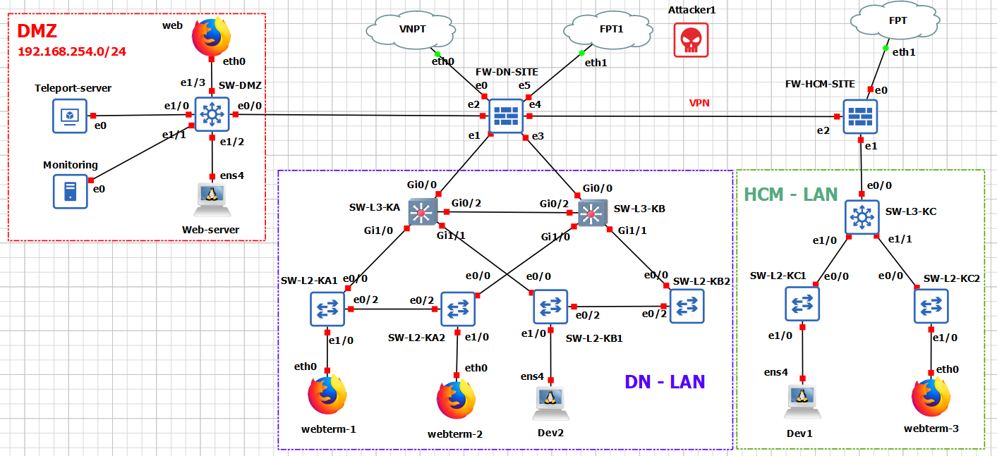

* + - * 1. Logic and Physical Network Design Diagram
* WAN area: Internet connection (Simulated IP: 192.168.1.13).
* DMZ (VLAN 254 - 192.168.254.0/24): Where critical servers are located.

Describe the equipment components present in the DMZ.

|  |  |  |
| --- | --- | --- |
| **Ingredient** | **IP address** | **Describe** |
| Switch DMZ (L3) | 192.168.254.1 | Switch for managing devices in the DMZ area. |
| Monitor Server | 192,168,254,254 | Server for centralized system monitoring and logging with Prometheus, Grafana, Loki, and Promtail. |
| Automation Server | 192,168,254,100 | The server manages connections centrally using teleport and automates device management using Ansible. |
| Web Server | 192.168.254.1 10 | Internal web server serving users. |

Gateway: 192.168.254.1 (Point-to-Point connection to port em2 (DMZ) on pfSense).

* LAN (User Zones):

Describe the equipment components present in the LAN area.

|  |  |  |  |
| --- | --- | --- | --- |
| **Device** | **Gate** | **IP address/mode** | **Describe** |
| SW-L3-KA | E0/0 | 10.10.10.2 | Connect to LAN1 (em1) port of pfsense. |
| E0/1 | Trunk | The trunk port connects to the E0/0 port of SW-L2-KA1. |
| E1/0 | Trunk | The trunk port connects to the E0/0 port of SW-L2-KB1. |
| SW-L3-KB | E0/0 | 10.10.20.2 | Connect to LAN2 (em3) port of pfsense |
| E0/1 | Trunk | The trunk port connects to the E0/0 port of SW-L2-KA2. |
| E1/0 | Trunk | The trunk port connects to the E0/0 port of SW-L2-KB2. |
| SW-L2-KA1 | E0/0 | Trunk | The trunk port connects to the E0/1 port of the SW-L3-KA. |
| E0/2 | Trunk | The trunk port connects to the E0/2 port of SW-L2-KA2. |
| E1/0 – E1/3 | Access | VLAN 10 |
| SW-L2-KA2 | E0/0 | Trunk | The trunk port connects to the E0/1 port of the SW-L3-KA. |
| E0/2 | Trunk | The trunk port connects to the E0/2 port of SW-L2-KA1. |
| E1/0 – E1/3 | Access | VLAN 20 |
| SW-L2-KB1 | E0/0 | Trunk | The trunk port connects to the E1/0 port of the SW-L3-KA. |
| E0/2 | Trunk | The trunk port connects to the E0/2 port of SW-L2-KB2. |
| E1/0 – E1/3 | Access | VLAN 30 |
| SW-L2-KB2 | E0/0 | Trunk | The trunk port connects to the E1/0 port of the SW-L3-KB. |
| E0/2 | Trunk | The trunk port connects to the E0/2 port of SW-L2-KB1. |
| E1/0 – E1/3 | Access | VLAN 40 |

* + 1. Monitoring and control data flow design
* The system operates based on the close coordination of four main data streams, ensuring comprehensive observation and automated operation capabilities:
* Monitoring Flow (Metrics):
* The Prometheus Server proactively pulls connections to data nodes periodically, every 15 seconds.
* Data source:
  + Network infrastructure: SNMP Exporter collects parameters from pfSense and Cisco Switch.
  + Server: Node Exporter collects CPU/RAM/Disk parameters from Linux servers.
* Application: Promtail counts the number of HTTP errors (404/403) from Nginx logs and converts them into metrics.
* Logging Flow (Event Log):
* Network Devices (pfSense, Cisco): Send logs via Syslog protocol (UDP port 1514) to Promtail Hub.
* Linux Servers: The Prompttail Agent reads local log files (/var/log/*) and application logs, then forwards them to Loki via HTTP (port 3100).
* Storage: All logs are normalized and stored at Grafana Loki.
* Visualization Flow (Display & Alerts):
* Grafana queries data from Prometheus (for graphs) and Loki (for log tables) to display a centralized dashboard.
* When metrics exceed thresholds (e.g., a sudden spike in error logs, backup failures), Alertmanager will send instant notifications via Telegram.
* Automation Flow:
* Auto Backup: The script periodically activates Ansible -> SSHs into the device to retrieve configuration -> Saves -> Sends status reports (Success/Fail) to Prometheus.
* Auto Provisioning: Interactive script activates Ansible -> SSH into the new server -> Installs Teleport Agent and configures it automatically.

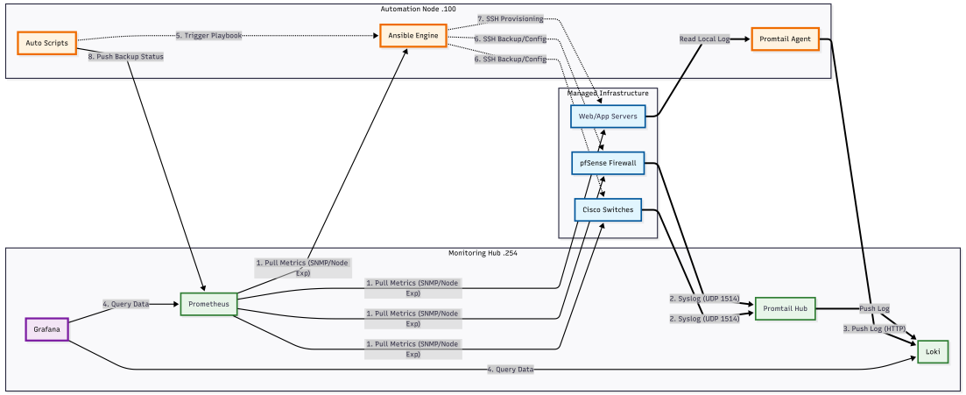

* + - * 1. Data flow diagram in the system
  1. Network Infrastructure Deployment: Switching and Routing

The network infrastructure is built on Cisco Layer 3 devices, using a layered design model to ensure performance and scalability. The system focuses on high availability through redundancy protocols and dynamic routing.

* + 1. IP planning and VLAN/Trunk configuration.

The system utilizes a Class C IP range (192.168.xx) for network planning in a 192.168.VlanID.Host structure, ensuring scalability for multi-branch businesses to separate data flows, enhance security, and improve network performance. The table below details the network planning:

VLAN layout table for the entire network system.

|  |  |  |  |  |
| --- | --- | --- | --- | --- |
| **VLAN ID** | **VLAN name** | **Subnet** | **Gateway (VIP HSRP)** | **Role** |
| 10 | STAFF LAN | 192.168.10.0/24 | 192.168.10.1 | Employee Network (LAN 1) |
| 20 | GUEST LAN | 192.168.20.0/24 | 192.168.20.1 | Guest Network (LAN 2) |
| 3 0 | AUTO | 192.168.30.0/24 | 192.168.30.1 | Technical team |
| 4 0 | MANAGER | 192.168.40.0/24 | 192.168.40.1 | Management Department – IT Admin |
| 254 | DMZ | 192.168.254.0/24 | 192.168.254.1 | Server area (Web, Monitor , etc. ) |

* + - 1. Trunk configuration on SW-L3-KA and SW-L3-KB:

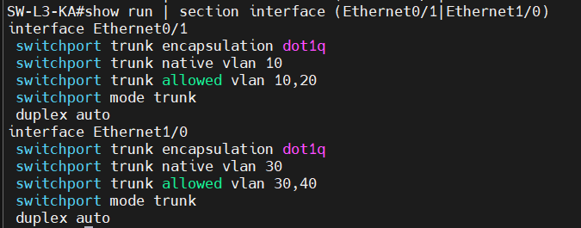

* + - * 1. Configure trunk 2 ports e0/1 and e1/0 on SW-L3-KA

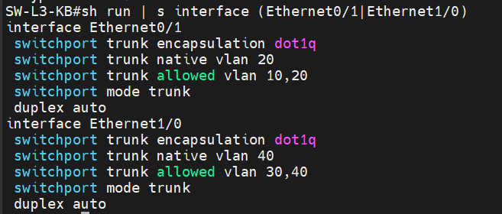

* + - * 1. Configure trunk 2 ports e0/1 and e1/0 on SW-L3-KB
      1. Trunk status on SW-L3-KA and SW-L3-KB

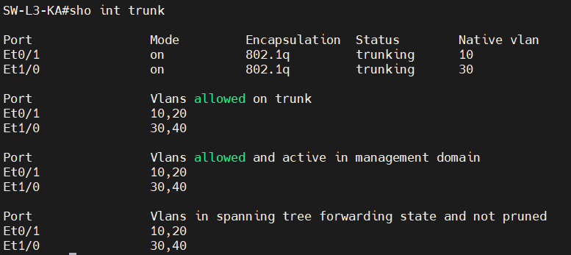

* + - * 1. Trunk status on SW-L3-KA

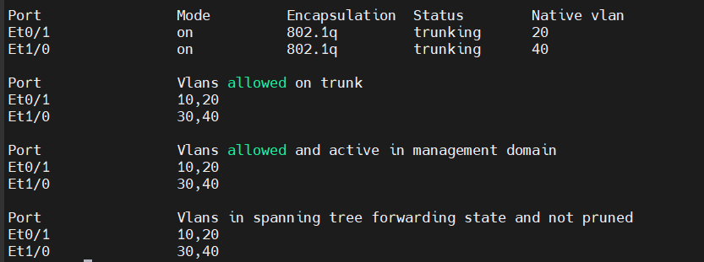

* + - * 1. Trunk status on SW-L3-KB
    1. Implementing High-Speed Gateway Backup (HSRP)

To ensure the network remains uninterrupted when a device fails, this project implements the HSRP protocol on a pair of Core Switches (SW-L3-KA and SW-L3-KB).

* HSRP Load Sharing Mechanism:
* Two switches share a single virtual IP address . SW-KA acts as the Active (traffic handler) with high priority (Priority 110) on VLANs 10 and 30, while SW-KB (Priority 90) acts as the Standby (redundant) switch on these two VLANs. The opposite is true for VLANs 20 and 40.
* Switch-L3-KA: Active VLAN 10, 30 (Priority 110) - Standby VLAN 20, 40. (Priority 90)
* Switch-L3-KB: Active VLAN 20, 40 (Priority 110) - Standby VLAN 10, 30. (Priority 90)

Commands for configuring VLANs and HSRP on SW-L3-KA:

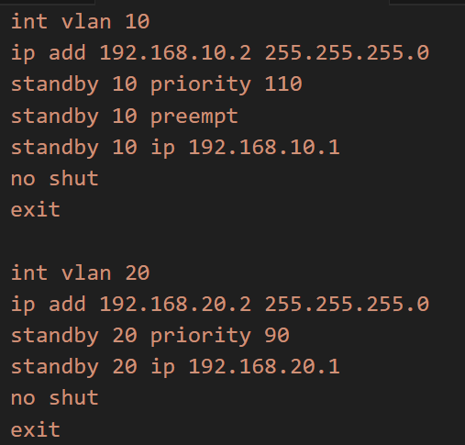

* + - * 1. HSRP configuration command
* Priority: An indicator used to determine which devices will play the Active role and which will play the Standby role.
* Virtual IP (VIP): HSRP creates a virtual address that both routers (Active and Standby) know, but only the Active router has the right to respond to and process packets sent to that address.
* Preempt: This feature is enabled to ensure that SW-KA automatically regains Active privileges upon recovery from a crash.
  + 1. Implementing OSPF Dynamic Routing

To automate the advertising of network ranges between the Firewall and Core Switches, this project uses the OSPF Area 0 (Backbone Area) routing protocol.

Benefit: When adding a new VLAN or changing network configurations, routing information is automatically updated system-wide without the need for manual Static Route configuration.

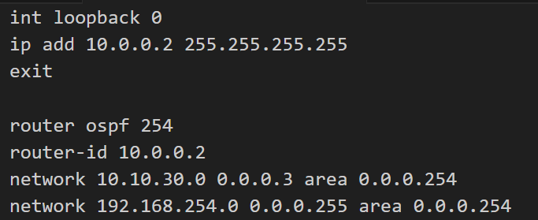

* + - * 1. Configuring OSPF on SW-DMZ

Deployment: All LAN ranges (10.10.x.0/24) and transit networks are advertised into OSPF.

* + 1. Configure Management Protocols

To support the centralized monitoring system, all network devices are configured with standardized management protocols:

SNMP v2c: Allows Prometheus to collect resource information (CPU, RAM, Bandwidth) with the Community string set to public (read-only mode).

Syslog: Push all activity logs (Interface Up/Down, configuration changes) to the Monitoring Server via UDP port 1514.

* Configure SNMP using the following command:
* snmp-server community public RO
* snmp-server community anphuc RW
* snmp-server host 192.168.254.254 public

Check the information:

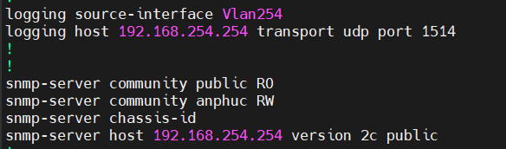

* + - * 1. Configure smnp v2 and log on SW-DMZ
  1. Deploying pfSense firewall and IPS/IDS (Suricata)
     1. Detailed settings

PfSense is installed on a virtual machine with 4 physical interfaces. NAT (Network Address Translation) rules are set up to allow servers in the DMZ to access the Internet for software updates, and Port Forwarding is configured to allow access to Web services from outside.

* Detailed settings
* Step 1: Select "New template" in the security devices section.
* Step 2: Select the version and download the correct version from the internet.

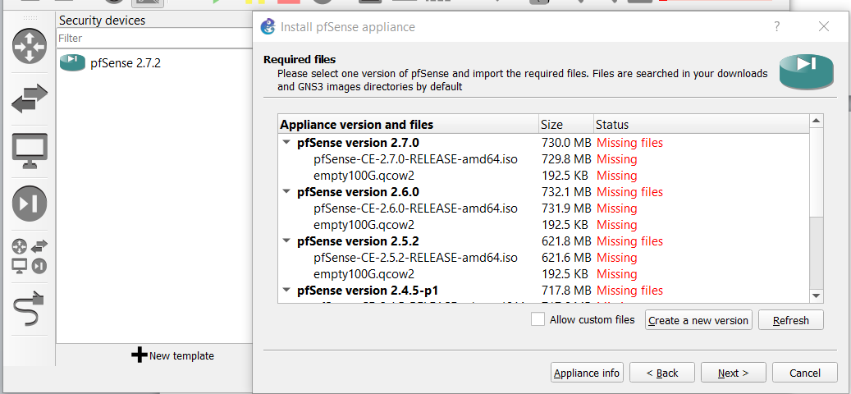

* + - * 1. Choose the installation version
* Step 3: Launch PFSense and continue configuring.

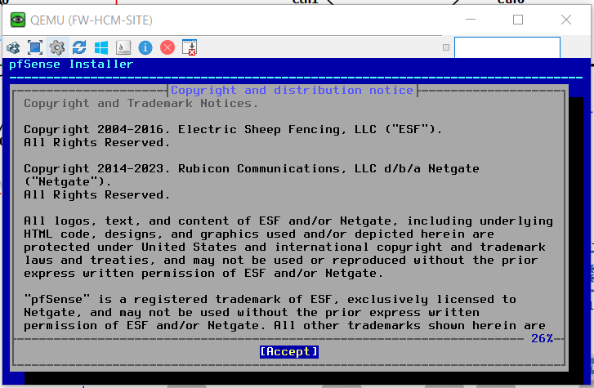

* + - * 1. Start PFSense
* Click on accept
* Automatic partitioning and installation

Step 4: After the installation is complete, reboot and proceed to the configuration settings.

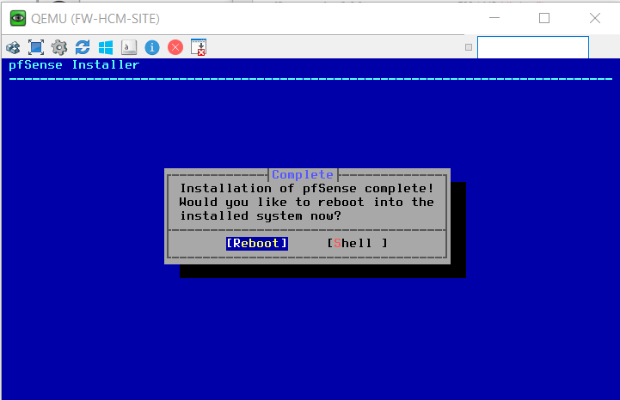

* + - * 1. Restart PFSense
    1. Basic functional configuration
       1. Network interface configuration

WAN port (em0)

The firewall access configuration uses a web interface with a WAN port and a dynamic IP address of 192.168.1.19: assuming this is a public address assigned by the internet service provider.

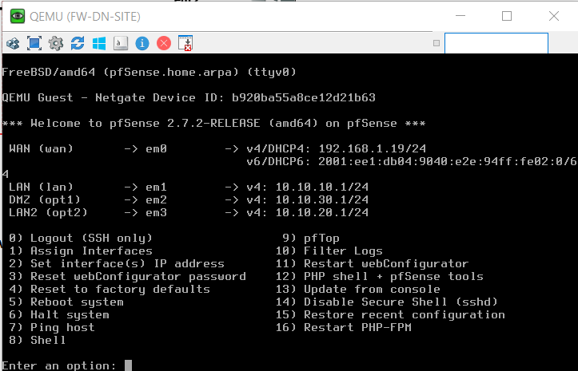

* + - * 1. WAN port is DHCP enabled.

Then access the WAN address on your web browser to access the Firewall GUI.

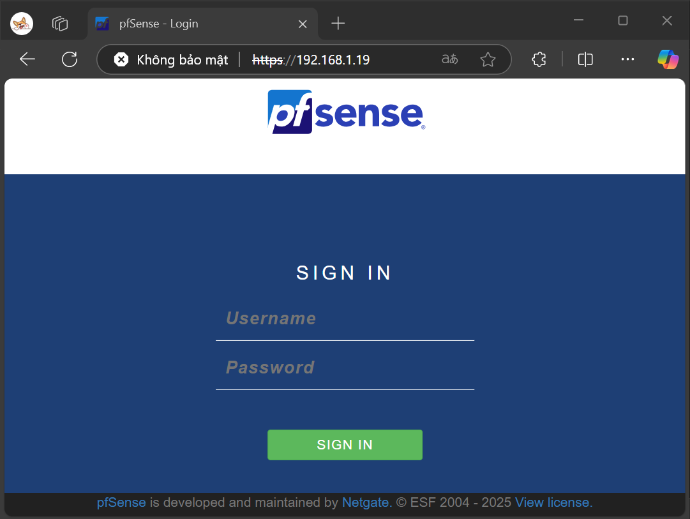

* + - * 1. Web GUI interface for access over the WAN port.

LAN port (em1) and LAN2

* LAN port ( em1): Assigns a static IP address of 10.10.10.1/24. Internal access to the Firewall's website is possible through this port address.

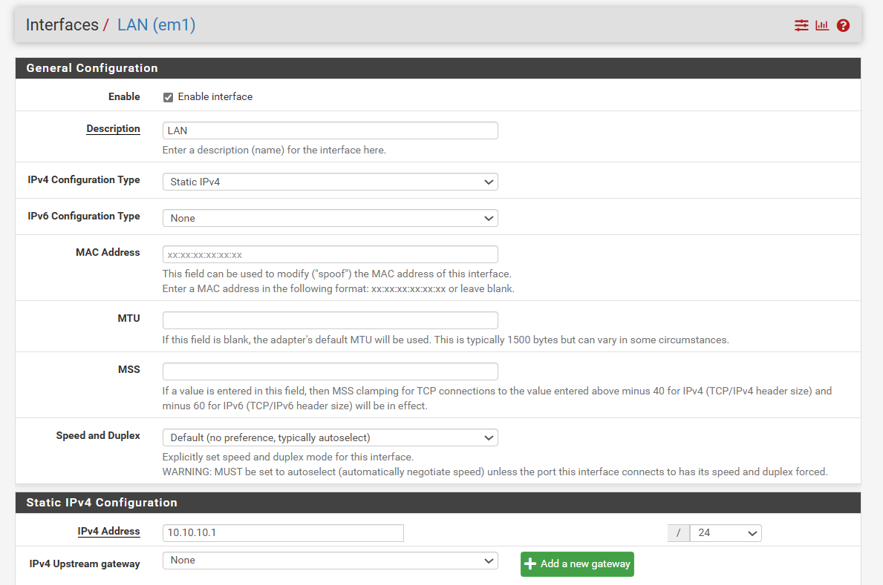

* + - * 1. Configure LAN ports
* LAN2(em3) port: This port is assigned a static IP address of 10.10.20.1/24 and is used to allow internal devices to access the internet.

DMZ (em2) gate

This port is assigned a static IP address of 10.10.30.1/24. This port uses high performance to allow devices in the DMZ to access and retrieve information from external devices .

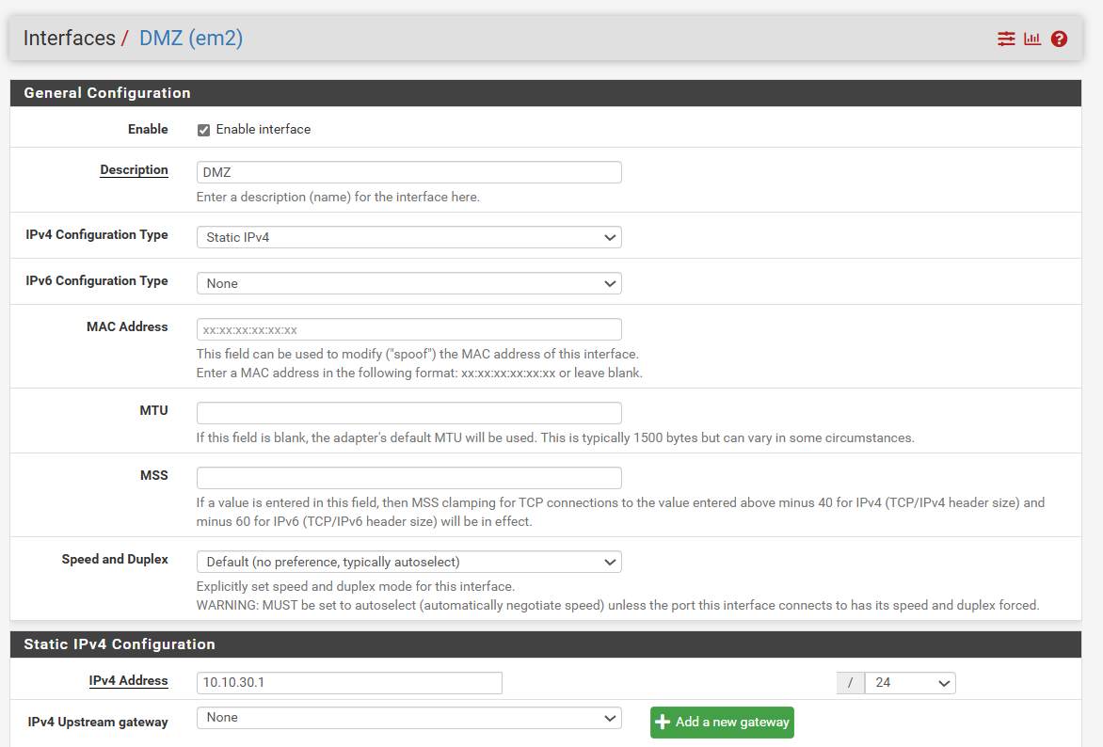

* + - * 1. DMZ port configuration
      1. Set up aliases

To simplify the management of network ranges and IP address groups during firewall configuration, the system utilizes the Alias feature in pfSense. Three primary aliases are created as follows:

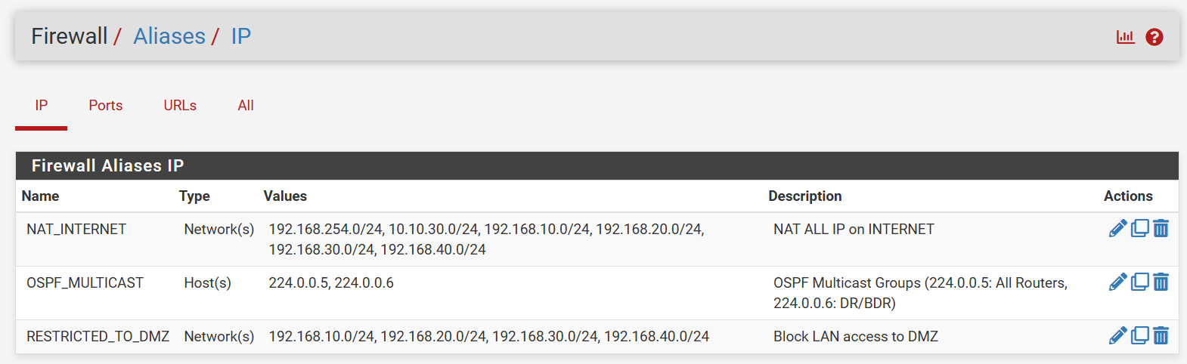

* + - * 1. Set up aliases

NAT_INTERNET

NAT mapping to the Internet for all internal networks and DMZ zones.

With 4 VLANs and 1 DMZ VLAN.

OSPF_MULTICAST

Used in OSPF routing between routers with specific values.

224.0.0.5 – OSPF All Routers

224.0.0.6 – OSPF DR/BDR

RESTRICTED_TO_DMZ

Used to restrict access from internal VLANs to the DMZ.

With 4 internal VLANs ranging from 10 to 40.

* + - 1. Set up NAT

NAT outbound

Switch to Manual Outbound NAT mode to precisely control which internal networks are allowed to access the Internet.

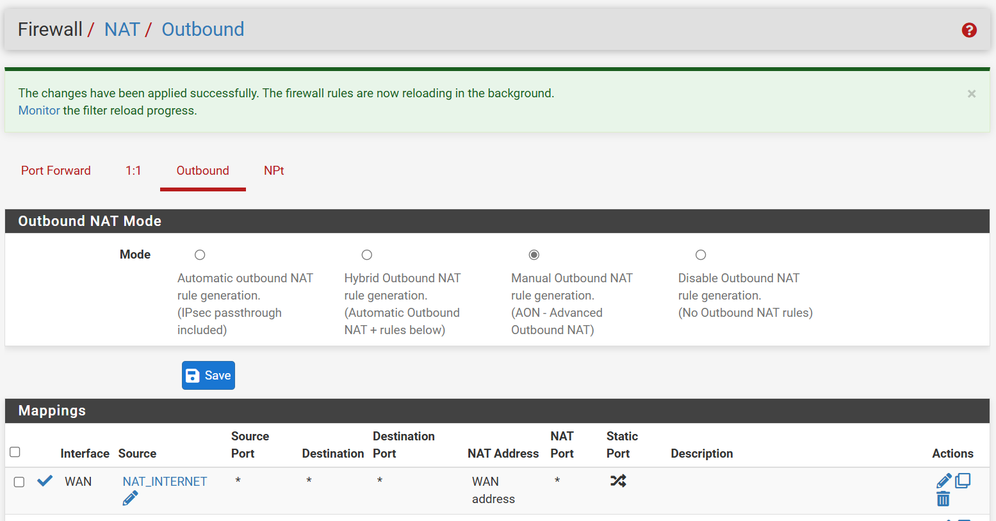

* + - * 1. Set up NAT Outbound

The configuration allows the NAT_INTERNET alias to access the Internet via the WAN address.

NAT Forward

To expose certain internal services to the Internet (on the WAN interface), the system utilizes the Port Forwarding function of pfSense. The following are the specific rules that have been configured:

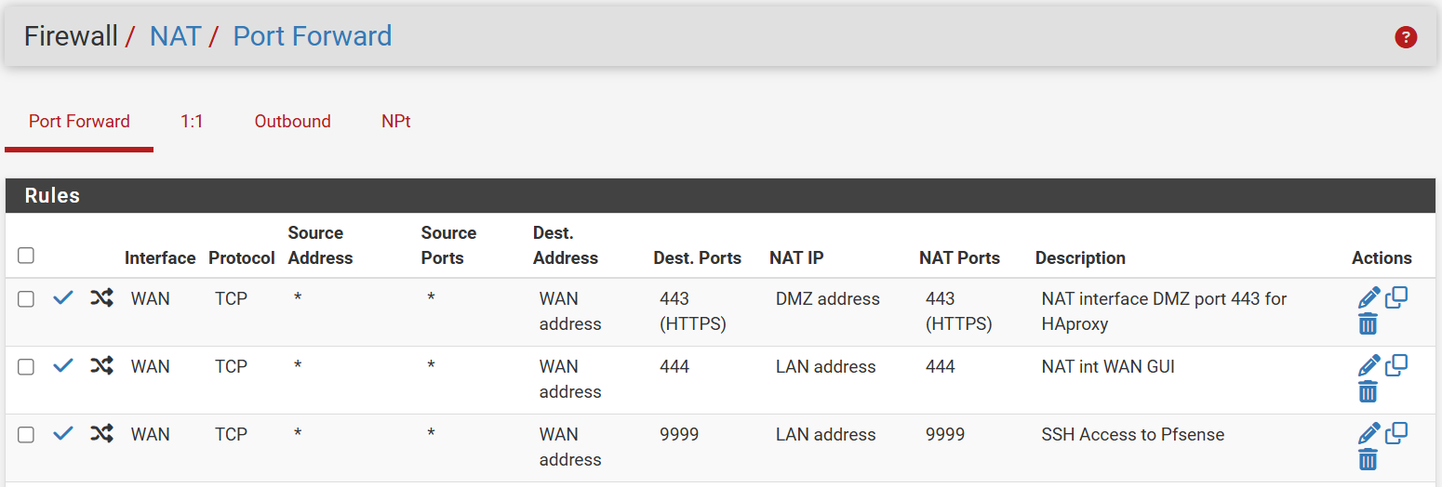

* + - * 1. Configure NAT port forwarding

With the above configuration, I allow some websites and services within the internal network to access the outside through the WAN port and corresponding custom ports.

This includes allowing access to Web Monitor from the Internet via port 9090, accessing Grafana via port 3000, and setting up SSH for remote connection without being on the local network.

* + - 1. Set up the RULE

On Floating

In pfSense, Floating Rules are used when it's necessary to apply firewall rules to multiple interfaces simultaneously, or for specific flows (inbound/outbound, pass/block in a particular direction, QoS, etc.). The system has established the following rules to control traffic from the NAT group to the Internet:

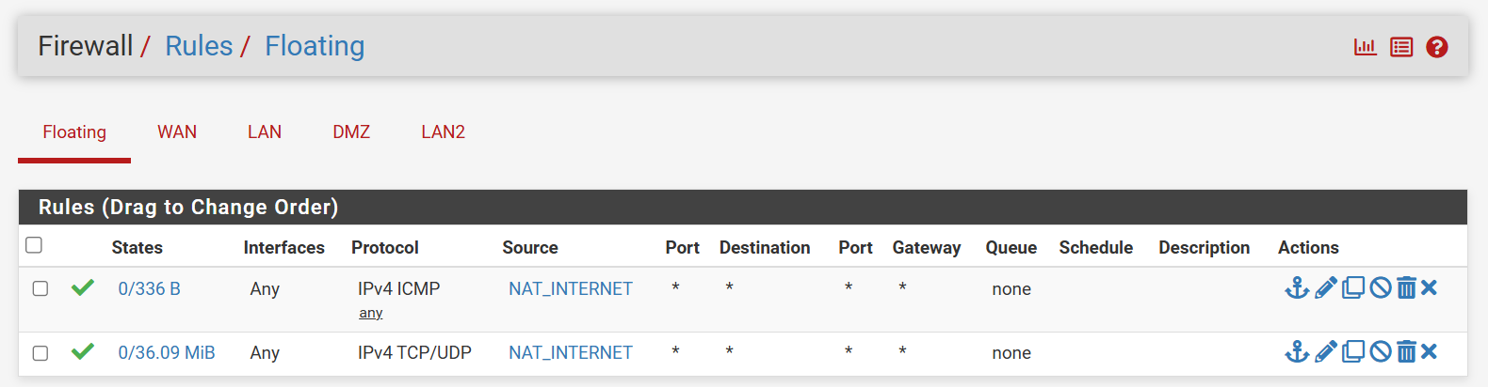

* + - * 1. Multiple tons
* Purpose: To allow devices within a NAT local network to:
* Send an ICMP message to check the connection (ping).
* Use standard TCP/UDP services such as HTTP, HTTPS, DNS, etc.

On WAN

Since NAT Forward has been set up, the configurations already set up on it will be automatically added to the Rule.

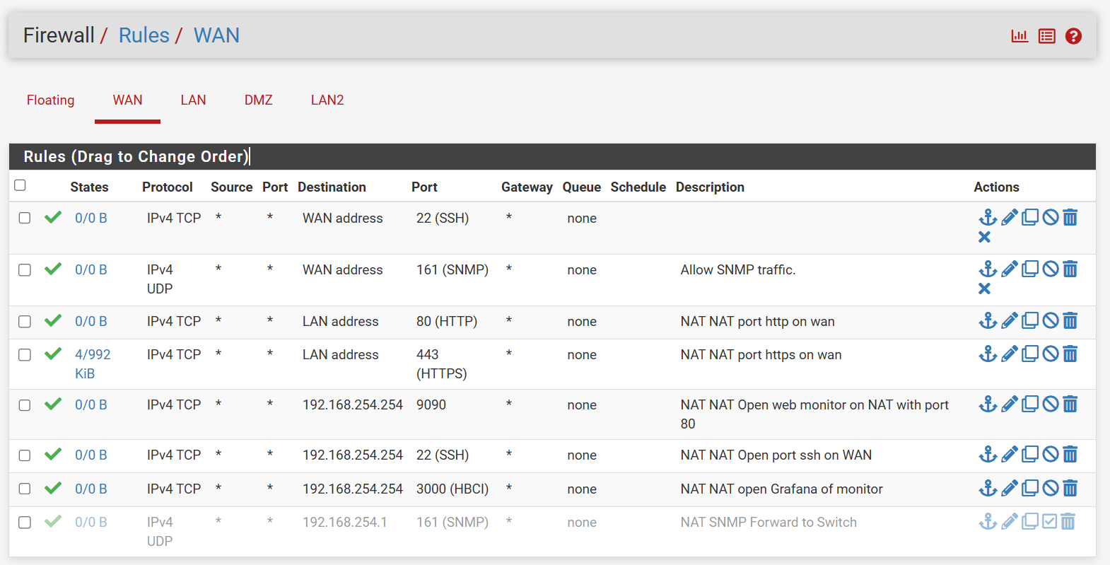

* + - * 1. WAN Rule
* Details: Rules allow forwarding of critical service ports:
* SSH (22): Remote system administration.
* SNMP (161): Device monitoring.
* HTTP/HTTPS (80/443): Web service.
* 9090 / 3000: Used for monitoring tools such as Grafana or internal web monitors.
* LAN address / WAN address: Allows mapping from an external WAN address to a specific LAN address or device within the internal network.
* Purpose:
* This configuration ensures that internal services can be accessed from the Internet via NAT, while also opening the correct ports necessary for remote system monitoring and administration.

On the DMZ

The DMZ (Decentralized Zone) is used to contain services that can be accessed from the external network without affecting the security of the internal network. Firewall rules are established to tightly control traffic into and out of the DMZ, including policies to block unwanted access and allow communication based on service demand.

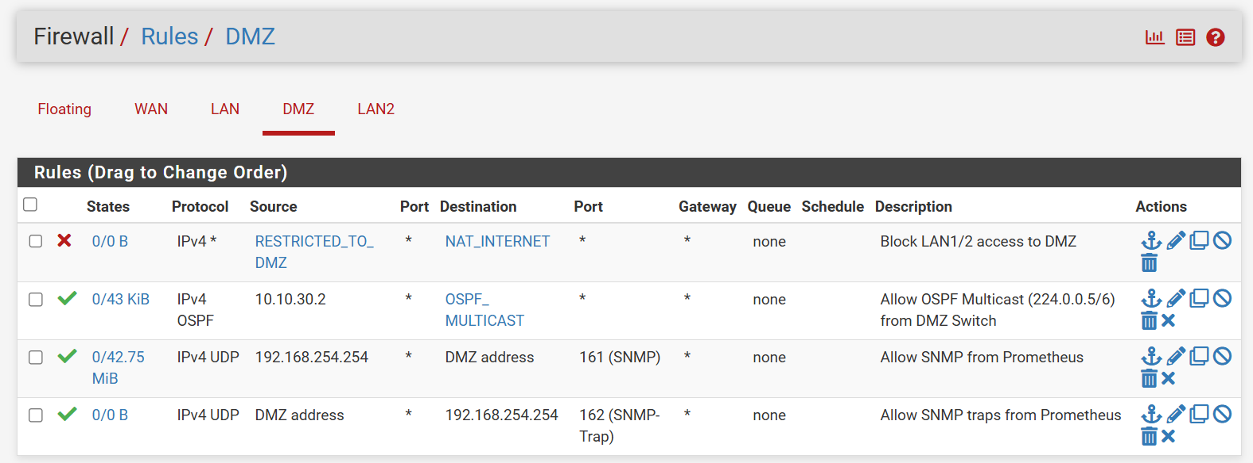

* + - * 1. DMZ Rule
* Detail:
* Rule 1: From the RESTRICTED_TO_DMZ source (representing LAN1/LAN2/LAN3/LAN4), all traffic to NAT_INTERNET is blocked to ensure that internal networks cannot directly access the DMZ.
* Rule 2: Enable OSPF Multicast (224.0.0.5/6) from the address 10.10.30.2 (switch or router), for dynamic routing in the network.
* Rule 3 & 4: Configure settings to allow Prometheus to perform monitoring via SNMP:
* Prometheus sends SNMP requests to devices in the DMZ via port 161.
* Devices in the DMZ send SNMP traps to Prometheus via port 162.
* Purpose:
* Ensure the DMZ is isolated from the local LAN network.
* Supports dynamic network monitoring and routing.
* Enhance security by allowing only necessary data streams to pass through the DMZ.
  + - 1. Set up monitoring

Activate SNMP service:

* The SNMP Daemon service is enabled to allow the system to respond to network monitoring queries. The settings include:
* Polling Port: Port 161 (default) is used to receive queries from the monitoring system.
* System Location: Set to 192.168.254.254 – this is the IP address of the centralized management system or monitoring device.
* Read Community String: defaults to public – this string acts as a simple password to restrict access to SNMP data. In a production environment, it should be changed to a stronger string for increased security.

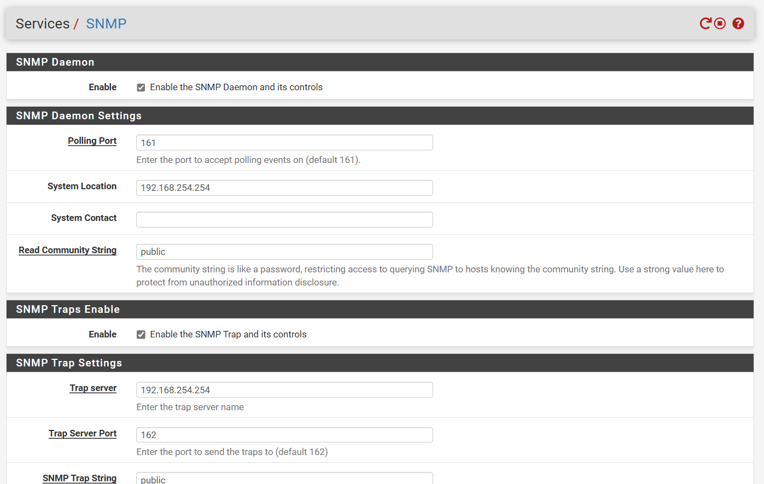

* + - * 1. Set up SNMP
      1. Establish additional external services.

Install the FRR package.

To use routing protocols such as OSPF, BGB

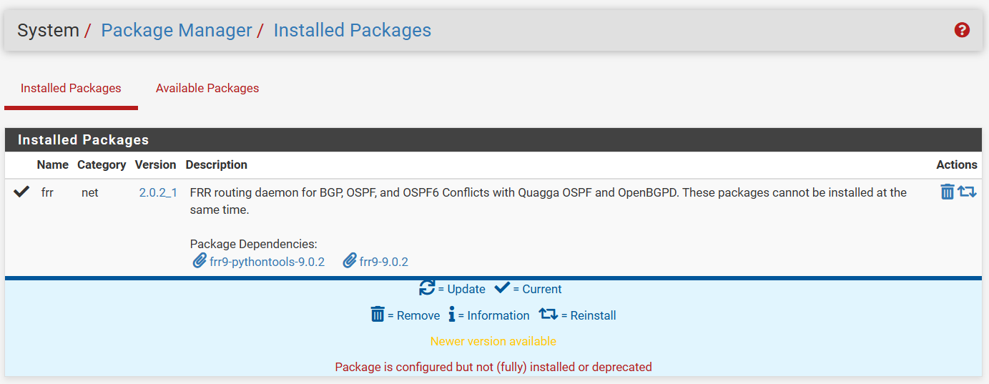

* + - * 1. Add frr package

OSPF configuration

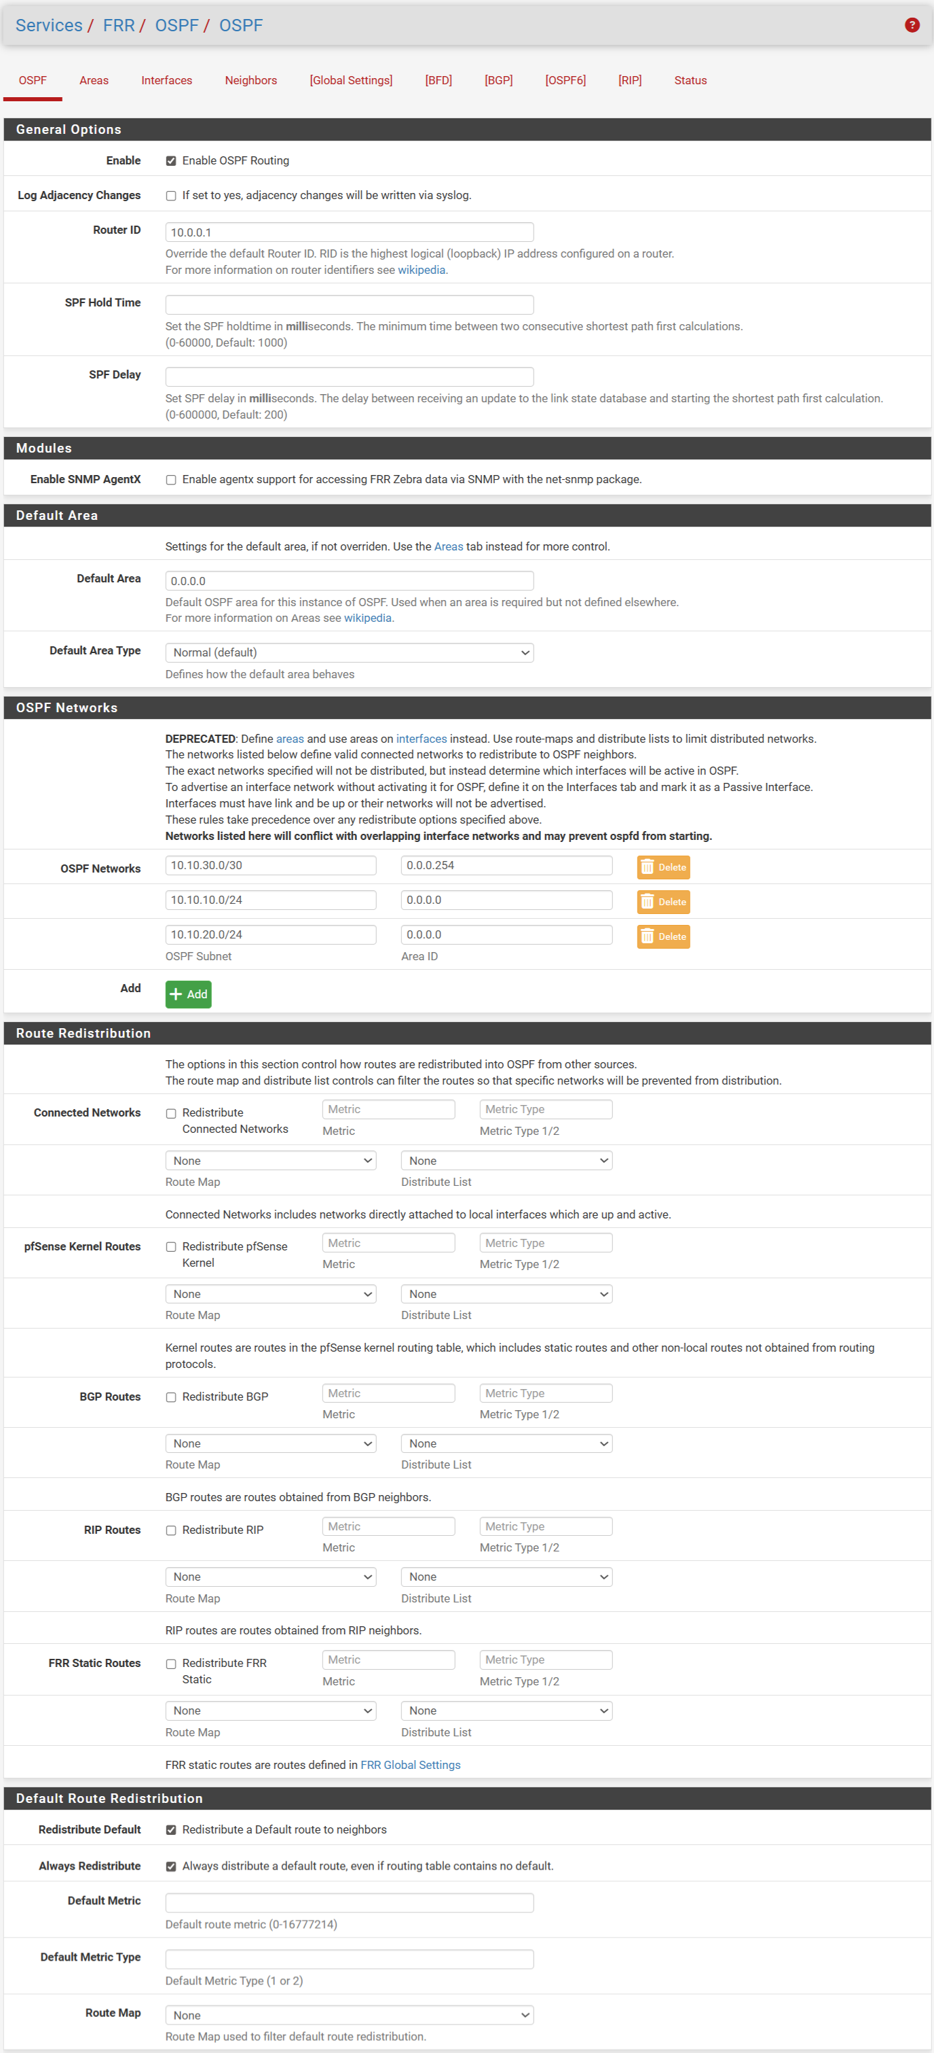

* + - * 1. OSPF configuration
* OSPF Routing is enabled.
* The router ID is set to 10.0.0.1.
* Default Area: 0.0.0.0 with the default type being Normal.
* Select the two boxes for Redistribute Default and Always Redistribute to
* Only distribute the default route (0.0.0.0/0) if the current router's routing table already has a default route available.
* Always assign a default route to your neighbor, even if the router doesn't have a default route in its routing table.

Add areas to define the regions that need OSPF coverage.

Network partitioning .

* Area 0.0.0.0 (Backbone):
* It serves as a central hub connecting all other areas.
* Example: In the image, lan and opt2 belong to Area 0 → They communicate directly with each other.
* Area 0.0.0.254 (DMZ):
* Non-backbone area, commonly used for DMZ (Public Servers) networks.
* Traffic from DMZ to LAN must pass through Area 0.

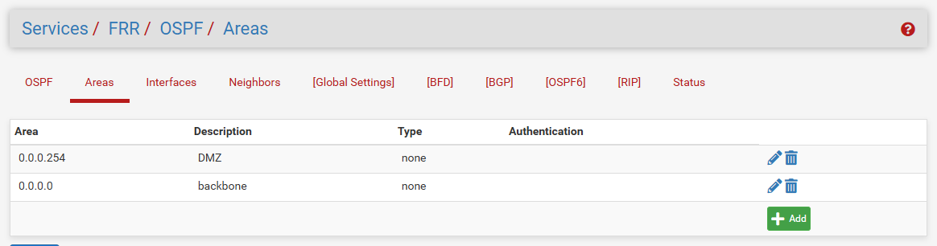

* + - * 1. Add areas

Declare the interface to participate in OSPF routing.

The listed interfaces (opt1, lan , opt2) will send/receive OSPF Hello packets to establish a neighbor relationship.

Decide which networks are advertised on OSPF.

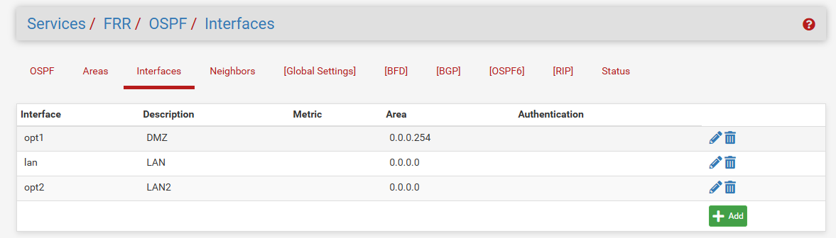

* + - * 1. Add interface

Enable FRR to activate OSPF.

The final step is to enable FRR so that all necessary services will run smoothly.

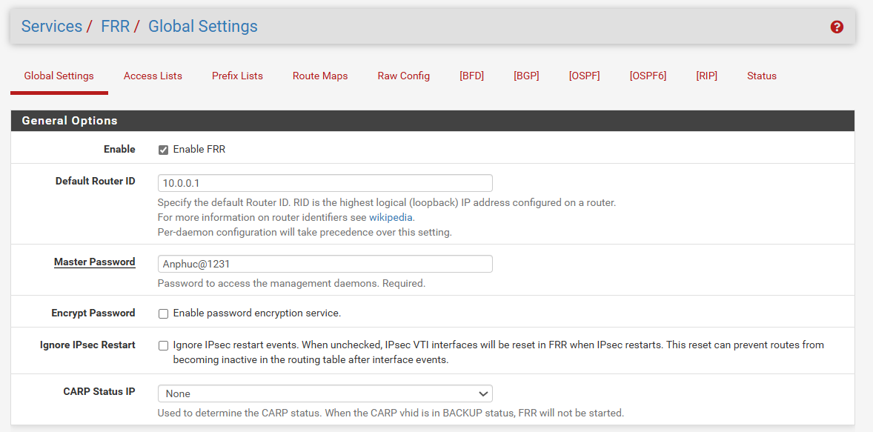

* + - * 1. Turn on FRR
    1. Deploying Suricata IDS/IPS
       1. Configure Global settings and update rules:

Use the ET Open (Emerging Threats) code. This is a high-quality community code, constantly updated with the latest offensive signature templates. The automatic update configuration is set to 12 hours to ensure the system is always aware of new threats.

* + - 1. Configure Blocking Mode:
* To make Suricata function as a true IPS, the project uses the following configuration:
* Block Offenders: Activate the feature to block attack sources.
* Kill States: Activates the feature to immediately disconnect current connections. This is extremely important to stop the ongoing attack.
* Block Mode: Use Legacy Mode. In this mode, Surricata will push the offending IP address to the snort2c table of the Packet Filter (pf). This is a stable, high-performance method that causes fewer conflicts with virtualized network cards.

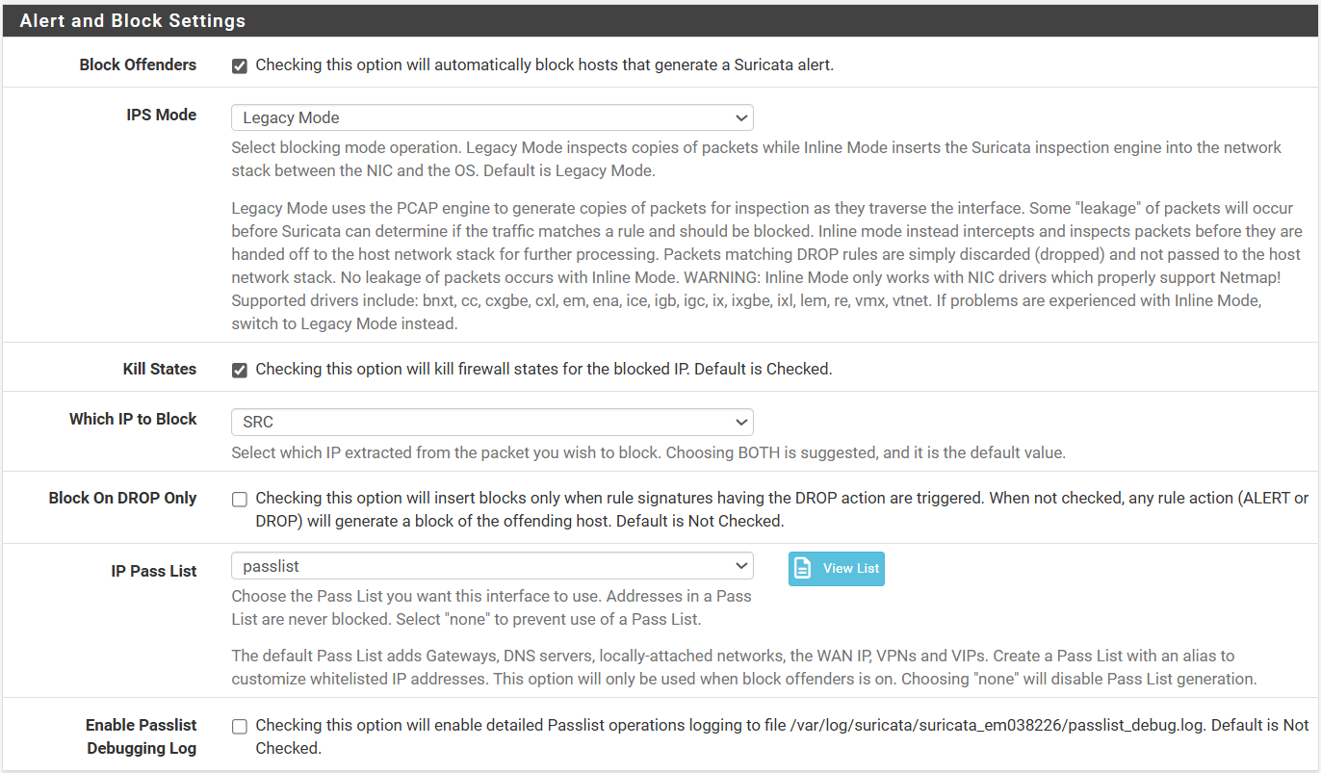

* + - * 1. Configure Block on WAN port
      1. Handling False Positives (False Alarms):
* In a real-world environment, Suricata can mistakenly block legitimate traffic (e.g., apt-get update processes from a DMZ server):
* Create a Passlist for the IP addresses of the administrator server and the Automation Server.
* Suppress rules related to excessive stream retransmissions to avoid blocking due to common network congestion.

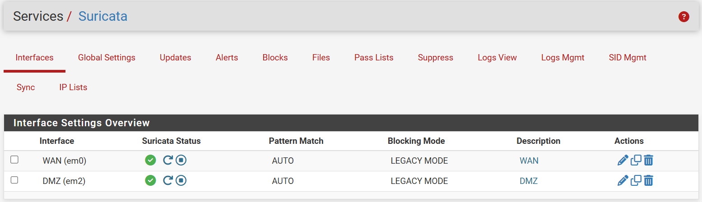

* + - * 1. Configuration Interface in Suricata
    1. Implement Load Balancing and Backward Proxy (HAProxy)

To securely and reliably broadcast DMZ services (Web Server, Teleport, Grafana, Prometheus) to the Internet, this project uses the HAProxy package on pfSense instead of traditional NAT Port Forwarding.

* + - 1. HAProxy Architecture:

Acts as a reverse proxy and SSL offloading service. Open only port 443 on the WAN, then use the domain name (SNI) to route traffic to the correct server internally.

* + - 1. Backend Configuration (Server Pools):
* Define the internal server groups that handle requests:
* web_backend: Points to IP 192.168.254.110, Port 80 (Nginx).
* teleport_backend: Points to IP 192.168.254.100, Port 443 (Teleport Proxy).
* grafana_backend: Points to IP 192.168.254.254, Port 3000 (Grafana).
* prometheus_backend: Points to IP 192.168.254.254, Port 9090 (Grafana).
  + - 1. Frontend Configuration (Public Listening):

Listening: DMZ Address (10.10.30.1) , Port 443 (HTTPS).

SSL Offloading: Uses an internal self-signed CA certificate ( anphuc.site ) to encrypt the transmission.

* Access Control Lists (ACLs): Routing based on hostname.
* If the host matches sneaker-shop.anphuc.site -> Use the web_backend backend .
* If the host matches teleport.anphuc.site -> Use the backend teleport_backend.
* If the host matches grafana.anphuc.site -> Use the grafana_backend backend.
* If the host matches prometheus.anphuc.site, use the prometheus_backend backend.

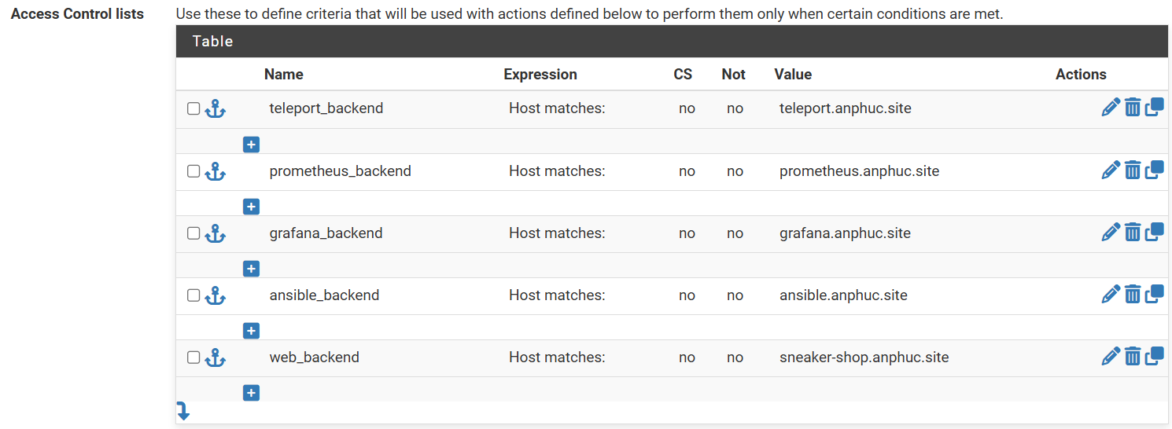

* + - * 1. Frontend and ACL configuration table on HAProxy
  1. Implement a Centralized Monitoring and Logging System (PLG Stack)

The monitoring system is deployed on Monitoring Server (192.168.254.254) using containerization technology with Docker Compose.

* + 1. Deploying Docker Stack (Infrastructure as Code)

The docker-compose.yml file was created to launch five core services synchronously. Network configurations and permissions were tightly controlled to ensure containers could communicate with each other and synchronize in real time with the physical server.

* The `docker-compose.yml` configuration file for deploying services:

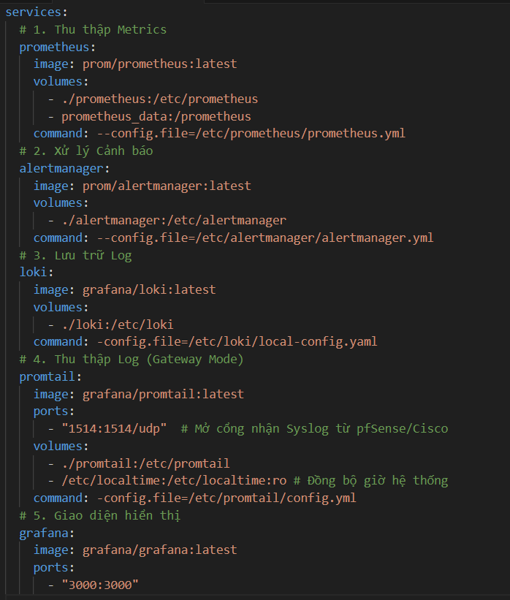

* + - * 1. Docker Compose configuration file
* The run includes containers :
* Prometheus: Stores metrics (retained for 15 days).
* Alertmanager: Manage alerts.
* Loki: Stores logs.
* Grafana: Display interface.
* Promtail (Gateway Mode): Listen to Syslog from the network device.
* The volume is mounted and configured accordingly in /data.



* + - * 1. The state of the containers for each service running on Docker.
    1. Configuring Prometheus (The Metrics Engine)

Prometheus is the heart of the metrics monitoring system. The configuration is divided into two main parts: defining monitoring targets and alert rules.

* + - 1. Directory structure:

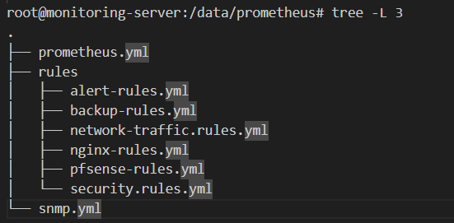

* + - * 1. Prometheus directory structure
      1. Main configuration file (prometheus.yml):
* The configuration defines the sampling frequency (scrape interval) and the list of targets. This project establishes a short sampling cycle (10s - 15s) for critical jobs to ensure timely attack detection.

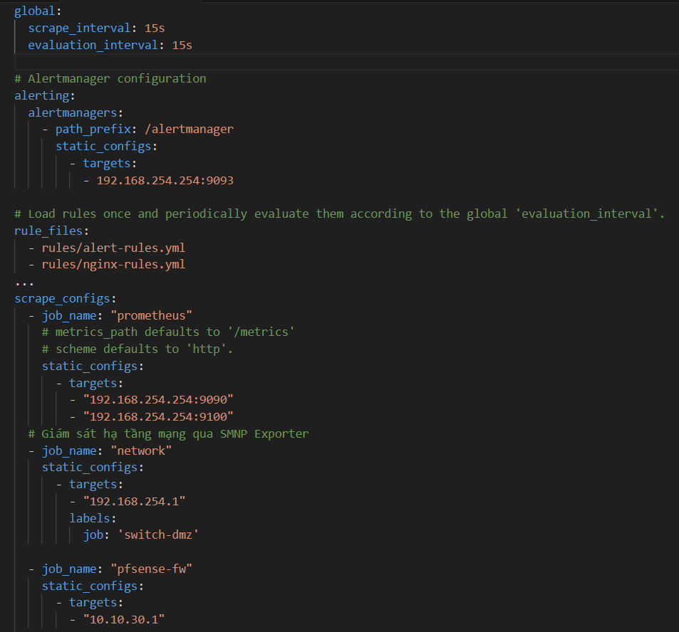

* + - * 1. prometheus.yml configuration file
      1. The alert rule configuration files (rules/):

Monitor device status (rules/alert-rules.yml):

* **The alert-rules.yml** file helps to immediately detect when a critical network interface is disconnected or a device goes offline.
* Use the ifOperStatus metric (port operating status). If the value is not 1 (Up), trigger an alert.
* Exclude virtual ports (Loopback, Docker, veth) to avoid false alarms.

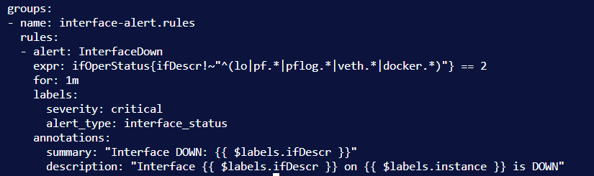

* + - * 1. Contents of the alert-rules.yml configuration file

Web Service Monitoring (rules/nginx-rules.yml):

* The file **nginx-rules.yml** This helps ensure Nginx is always operational and ready to serve users.
* Use the `nginx_up` metric from Nginx Exporter. If the value is 0 (Down) within 1 minute, trigger a Critical alert. Include instructions for handling this (Runbook), such as checking the `systemctl` service status in Nginx.

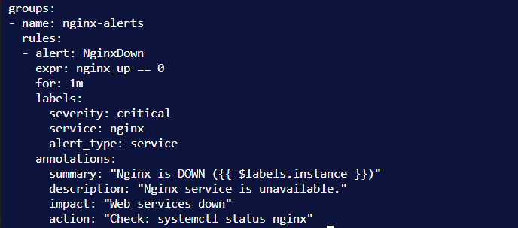

* + - * 1. Contents of the nginx-rules.yml configuration file

Monitoring Automation Processes (rules/backup-rules.yml):

* **The backup -rules.yml** file helps ensure that the daily configuration backup process is successful.
* The auto_backup.sh script, after execution, will push the auto_backup_status metric to Prometheus.
* If the value = 1 (Failure) -> Send a warning with detailed error information (e.g., "SSH Connection Refused").
* Timeout ( for ): 5m (Notify when the script finishes within 5 minutes).

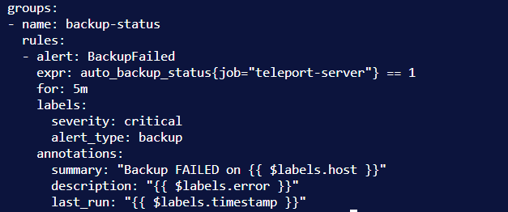

* + - * 1. Contents of the backup-rules.yml configuration file

Firewall Resource Monitoring (rules/pfsense-rules.yml):

* **pfsense-rules.yml** file helps ensure memory status in pfsense so that memory conditions can be reported.
* Technique: Use Recording Rules to pre-calculate the percentage of RAM used (pfsense:memory:usage_percent) to reduce the computational load each time a query is made.
* Warning levels:
* Warning: RAM > 70%
* Critical: RAM > 85%
* Emergency: RAM > 90%

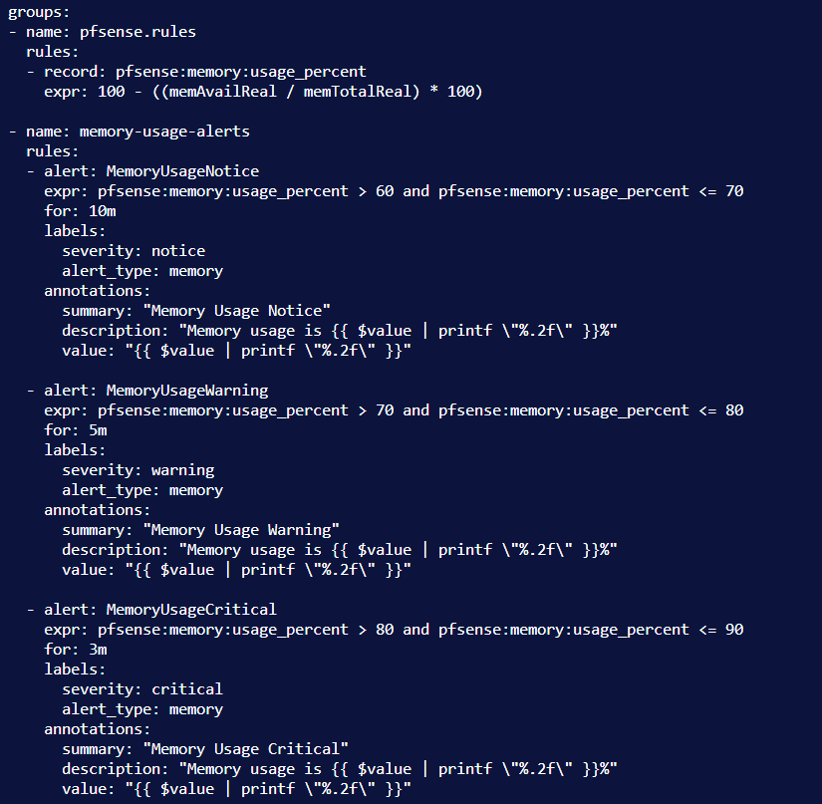

* + - * 1. Contents of the pfsense-rules.yml configuration file

Network Traffic Monitoring (rules/network-traffic.rules.yml):

* The file network-traffic.rules.yml helps detect network congestion or unusual data transmission behavior.
* Calculate the average transmission speed in 5 minutes (irate(...[5m])).
* Inbound Traffic > 100Mbps -> Warning.
* Inbound Traffic > 150Mbps -> Critical Warning.
* Anomaly Detection: Compares current traffic flow with the average traffic flow for the same time last week to detect anomalies.

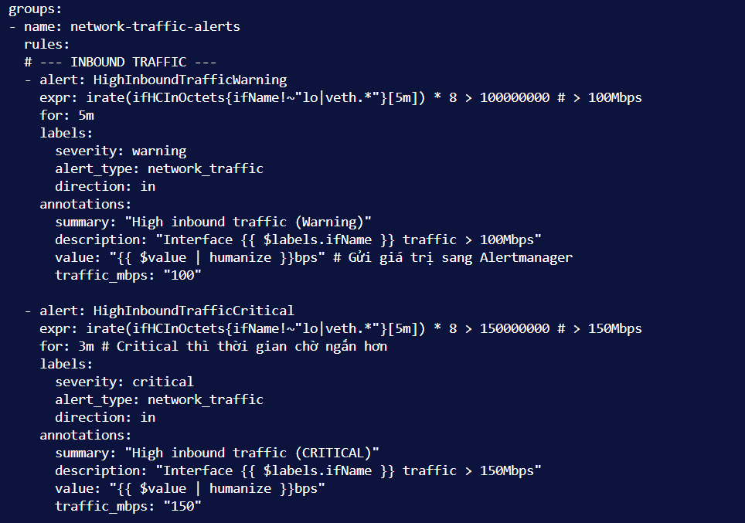

* + - * 1. Contents of the network-traffic.rules.yml configuration file

Next, we configure the alert manager to receive alerts via methods such as Telegram or email.

* + 1. Configure Alertmanager (The Notification Handler)

Alertmanager is responsible for receiving signals from Prometheus and routing them. A unique aspect of this configuration is the routing: Regular alerts are sent to Telegram.

* The Prometheus system combined with Alertmanager was deployed to:
* Monitor network status and system resources.
* Instantaneous fault detection (Interface Down/Backup Fail).
* Monitor traffic/memory trends.
* Sending multi-channel alerts (Telegram + Email) enables a quick response.
  + - 1. Connect alert configuration to Telegram.
* Establish a connection to alertmanager by creating an alertmanager.yml file in /data/alertmanager/
* Configure token-id and chat-id to connect to Telegram.
* The Alert Rules include the rules listed above.

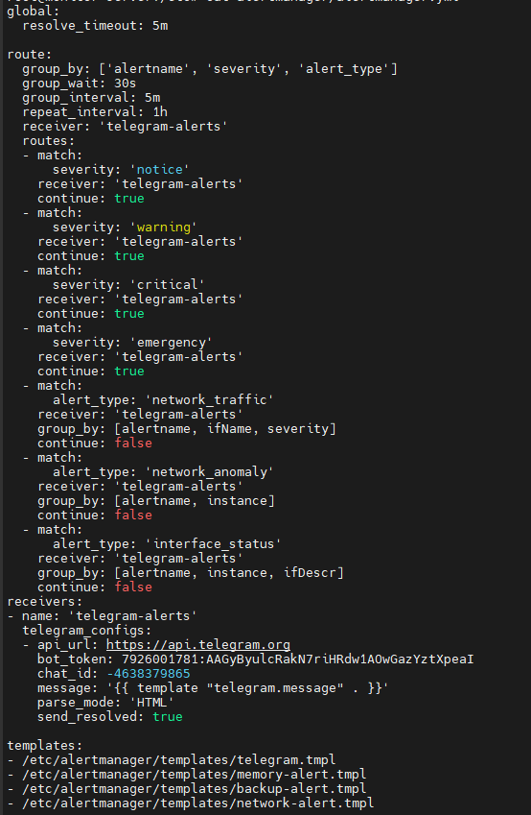

* + - * 1. Configure alertmanager.yml

Restart and check the operational status of AlertManager.

* + - 1. Alert sending mechanism

We create templates based on specific rules to accurately track the information we receive. We use two main channels, Telegram and email, to receive information.

Standard templates from telegram.tmpl

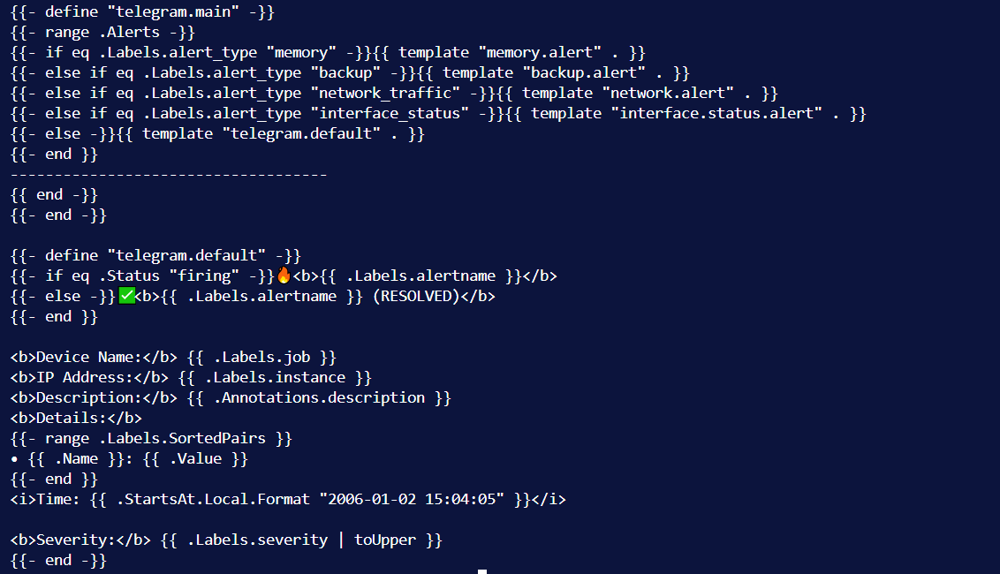

* + - * 1. Standard template for Telegram

Templates backup-alert.tmpl

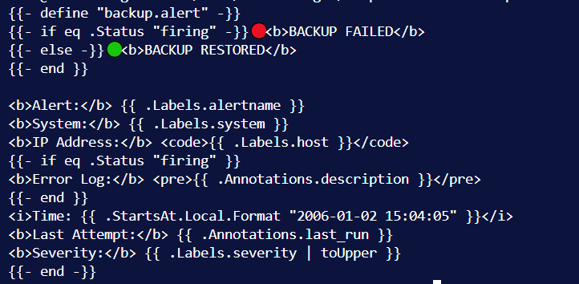

* + - * 1. Template for the Backup status alert

Template of memory-alert.tmpl

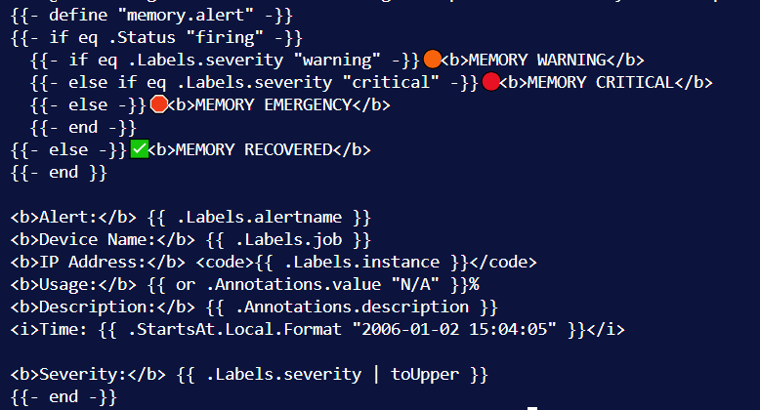

* + - * 1. Template for memory warnings on pfsense

Template of network-alert.tmpl

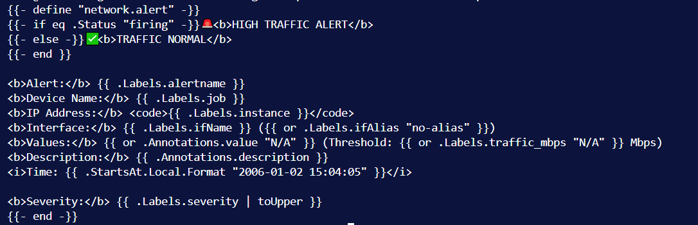

* + - * 1. Network traffic alert template

Template of port-alert.tmpl

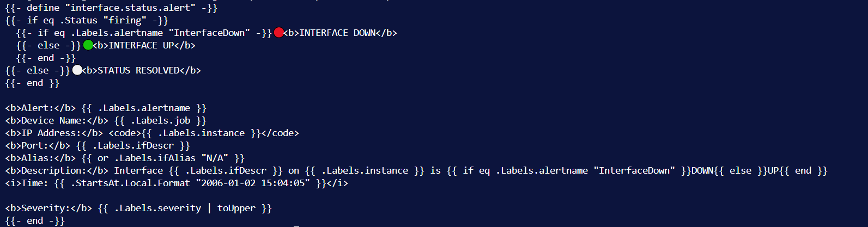

* + - * 1. Template for UP/DOWN status alerts on the port.
    1. Promtail and Loki (Log Pipeline) Configuration

The log processing system operates according to the model: Promtail -> Loki -> Grafana.

* + - 1. Grafana Loki (Archive):

Loki acts as a log database (Log Store). In this project, Loki is configured in filesystem mode, storing data directly on the Monitoring Server's hard drive. Loki listens on port 3100 to receive data pushed back from Promtail.

Configuration (loki-config.yaml): Sets the retention period and the mechanism for managing data chunks.

* + - 1. Promtail (Collection and Processing):

Promtail acts as a gateway for receiving logs. The most important configuration involves opening the port to listen for Syslog and processing the raw data. Promtail is configured to open UDP port 1514. Devices such as pfSense and Cisco Switches will point their Log Server to this IP address. Promtail will "wait" and capture incoming log packets.

* Configure promtail-config.yml:

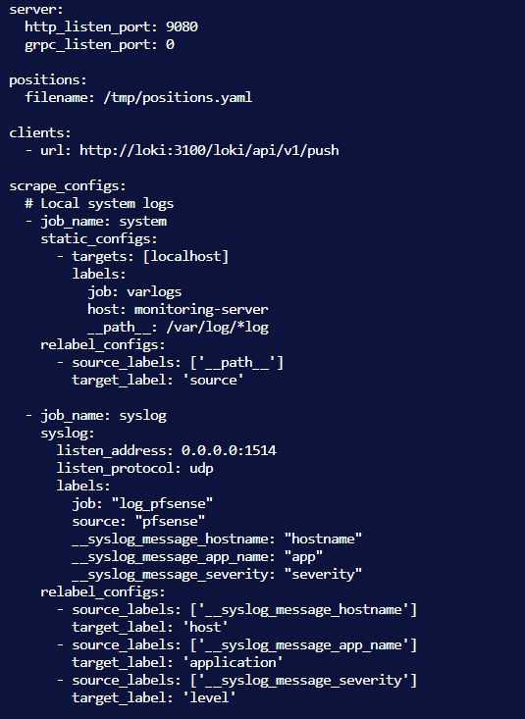

* + - * 1. Promtail configuration

The configuration file is divided into separate Jobs to handle each type of log source, and labels are standardized for easier querying in Loki.

* + 1. Building a Dashboard in Grafana

Grafana is used to visualize data from two sources: Prometheus (Metrics) and Loki (Logs), creating a consistent monitoring interface (Single Pane of Glass).

* + - 1. Backup Status Dashboard:

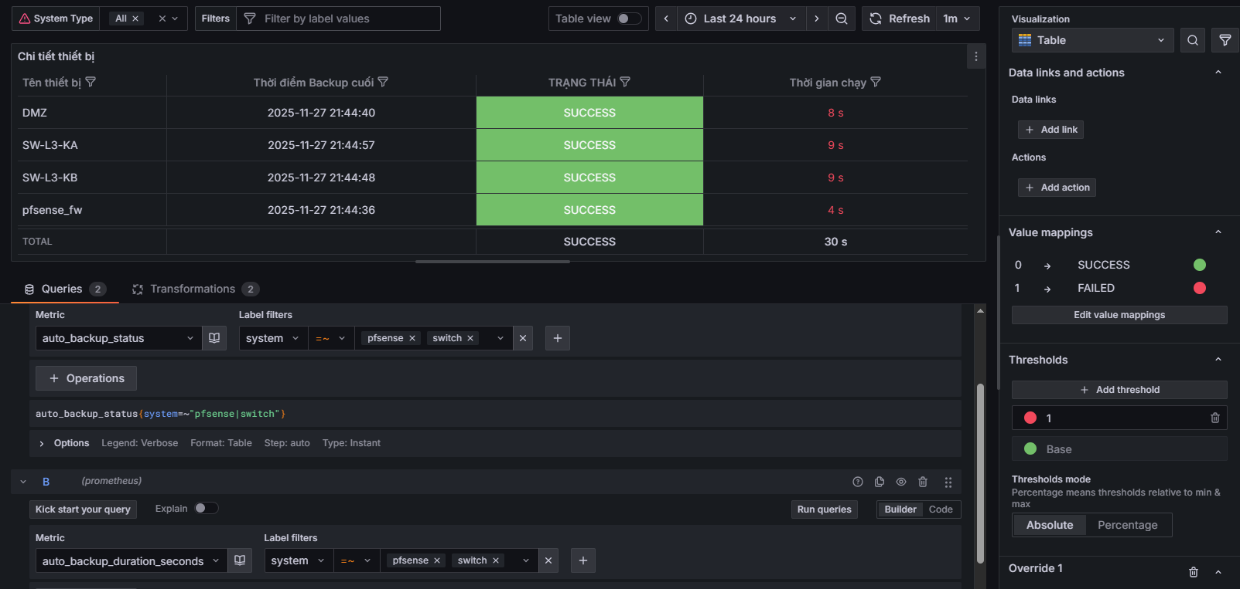

* + - * 1. Configure backup status panel
* Data source: Prometheus.
* Objective: To display the success/failure status of automated backup processes.
* Main panel:
* Status History: Backup status graph over time (Green = Success, Red = Failed).
* Last Run: The time of the most recent backup.
* Metrics: Use the auto_backup_status metric pushed from the Automation script.
  + - 1. Centralized Log Dashboard (Centralized Logs):

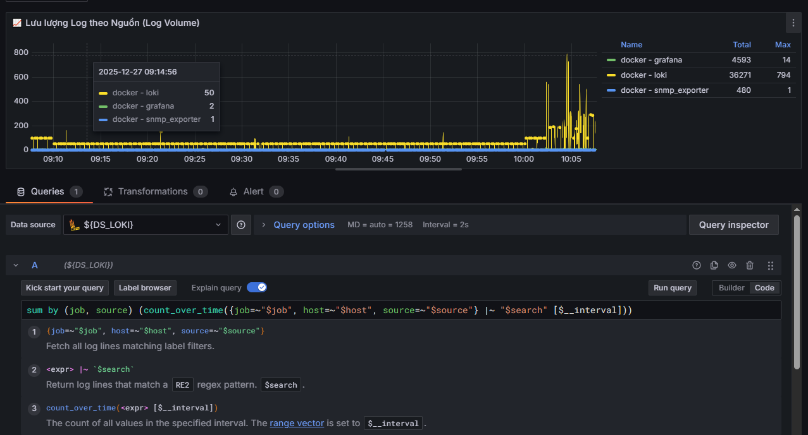

* + - * 1. Configure the log traffic display panel.
* Data source: Loki.
* Objective: To retrieve and analyze logs from pfSense, Switches, and Containers.
* Configure the Logs Panel: Use the LogQL query language to filter logs by label. Sample query: {job="log_pfsense"} to view all network logs.
* Sample query: {job="docker", source="alertmanager"} to view the activity logs of the alert system.

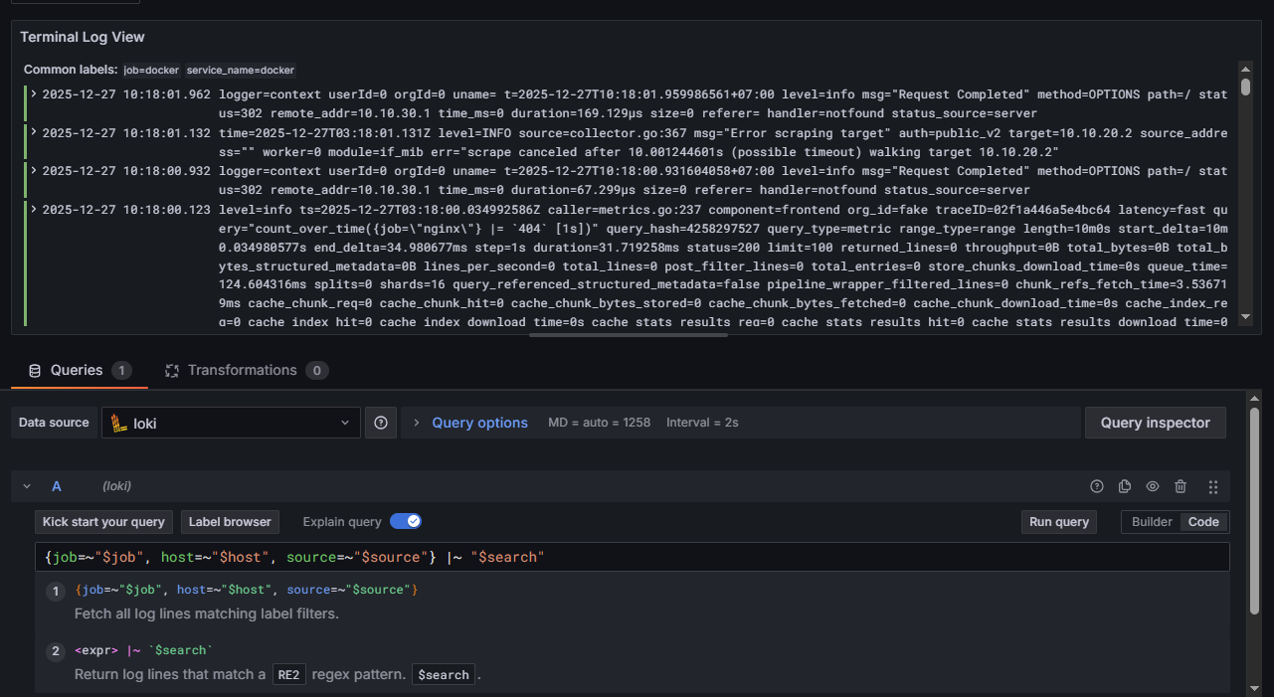

* + - * 1. Configure the live log panel to display in real time.

Feature: The dashboard allows searching for keywords (e.g., "Block", "Error", "Suricata") across the entire system log, helping to quickly identify the cause of the problem.

* + - 1. Network Infrastructure Monitoring Dashboard (SNMP Traffic):

Data source: Prometheus (via SNMP Exporter).

* Objective: To monitor the health and traffic of Cisco Core/Distribution Switches.
* Main panel:
* Interface Status: Up/Down status table for important ports.
* Network Traffic (In/Out): Line graph showing bandwidth usage on Uplink ports (VLAN Trunk). Use the function irate(ifHCInOctets[5m]) * 8 to calculate the Mbps speed.
* Device Health: CPU and RAM of network devices.

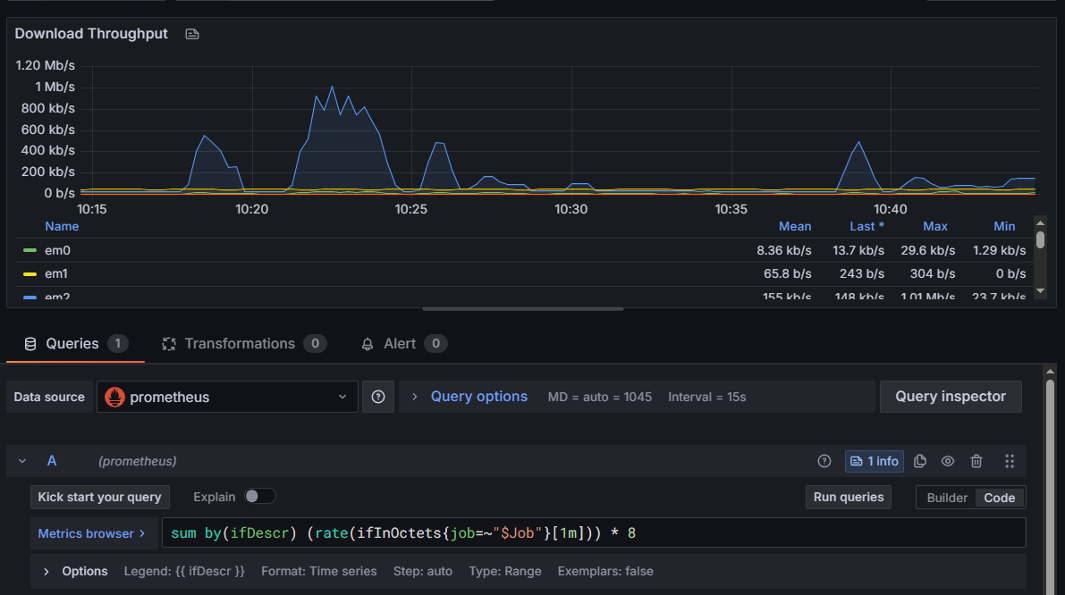

* + - * 1. Configure the panel to display total load usage.

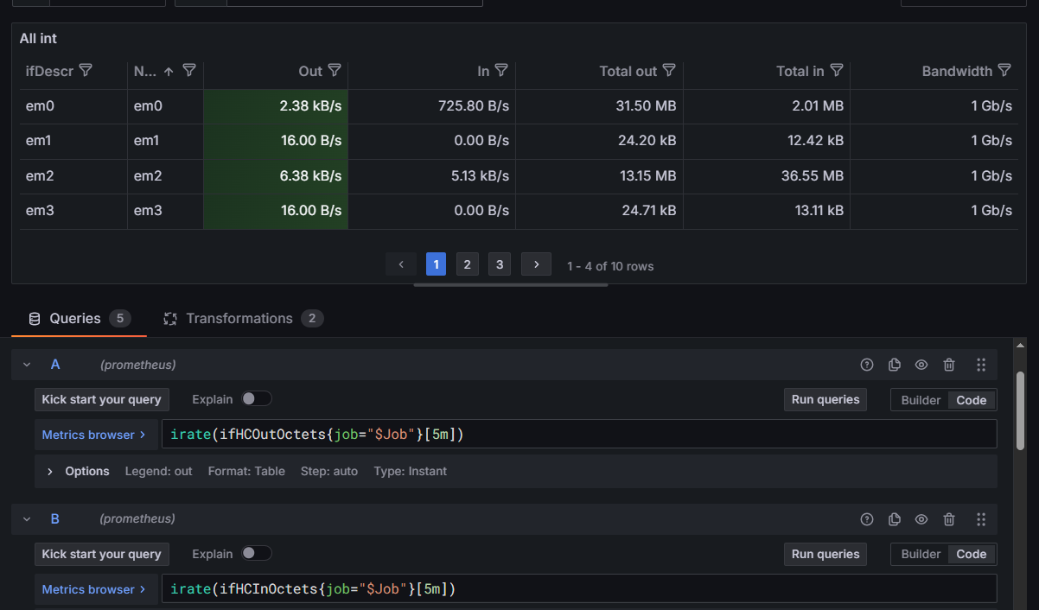

* + - * 1. Configure the display panel to show the total input/output for each port.

Firewall Monitoring Dashboard (pfSense):

* Data source: Prometheus (SNMP Exporter with pfSense module).
* Objective: Monitor Gateway performance and connection board status.
* Main panel:
* Rule Statistics: Flow rate for each specific rule
* System Load: CPU Load, Memory Usage, Disk Space.
* Interface Statistics: Traffic through WAN, LAN, and DMZ ports.

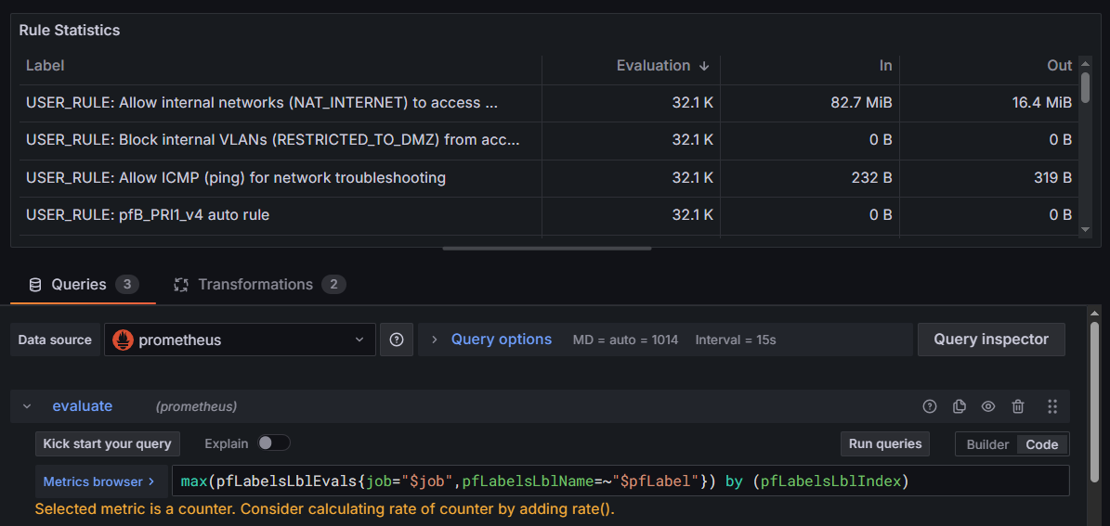

* + - * 1. The Rule Statistics panel configuration displays traffic flow across rules.

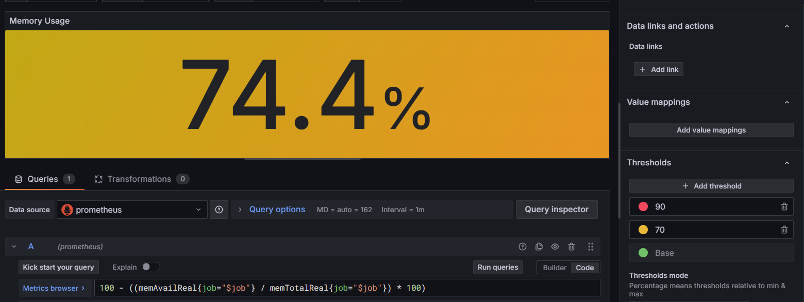

* + - * 1. The configuration panel displays the current memory status.

Server Health Dashboard (Node Exporter):

* Data source: Prometheus (via Node Exporter installed on Linux servers).
* Objective: To monitor the resources of the Monitoring Server, Automation Server, and Web Server.
* Main Panel (Usage Methods - Utilization, Saturation, Errors):
* CPU Utilization: A graph showing the percentage of CPU usage by each core.
* Memory: Used RAM, Cache, Free.
* Disk I/O: Hard drive read/write speed and available storage space.
* Network: Network traffic entering/exiting each server.

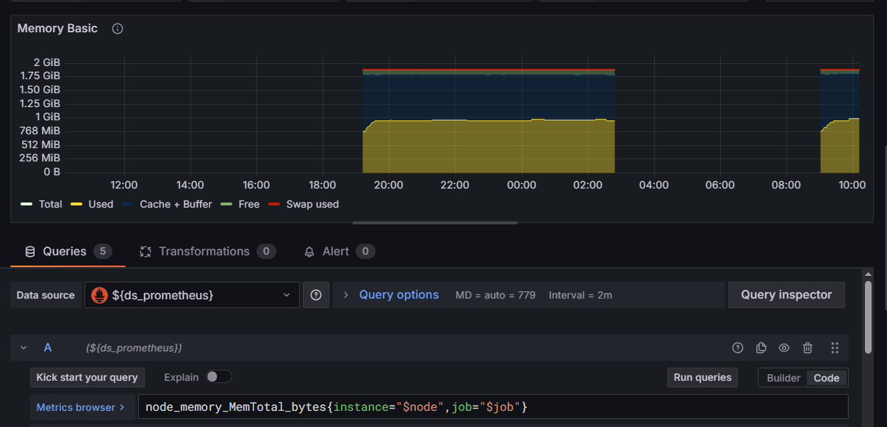

* + - * 1. Memory Basic panel configuration
    1. Build automated reports and alerts via Telegram.
* The reporting module is built using the Python programming language and acts as middleware connecting the monitoring system and the end user.
* Automation: The system automatically collects data at the end of the day without manual intervention.
* Multidimensional: Combines data from all three sources: Network traffic (Prometheus), System logs (Loki), and Backup status.
* Convenience: Sending reports in PDF format directly via the Telegram app allows administrators to monitor system status anytime, anywhere.
  + - 1. Script processing procedure:

Trigger: The cron job activates the daily_runner.py script at 20:00 every day.

The scripting system is divided into functional modules for easy maintenance and expansion:

* Log processing module (generate_log_report.py):
* Perform a "cleanup" of the raw log data, removing special characters that cause formatting errors.
* The error rate is automatically calculated. If this rate exceeds the safe threshold (>5%), the report will automatically highlight it in red as a warning.
* Traffic processing module (generate_traffic_report.py):
* Automatically scan the list of active SNMP devices.
* Identify critical interfaces that are in a DOWN state and list them in detail in the report.
* Scheduling module (daily_runner.py):
* Responsible for sequentially calling and executing the child modules.
* Gather all the resulting PDF files and send them all at once, avoiding the problem of sending scattered spam messages.

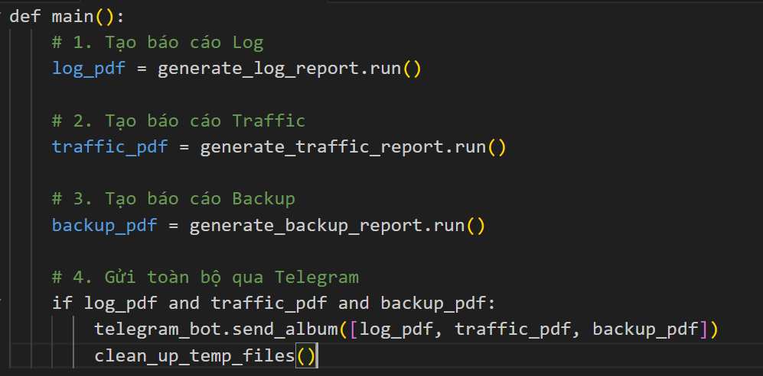

* + - * 1. This pseudocode describes the core logic of sending the report.
  1. Implementing Automation with Ansible and Teleport

The automation system is built on Automation Server (192.168.254.100), which acts as a controller to manage configuration, application deployment, and incident response.

* + 1. Ansible's directory structure and architecture

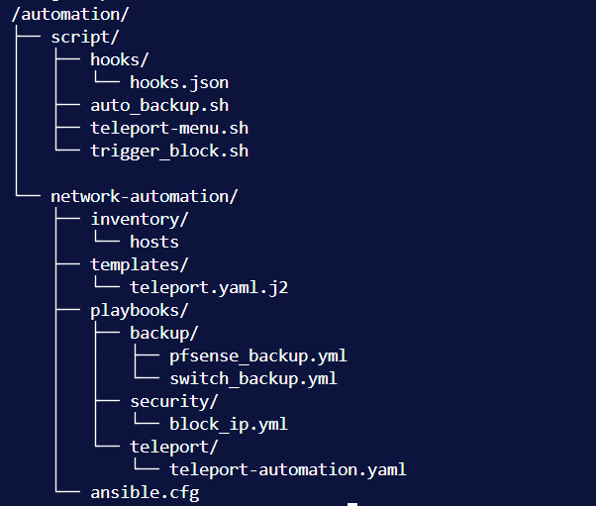

* + - * 1. Ansible configuration directory structure

Provide a detailed description of the functions of folders and files:

* directory : This is where control scripts and webhook configuration files are stored. These scripts act as a bridge between the operating system, the monitoring system, and Ansible.
* auto_backup.sh: A Bash script that performs a periodic backup process. It calls backup playbooks, catches output errors, and sends the status to Prometheus.
* teleport-menu.sh: An interactive CLI menu that allows administrators to easily select devices to install the Teleport Agent without typing lengthy commands.
* hooks/hooks.json: This configuration file defines the endpoints for the Webhook Server, specifying which scripts will be executed when an HTTP POST signal is received.
* The /automation/network-automation/ directory: This is the root directory of the Ansible project, containing all the infrastructure configuration source code (Infrastructure as Code).
* ansible.cfg: Ansible runtime environment configuration file (e.g., disable host key checking, log path).
* inventory/hosts: The system's "contact list". This file contains a list of IP addresses, login information (user/password), and connection methods for each group of devices (Switch, Firewall, Linux Server).
* templates/teleport.yaml.j2: This is a Teleport configuration file template written in Jinja2. When run, Ansible will dynamically fill in this template with values (such as Token, Machine Name) to create a complete configuration file on the target machine.
* The /automation/network-automation/playbooks/ directory contains automation scripts (playbooks) categorized by business function.
* backup/: Contains configuration backup scripts.
* pfsense_backup.yml: A script to SSH into pfSense to retrieve the XML configuration file.
* switch_backup.yml: A script to connect to a Cisco switch and retrieve its running configuration.
* security/: Contains security incident response scenarios.
* block_ip.yml: Script for executing an emergency IP blocking command in pfSense.
* teleport/: Contains system deployment scenarios.
* teleport-automation.yaml: A script to install, configure, and start the Teleport Agent service on new servers.
  + 1. Implementing an Auto Backup Script

The backup process is designed to ensure data integrity and the ability to monitor the backup status.

* + - 1. Cisco Switch Backup Playbook (switch_backup.yml):
* Function: Connects via SSH to L3 switches, executes the `show running-config` command to retrieve the current configuration.
* Module used: cisco.ios.ios_command
* Storage: Use the copy module to save the retrieved content to a directory with a date format (/backups/switches /{ { hostname }}/YYYY-MM-DD/).

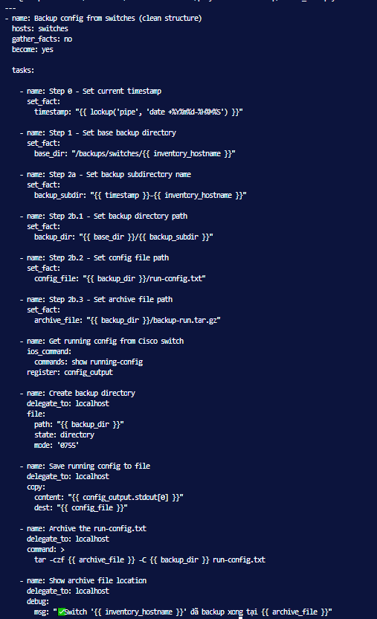

* + - * 1. Configure Playbook Backup pfSense
      1. Playbook Backup pfSense (pfsense_backup.yml):

Function: Connects to pfSense via SSH and retrieves the most important XML configuration file (/conf/config.xml).

Technical aspects: Due to pfSense (FreeBSD) limitations regarding SFTP, the playbook uses the fetch module or the command `cat` in combination with registers to reliably retrieve file contents.

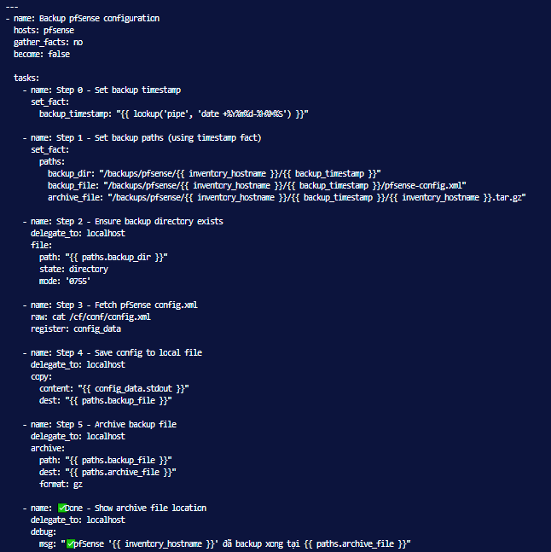

* + - * 1. Configure Playbook Backup pfSense
      1. The auto_backup.sh script is activated.

The auto_backup.sh script, when executed, selects which device to back up based on the specified host files, and upon successful execution, creates the metric file auto_backup_status.prom to store the metrics .

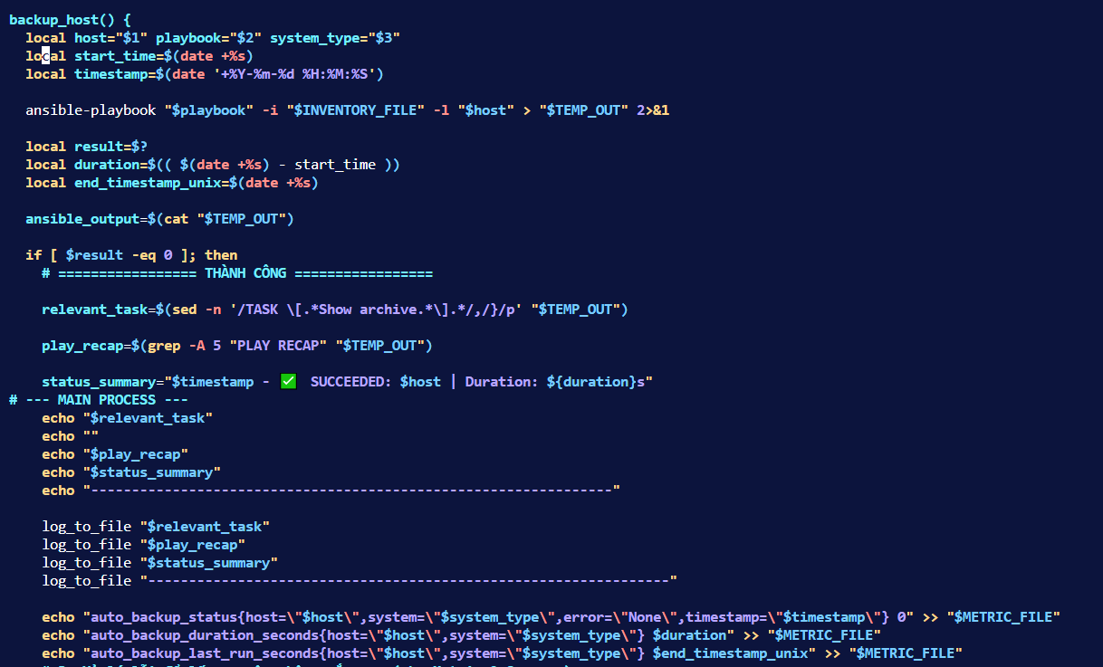

* + - * 1. The main code snippet runs the playbook when the script file is executed.

This allows the status to be displayed directly on the Grafana Dashboard.

* + 1. Implementing the Teleport Setup (Provisioning) Scenario

To address the system scaling problem, this project aims to develop a fully automated process for adding new devices to a centralized management system.

* + - 1. Playbook installs teleport agent

The playbook teleport-automation.yaml helps create a token and set up an agent on the specified server, and the playbook performs two parts (Plays):

* Play 1 (On Auth Server):
* Connect to the Teleport Auth Server.
* Run the command `tctl tokens add --type=node` to generate a short-term Join Token.
* Save this token to the (Variable) memory.

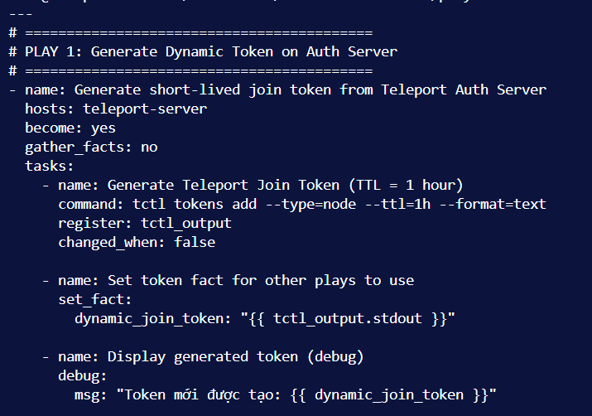

* + - * 1. Configure to create a new token for authentication.
* Play 2 (On Target Node - New Machine):
* Connect to the server where you want to install the software.
* Download the Teleport (Binary) installer and extract it.
* Use the teleport.yaml.j2 template to create the /etc/teleport.yaml configuration file. At this step, the auth_token variable in the template will be replaced with the token generated in Play 1.
* Create a Systemd Service and start Teleport.

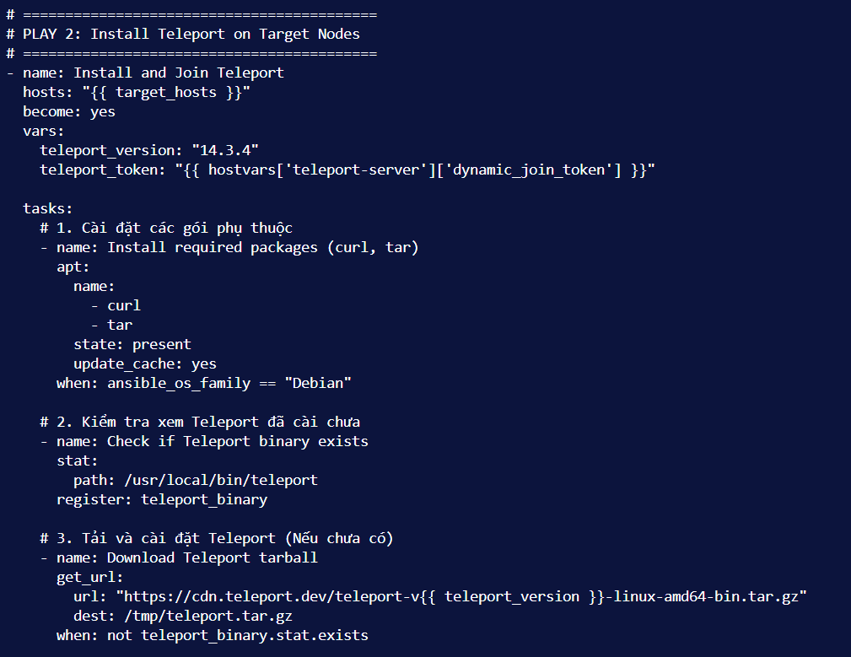

* + - * 1. Configure and set up teleport testing with the token generated above.

Result: The new server automatically connects to the Teleport cluster without the administrator needing to manually copy/paste the token.

* + - 1. Playbook removes teleport agent.
* The playbook teleport-remove.yaml allows you to remove the agent on the specified server.
* Perform tasks such as stopping, deleting packages, deleting services, and removing related configuration files.
* Check on the server to see if the agent is actually still present.

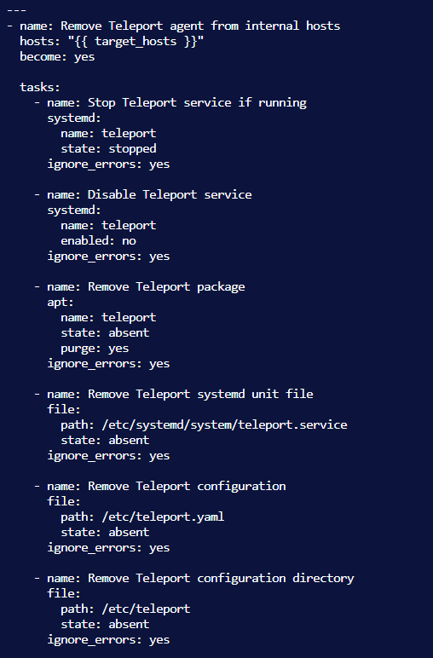

* + - * 1. Configure the teleport-remove.yaml file.
      1. The teleport_menu.sh script activates this feature.

The following teleport_menu.sh script selects which device to install or remove the teleport agent on based on the specified host files.

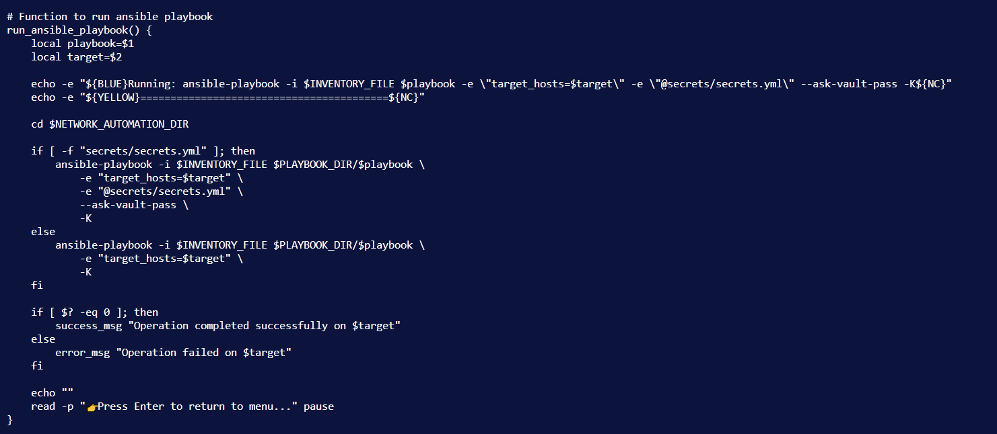

* + - * 1. The main code that runs the playbook when executing the script file.
  1. End of Chapter 2

Chapter 2 detailed the implementation process of the NetDevOps solution, from architectural design to specific technical deployment. The system was fully built with tight integration between infrastructure, monitoring, and automation components:

Regarding network infrastructure: We have successfully built a layered enterprise network with high redundancy thanks to the HSRP protocol and OSPF dynamic routing on Cisco L3 switches, and established the pfSense firewall as the central gateway for multi-zone security control.

Regarding log monitoring and management: We have successfully deployed the Prometheus - Grafana - Loki (PLG Stack) toolkit on a Docker platform. The system not only collects real-time metrics but also solves the challenging problem of centralized log standardization from multiple devices thanks to Promtail's pipeline processing technology.

Regarding automation and security: We have implemented an "Infrastructure as Code" process using Ansible to automate daily administrative tasks such as configuration backups and service deployments.

These deployment results provide a solid foundation for conducting realistic test scenarios and evaluating system performance, which will be discussed in detail in Chapter 3: Experimental Results and Evaluation.

.

1. EXPERIMENTAL RESULTS AND EVALUATION
   1. Experimental deployment environment

To verify the solutions designed in Chapter 2, the project built a complete lab environment simulating the network infrastructure of a small and medium-sized enterprise. The system was deployed on a VMware Workstation virtualization platform combined with GNS3.

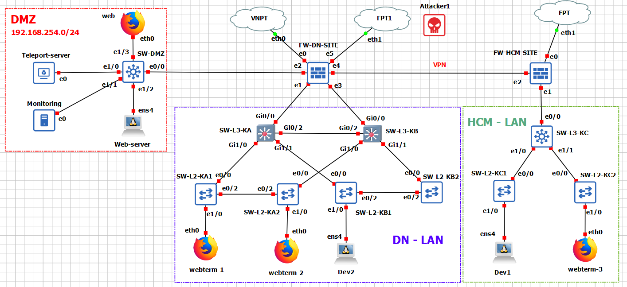

* + - * 1. Network model diagram
    1. Server specifications

The system consists of virtual machines running Linux (Ubuntu Server 22.04 LTS) and FreeBSD (pfSense) operating systems, with resources allocated as follows:

Experimental System Resources

|  |  |  |  |
| --- | --- | --- | --- |
| **Hostname** | **IP Incorrect** | **Configuration (CPU/RAM/HDD)** | **Installation service** |
| pfSense FW | 10.10. 10.1 | 2 vCPU / 2 GB / 20 GB | Firewall, Suricata, HAProxy, DHCP, DNS Resolver |
| Monitoring | 192,168,254,254 | 2 vCPU / 2 GB / 20 GB / 40 GB | Docker (Prometheus, Loki, Grafana, Alertmanager) |
| Automatic | 192,168,254,100 | 2 vCPU / 2GB / 30GB | Ansible Core, Teleport Auth/Proxy, Webhooks, Nginx |
| Web Server | 192,168,254,200 | 1 vCPU / 1GB / 10GB | Nginx Web App, Promtail Agent |
| Switches | (GNS3) | N/A | Cisco IOS L3 (SW-KA, SW-KB, SW-DMZ) |

* + 1. Test script
* The experimental process was divided into four main phases for a comprehensive evaluation of the system:
* Check network infrastructure availability (HSRP/OSPF) and HAproxy.
* Check the operation of the centralized monitoring and logging system.
* Test the administrative automation feature (Backup/Provisioning).
* Test the ability to detect and prevent automated attacks (Security Automation).
  1. Network infrastructure deployment results
     1. Check Gateway routing and redundancy.
        1. Check routing between devices.

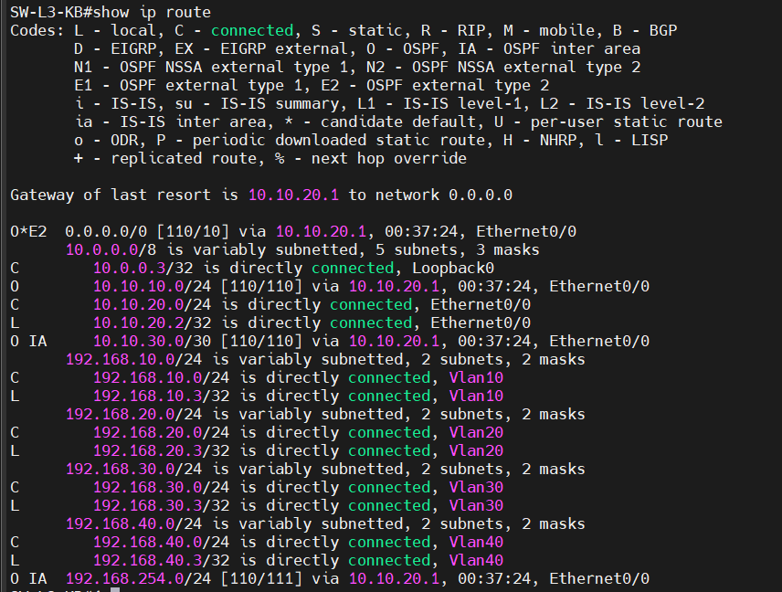

* + - * 1. Check the routing table on SW-L3-KB
* Result:
* There is an internet connection via port 10.10.20.1
* There is a path to other networks thanks to the OSPF protocol.

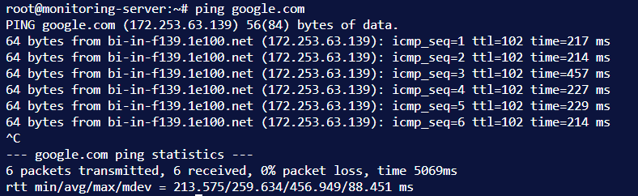

* + - * 1. Check if internet connection is successful.
      1. Preventive testing
* The network system has been operating stably with the HSRP protocol on the Core Switch pair.

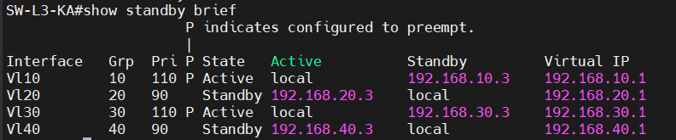

* + - * 1. HSRP status on SW-L3-KA

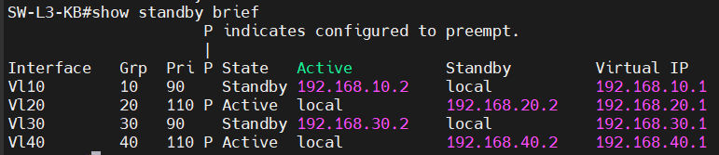

* + - * 1. HSRP status on SW-L3-KB

Results: When tested on the L3 KA switch, the HSRP status is Active on VLAN 10, VLAN 30, and VLAN 20, while VLAN 40 is in Standby mode . When tested on the L3 KB switch, the HSRP status is Active on VLAN 20, VLAN 40, and VLAN 10, while VLAN 30 is in Standby mode.

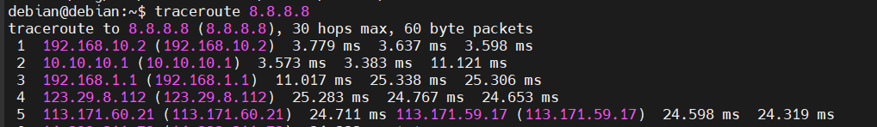

* + - * 1. Results of redundancy testing

Fault testing: When the Uplink Interface of Switch KA is disabled, network traffic from Client (VLAN 10/20) automatically switches to Switch KB without causing any loss of Internet connectivity.

* + 1. Check inter-regional connectivity
* The firewall rules on pfSense worked as designed:
* From the LAN, you can access the Internet and other services permitted within the DMZ.
* Web servers can be accessed from the Internet via Port Forwarding (NAT).
* Any unauthorized access from the LAN to the DMZ administration area (SSH Port 22) will be blocked and logged.
  + 1. Results of HAProxy deployment

This project tested the ability to access internal services from the Internet via the HAProxy Reverse Proxy.

* Access Prometheus and Grafana: Use your browser to access “https://prometheus.anphuc.site” and “https://grafana.anphuc.site.”

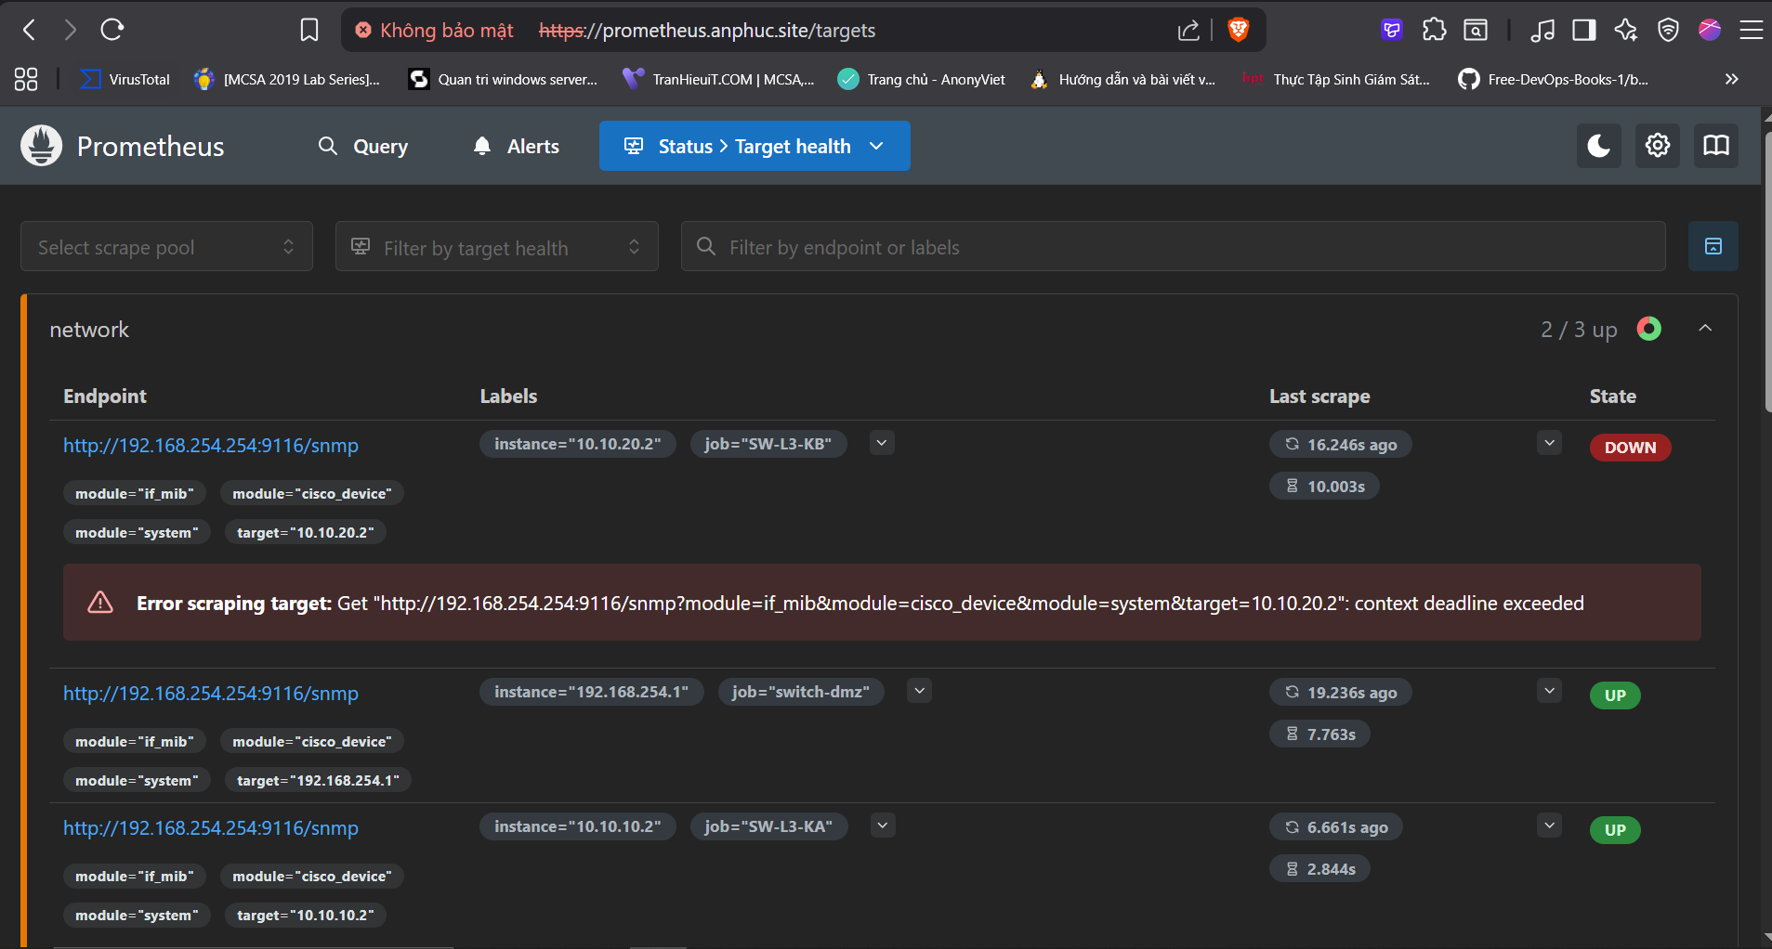

* + - * 1. Prometheus Access Interface

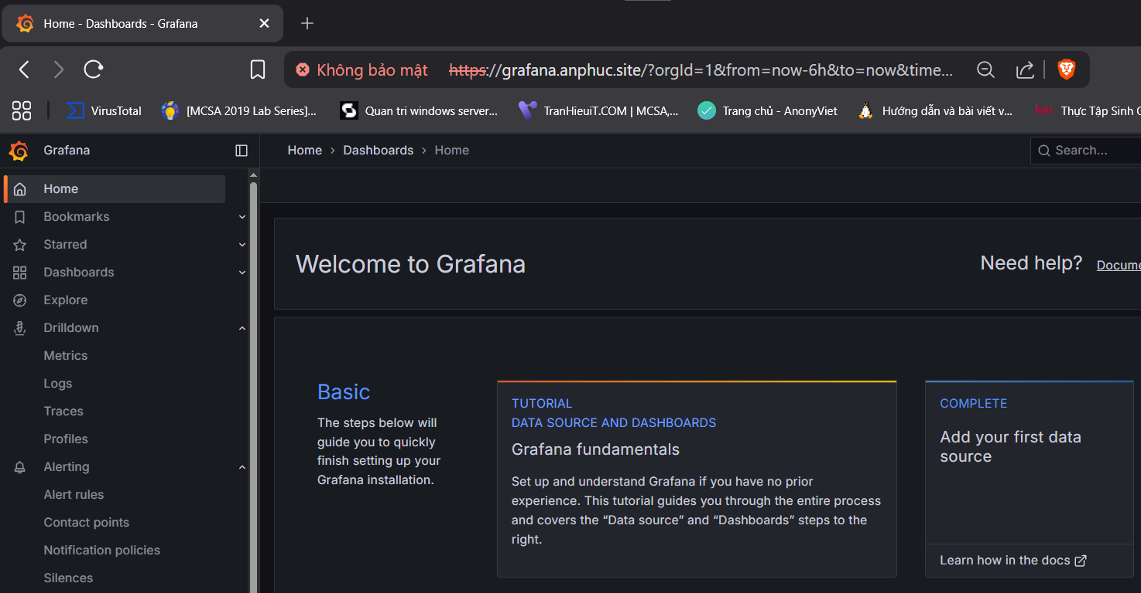

* + - * 1. Grafana access interface

Result: Correctly displayed the Prometheus and Grafana homepage from server 192.168.254.254 . SSL/TLS encrypted connection successful (green padlock).

* Access Teleport: Go to “ https://teleport.anphuc.site. ”

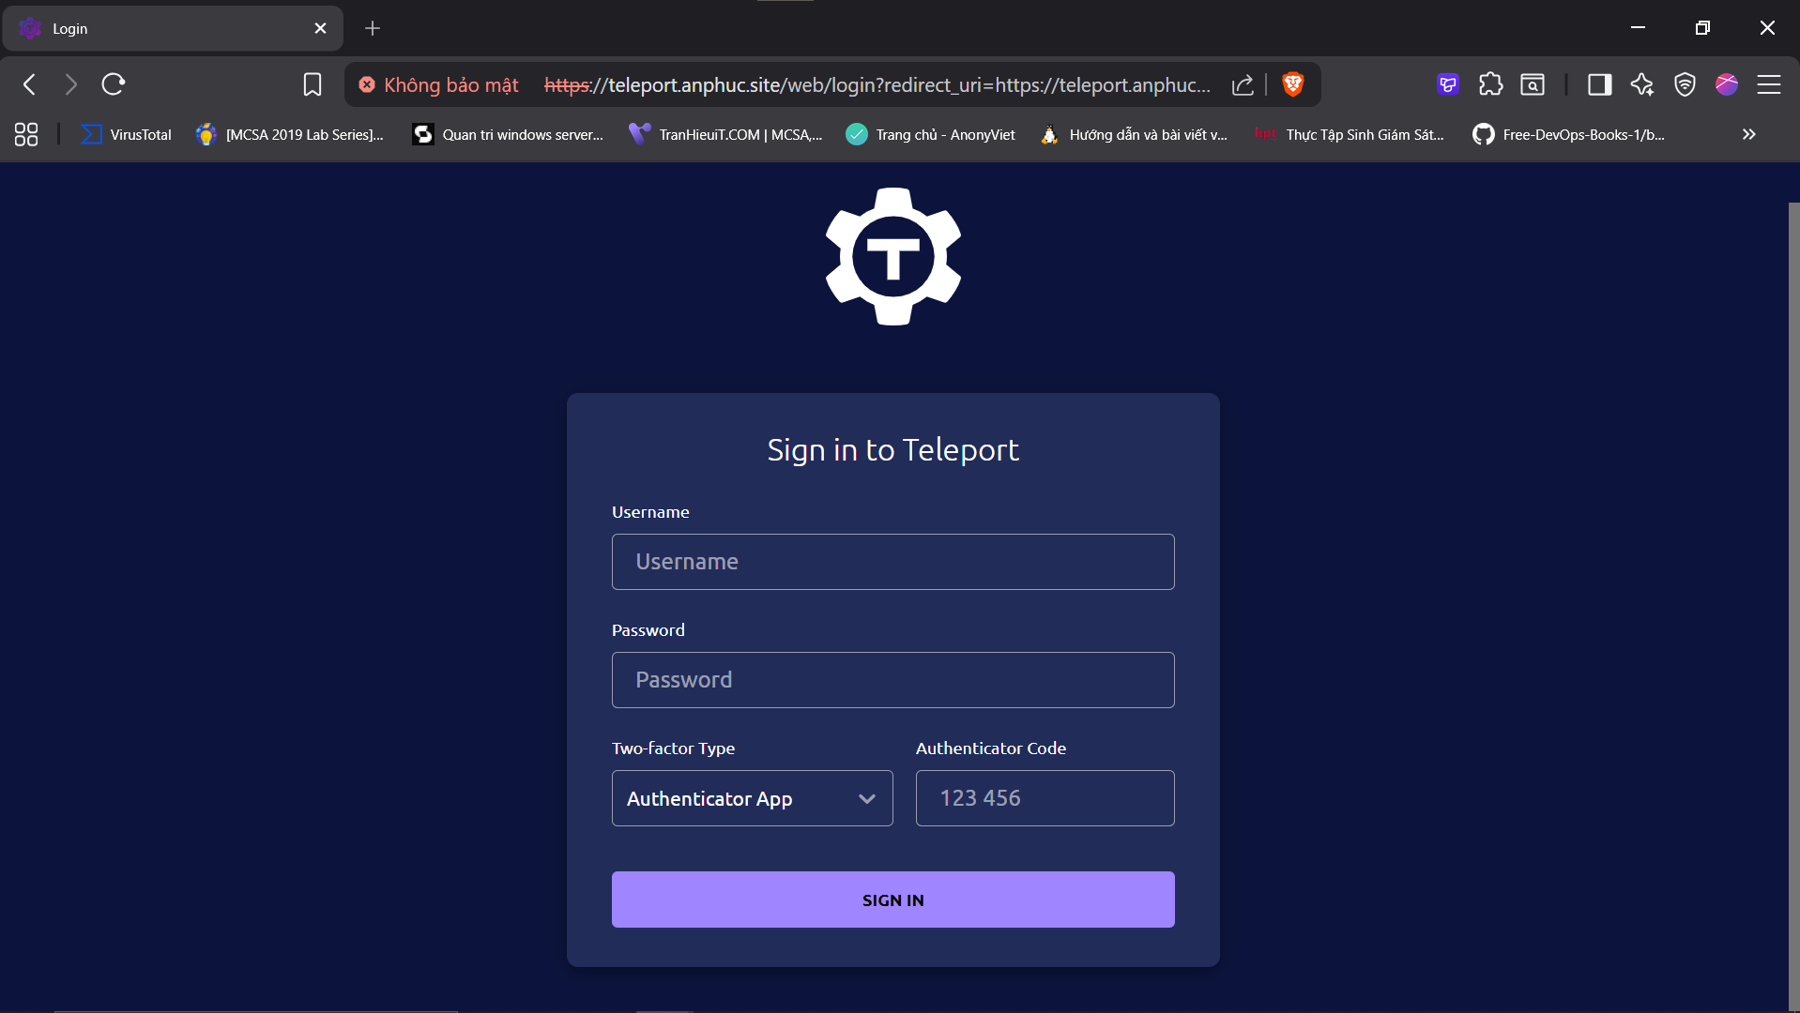

* + - * 1. Teleport access interface

Result: Successfully redirected to the Teleport Auth Server login page (192.168.254.100).

HAProxy Monitoring: The HAProxy statistics dashboard on pfSense displays the UP status of backends and traffic in real time.

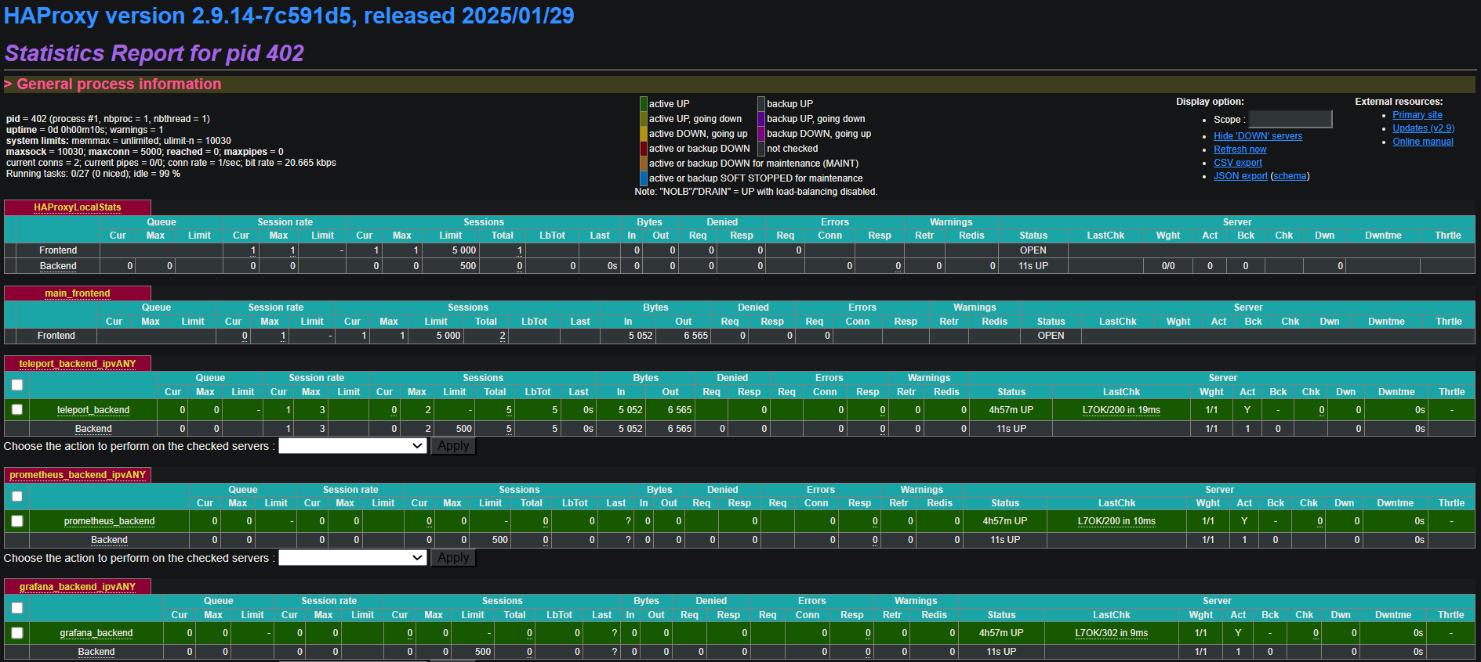

* + - * 1. The HAProxy Statistics Page displays the status of the backends.
  1. Results of the centralized Monitoring and Logging system

The PLG Stack (Prometheus - Loki - Grafana) system has successfully collected data from all devices.

The following will show the results after setting up the Grafana dashboards and the alert status:

* + 1. Dashboard Network Automation Backup Status

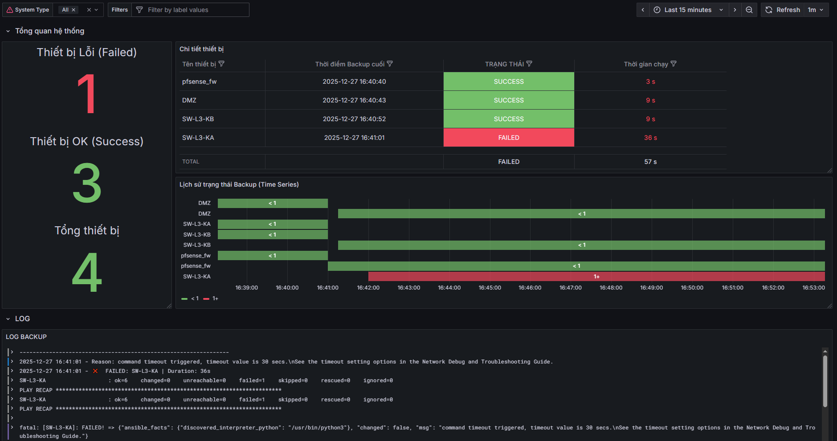

* + - * 1. Backup Status Overview Dashboard
* Result:
* Displays the backup status of each device.
* Backup runtime
* Displays the overall backup log.
  + 1. Dashboard Centralized Logs (Loki)

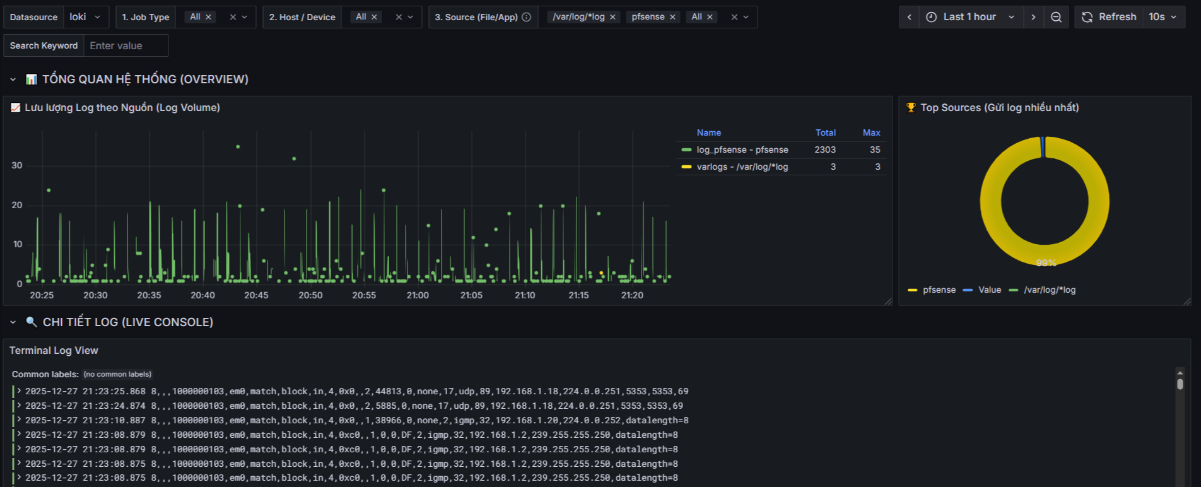

* + - * 1. Dashboard logs are collected from multiple sources.
* Result:
* Collect logs from all sources: pfSense (Suricata, Filterlog), Cisco Switch, Nginx, System Log.
* Displays a log density graph over time, helping to detect anomalies (spikes).
* The log search and filtering feature based on fields (Host, App Name, Source IP) works correctly thanks to the Promtail Pipeline configuration.
  + 1. Dashboard Network Traffic (SNMP)

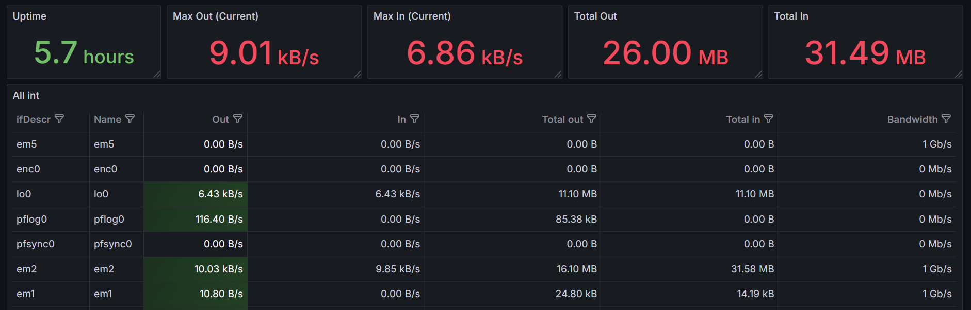

* + - * 1. Dashboard for monitoring switch devices

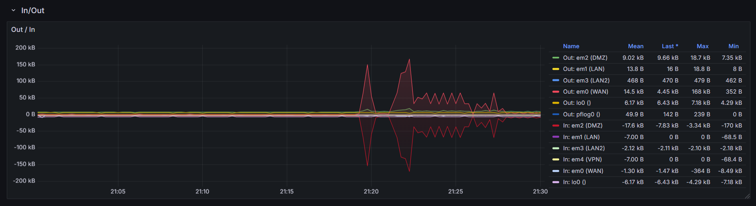

* + - * 1. Monitor traffic in and out at each port.
* Result:
* Display real-time inbound/outbound bandwidth on key uplink ports of the Core Switch.
* Provides the Up/Down status of each physical interface.
* The visual chart helps assess bandwidth usage.
* Status of Telegram alerts being sent:

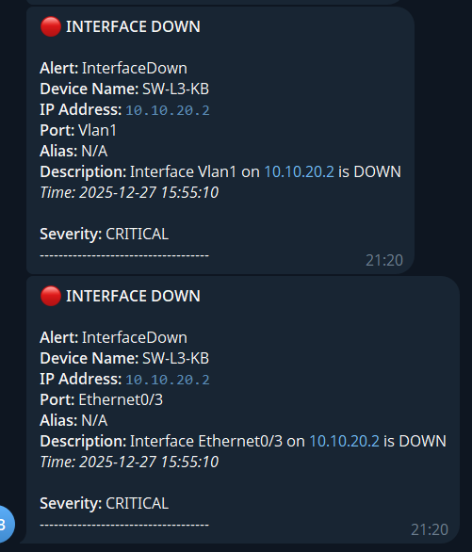

* + - * 1. Send alerts when the port is down.
* The DOWN status accurately reflects the current port condition.
* Display the time when the port was down.
* Display the correct device address and name.
* There is a warning that the situation is CRITICAL.

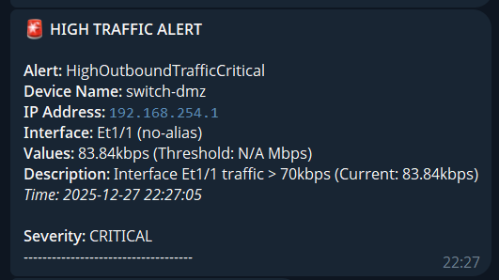

* + - * 1. Send alerts when network traffic is high.
* A WARNING alert will be sent when bandwidth exceeds 40Kbps (a low level suitable for a lab environment).
* Send a CRITICAL alert when bandwidth exceeds 70Kbps.
  + 1. Dashboard pfSense Firewall Monitoring

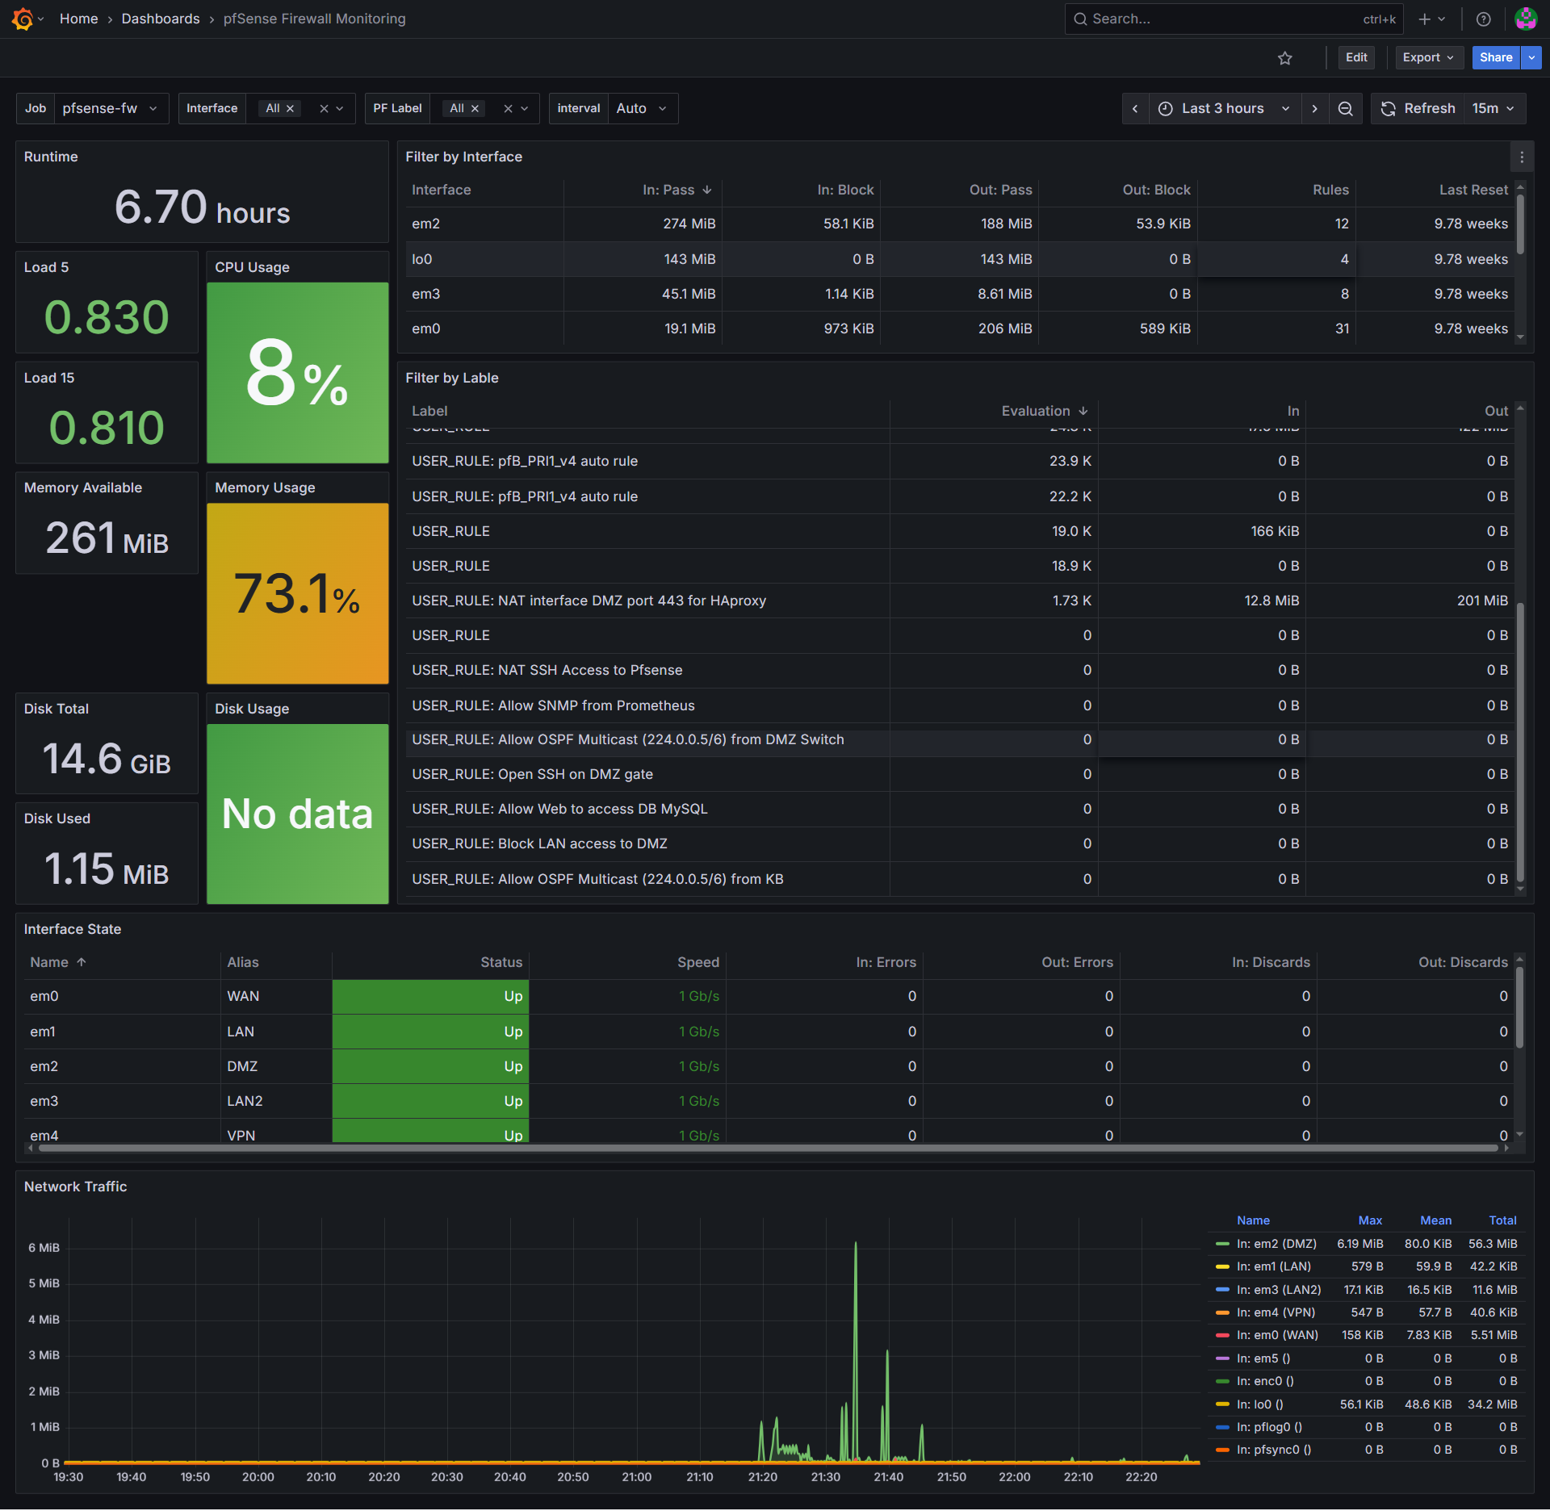

* + - * 1. pfSense Firewall Performance Monitoring Dashboard
* Result:
* System resource monitoring: Displays detailed real-time CPU, RAM, disk usage, and CPU temperature data.
* State Table Monitoring: Track the number of current connections and MBUF usage to detect potential overload or DDoS attacks early.
* Interface Traffic Statistics: Visual graphs of sent/received traffic on WAN, LAN, and DMZ ports, helping administrators quickly understand bandwidth status.
* Gateway Status: Monitoring of the WAN Gateway's Latency (RTT) and Packet Loss.
* Status of Telegram alerts being sent:

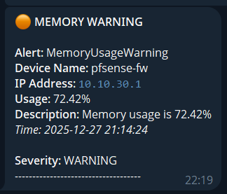

* + - * 1. Firewall resource warning
* Send alerts when the firewall's CPU or RAM usage is high (above 80%) for extended periods.
  + 1. Dashboard Node Exporter (Server Health)

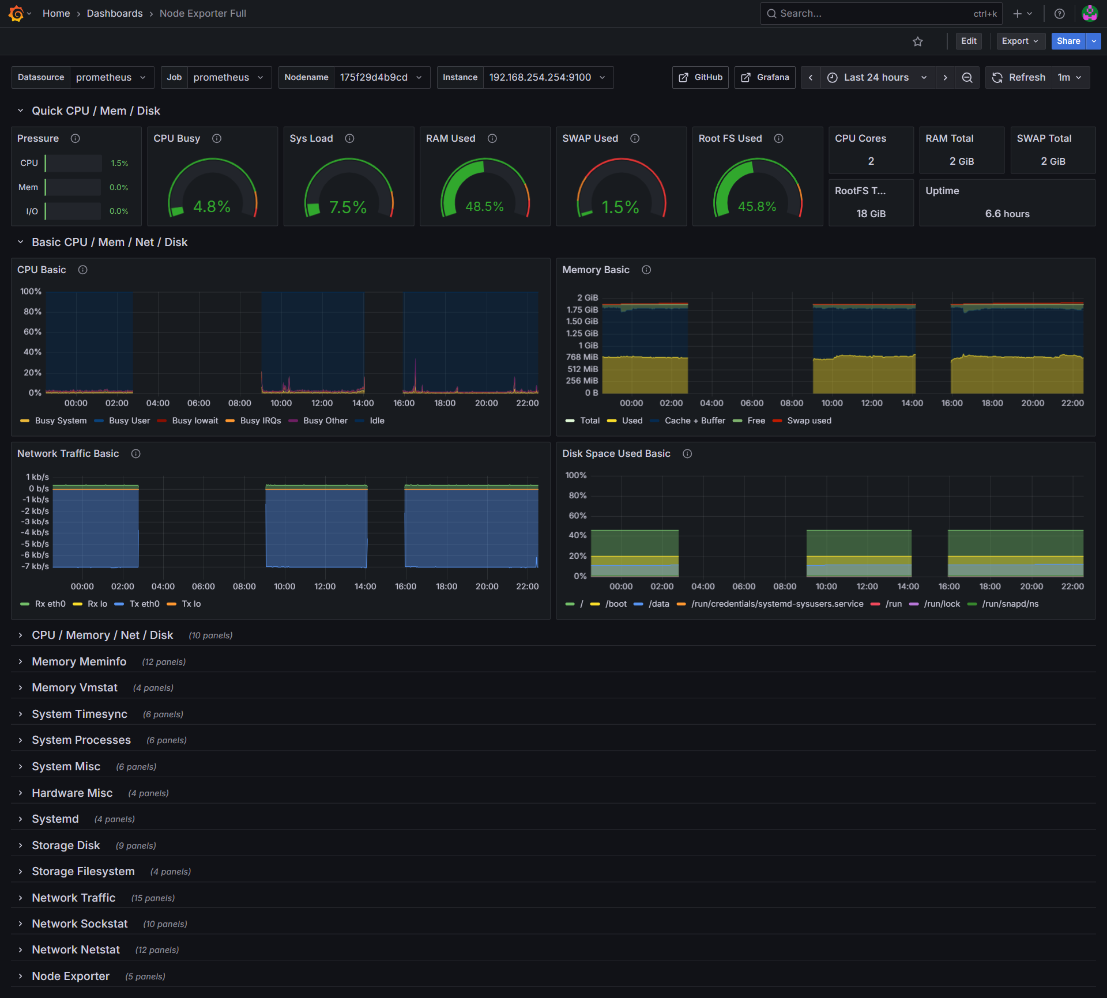

* + - * 1. Linux Server Health Monitoring Dashboard
* Result:
* Comprehensive monitoring of resources across Linux servers (Monitoring Server, Automation Server, Web Server).
* Key metrics such as CPU, Memory, Disk I/O, and Network Traffic are displayed in detail for each machine.
* It helps administrators quickly understand the health status of their server infrastructure.
  1. Results of Management Automation
     1. Result of Automatic Configuration Backup (Auto Backup)

The auto_backup.sh script is scheduled to run periodically (Cronjob) for 2 hours each day.

Execution process: The script automatically connects via SSH, retrieves the configuration from the Cisco switch (show running-config) and pfSense (config.xml), and then saves it to the /backups/YYYY-MM-DD/ directory.

Status monitoring: Backup results (Success/Failure) are visually displayed on the Grafana Dashboard via the auto_backup_status metric.

Error testing: When intentionally changing the SSH password in Inventory incorrectly, the backup system reports an error and immediately sends a "Backup Failed" warning to Telegram.

* the auto_backup.sh script file is executed:

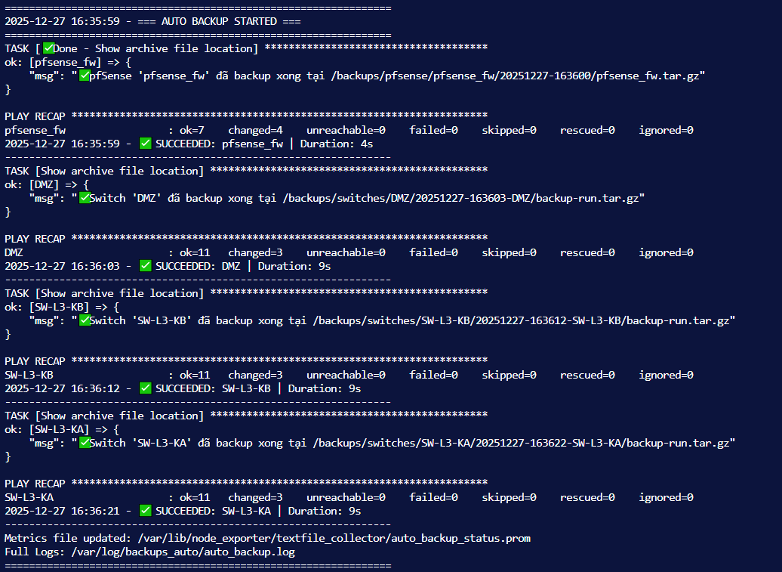

* + - * 1. Display details of the stages when running the playbook.
* Status of Telegram alerts being sent:

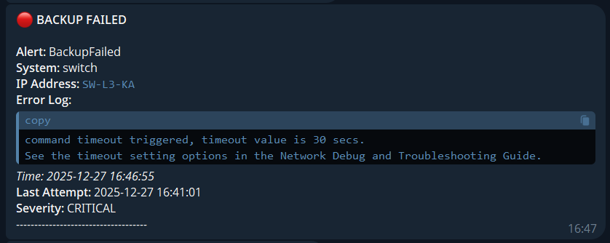

* + - * 1. Send alerts when backup fails.
* Success displays error and CRITICAL status when backup fails.
* Displays the time when the backup failed.
  + 1. Results of Teleport (Provisioning) Implementation

Use the teleport-menu.sh script to add a new server (Dev Node) to the system.

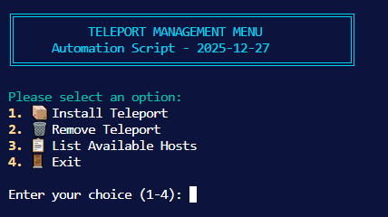

* + - * 1. Execute the teleport-menu.sh script.
* Install the teleport agent on the server.

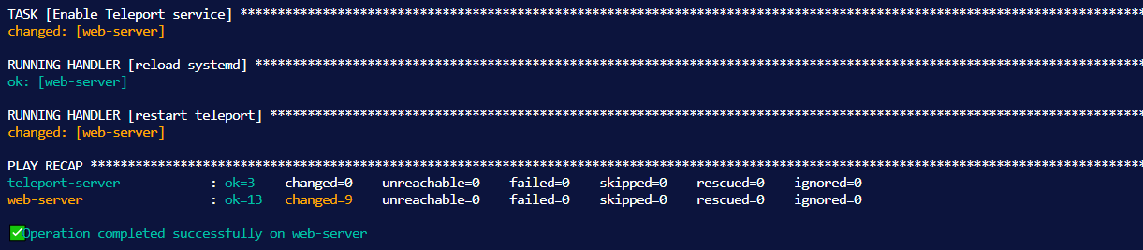

* + - * 1. The results are displayed after installing the teleport agent.

Result: Ansible automatically installs the Teleport Agent, generates a dynamic token, and connects that server to the Teleport Cluster. Administrators can immediately access the new machine via SSH through the Teleport web interface without manual configuration.

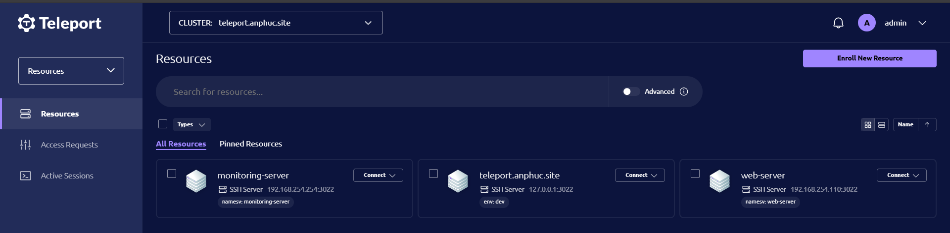

* + - * 1. The Teleport interface displays a list of nodes that have been automatically joined.
    1. Summary of Telegram report results

The cron job activates the daily_runner.py script at 20:00 every day.

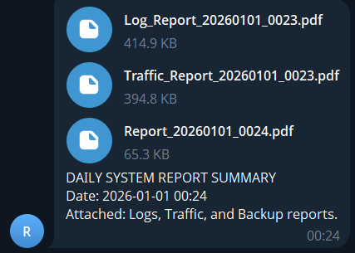

* + - * 1. Summary of report results on Telegram

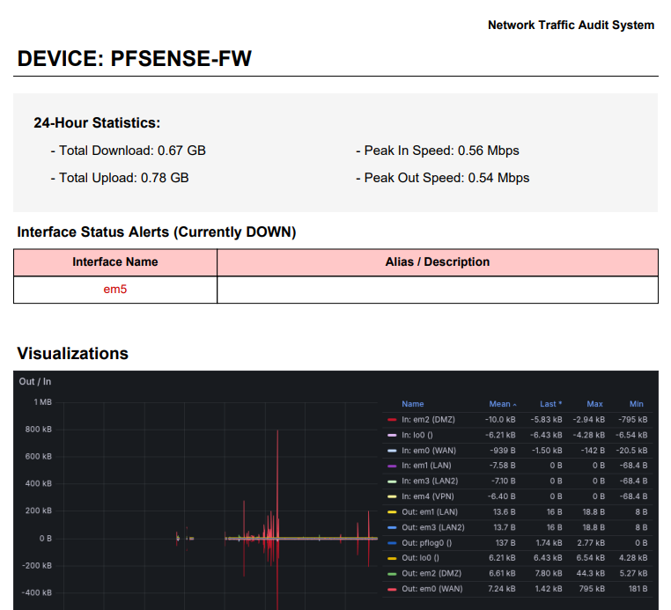

* + - * 1. Detailed PDF report on Traffic and Interface

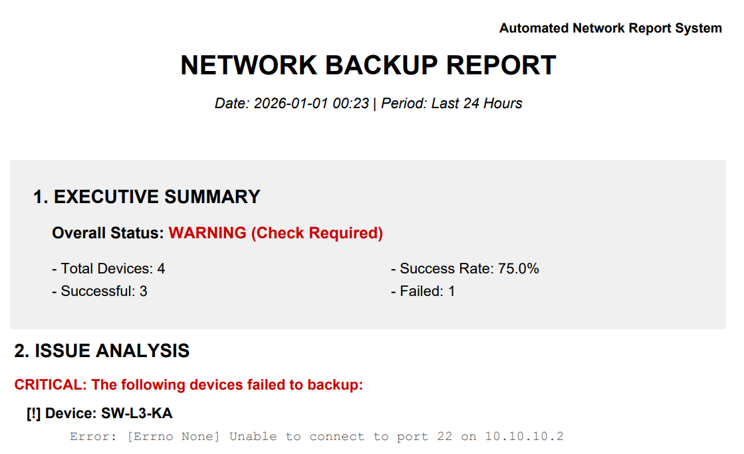

* + - * 1. Detailed report on 24-hour backups.

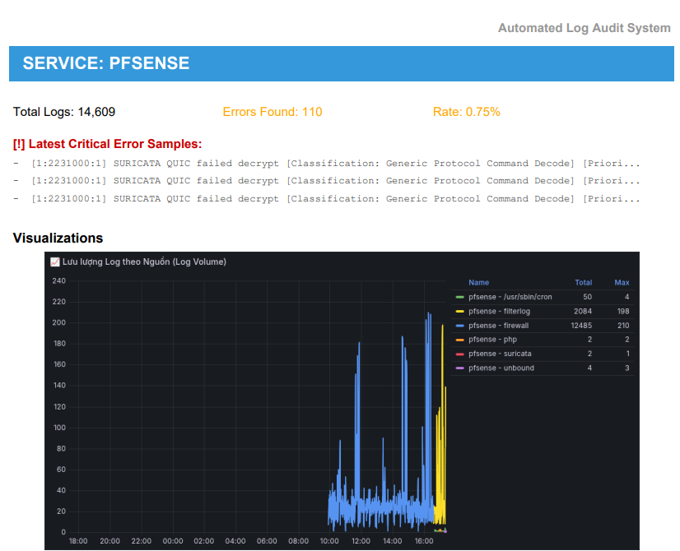

* + - * 1. Detailed PDF report on logs and error alerts.

Assessment: The automated reporting system reduces the time administrators spend manually retrieving data by 90%. Error logs and interface downtime alerts are accurately detected and reported, supporting timely troubleshooting decisions.

* 1. Results of the Active Defense System (Suricata IPS)

During the experiment, the project switched the defense mechanism from using Ansible to directly using Suricata in IPS (Legacy Mode) on pfSense. This enabled the system to achieve real-time response capabilities to threats.

The testing process was performed using a Kali Linux attack machine with 2 scenarios:

* + 1. Scenario 1: Preventing Network Scanning Attacks

Description: The attacker uses the Nmap tool to scan open ports and identify the operating system of the target server.

Execute command: nmap -A -v 192.168.254.110

* The system's response results:
* Detection: As soon as the first probing packets (SYN Scan) reach the WAN port, Suricata analyzes and matches them to the ET SCAN (Emerging Threats) rule set.
* Prevention:
* Suricata immediately adds Kali's IP address to the snort2c blocking table in Packet Filter. It then performs a Kill States action to immediately terminate the ongoing connection.
* On the attacker's machine: The scanning process is interrupted, Nmap reports a "Host seems down" error, or the connection repeatedly times out.
* The Grafana Suricata log shows the warning "ET SCAN Suspicious inbound to MySQL port 3306"

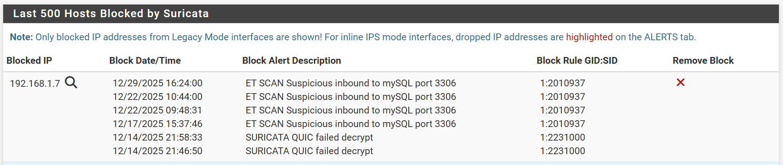

* + - * 1. The list of blocked IPs in the snort2c table on pfSense
    1. Scenario 2: Preventing a Denial of Service (DoS SYN Flood) Attack

Description: Using the Hping3 tool to generate a large number of continuously spoofed TCP SYN packets, this test aims to assess the resilience of firewalls and web servers against state table exhaust.

Purpose: To check if the system crashes or becomes overloaded when receiving transport layer (Layer 4) attack traffic.

Execution command : sudo hping3 -S --flood -V -p 443 sneaker-shop.anphuc.site

* The system's response results:

Detection: Suricata monitors the data stream and detects an anomaly when too many SYN packets are sent without completing the 3-way handshake process (SURICATA STREAM 3way handshake SYN resend different seq on SYN recv).

* Prevention:
* With IPS mode activated, the source IP of the attacking machine is blacklisted (snort2c).
* Subsequent Flood packets are dropped by the Firewall directly at the WAN port, without affecting the resources of the downstream Web Server.
* Logging: The system records alerts about abnormal traffic and displays them on the Grafana Dashboard.

Effectiveness: The web server remained accessible from other IP addresses while the attack was ongoing, demonstrating the system's accurate classification and prevention capabilities.

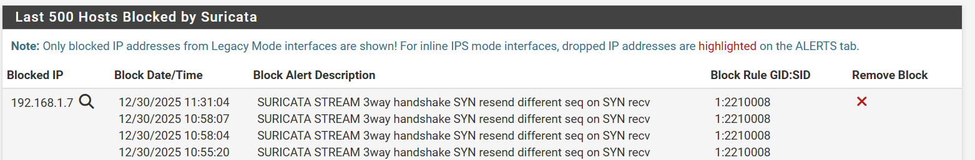

* + - * 1. Log Suricata detects and blocks DoS/Flood attacks.
  1. Overall assessment
     1. System effectiveness

The system has fully met the stated objectives:

Observability: Achieved 100%. All activities, from hardware resources and network traffic to security logs, are visually displayed and centrally located on Grafana (Single Pane of Glass).

Automation: Minimizes manual operations in configuration backup and service deployment.

Security: The proactive protection mechanism using Suricata IPS works accurately, blocking attacks right at the gateway without requiring administrator intervention.

* + 1. Advantages of the implemented architecture

Response speed: Using Suricata directly on the firewall eliminates the latency of indirect blocking solutions (via API/SSH), ensuring absolute security for internal services.

Scalability: The monitoring (Docker) and administration (Ansible) systems are easily expandable to manage hundreds of new devices simply by updating the configuration files.

Cost-effective: The entire solution uses open-source software, eliminating licensing costs while delivering performance comparable to commercial solutions.

* 1. Conclusion of Chapter 3

Chapter 3 comprehensively presented the system deployment and testing process in a simulated environment closely resembling reality. The experimental results obtained are significant, proving the correctness of the design solution:

Firstly, in terms of operations, the system has freed administrators from tedious and error-prone repetitive tasks. The automatic backup and rapid deployment processes operate stably and accurately, significantly saving time and resources.

Secondly, in terms of monitoring, the successful integration of the Prometheus-Loki-Grafana trio has provided extensive deep observability. Administrators no longer need to manually access each device to view logs or check status, but can grasp the entire system health through a single screen. Dashboards visualizing data from raw logs (such as the Suricata logs) are clear evidence of the effectiveness of data normalization.

Thirdly, in terms of security, the system has successfully transitioned from a passive to an active defense model. Real-world attack scenarios (network scanning, database attacks) are immediately thwarted by Suricata IPS. The combination of a hardware layer (firewall/IPS) and a software monitoring layer (alerting) creates a robust multi-layered defense system (Defense in Depth).

In summary, the experimental results confirm that the proposed NetDevOps model is entirely feasible for application in enterprise environments, helping to improve management efficiency, optimize costs, and enhance information security capabilities.

CONCLUSIONS AND FUTURE WORK

1. CONCLUSIONS

Through the implementation of the project "Building an enterprise network system applying automation with Ansible, monitoring with Prometheus, and security with pfSense IDS/IPS," the following specific results have been achieved:

Theoretical Contributions: The project demonstrated a mastery of modern network management architectures (NetDevOps), marking a successful transition from manual operations to Infrastructure as Code (IaC). It provided a deep understanding of the operating mechanisms of critical protocols (SNMP, Syslog) and the structure of attack signatures within IDS/IPS systems. Furthermore, the project successfully applied leading open-source monitoring stacks (Prometheus, Loki) to handle complex log data pipelines.

* Experimental Implementations:
* Infrastructure Design: Successfully deployed a complete simulated network system with functional partitioning (DMZ, LAN, WAN), integrating routing (OSPF) and redundancy solutions (HSRP) on Cisco equipment.
* Centralized Monitoring: Established a "Single Pane of Glass" monitoring system on Grafana, enabling comprehensive visibility of system health from the physical infrastructure layer up to the application layer.
* Automation: effectively utilized Ansible to resolve periodic configuration backup challenges and facilitate the rapid deployment of secure access services (Teleport).
* Active Defense: Successfully constructed an Automated IPS capable of detecting and blocking cyberattacks in real-time, validating the effectiveness of combining monitoring with automated response actions.

Practical Value: The system has proven highly feasible for application in real-world business environments, offering solutions to optimize operating costs and enhance information security. The implementation process also fostered critical problem-solving skills regarding system integration (resolving Regex parsing, SSH connectivity, and Suricata conflicts) and developed systems thinking capabilities to connect disparate technologies into a unified solution.

1. FUTURE WORKS

Acknowledging current limitations regarding hardware simulation resources, the lack of stress testing under heavy loads, and the reliance on static rule-based automation, the planned directions for future research and development are as follows:

Integration of AI and AIOps: Conduct further research into integrating Artificial Intelligence (AI) and Machine Learning into the monitoring system (e.g., utilizing Prometheus AIOps). The goal is to achieve dynamic anomaly detection without the need to manually define static alert thresholds, moving toward predictive maintenance.

Advanced Automation Management: Expand Ansible capabilities by implementing Ansible Tower (or AWX). This will provide a centralized management interface, Role-Based Access Control (RBAC), and complex workflow scheduling suitable for large-scale enterprise environments.

Hybrid Cloud Expansion: Research solutions to extend the monitoring architecture to a Hybrid Cloud environment. This involves unifying on-premise infrastructure monitoring with cloud service metrics (AWS/Azure) onto a single Grafana platform to ensure seamless observability.

LIST OF REFERENCES

Vietnamese

Nguyễn Tuấn Anh (2019), “Nghiên cứu giải pháp giám sát an ninh mạng sử dụng phần mềm mã nguồn mở”, Tạp chí Khoa học và Công nghệ, Đại học Đà Nẵng, 17(1), tr 45-50.

Nguyễn Thúc Hải (2014), Mạng máy tính và các hệ thống mở, Nhà xuất bản Giáo dục, Hà Nội.

Hồ Đắc Phương (2004), Giáo trình An toàn dữ liệu và bảo mật thông tin trong mạng máy tính, Nhà xuất bản Giáo dục, Hà Nội.

Bộ Thông tin và Truyền thông (2022), Báo cáo tình hình an toàn thông tin mạng Việt Nam năm 2022, Hà Nội.

English

Geerling, J. (2020), Ansible for DevOps: Server and Configuration Management for Humans, Leanpub.

Brazil, B. (2018), Prometheus: Up & Running: Infrastructure and Application Performance Monitoring, O'Reilly Media, Sebastopol, CA.

Johansen, A. (2020), Mastering pfSense: Manage, secure, and monitor your on-premise and cloud network with pfSense 2.4, 2nd Edition, Packt Publishing, Birmingham.

Turnbull, J. (2016), The Art of Monitoring, Turnbull Press, New York.

Red Hat Inc. (2024), "Ansible Documentation", accessed from https://docs.ansible.com/.

The Prometheus Authors (2024), "Prometheus Documentation", accessed from https://prometheus.io/docs/.

Open Information Security Foundation (2024), "Suricata User Guide", accessed from https://suricata.io/documentation/.

Grafana Labs (2024), "Loki Documentation", accessed from https://grafana.com/docs/loki/latest/.